Com 1005 – Visual Composition

Words – Literally Assignment

Instructions
Choose two words from the list below. In two different compositions, arrange each word to express its meaning (one word per composition). You may use any computer program that you wish to accomplish this task (Microsoft word, Photoshop, pages, etc.). The composition should be 15 cm x 15 cm (6” x 6”) square. You may vary the size, spacing, placement, and orientation of the letters. Use the typeface Futura Bold.

You may repeat, omit, slice, block, or overlap words or letters. Do not use drop shadows or horizontal/vertical scaling (distortion). Consider the entire space of the square.

Once complete, upload both files into the Session 3: Words Literally Assignment Folder and add them to your e-portfolio.

Presentation

compression EXAMPLE
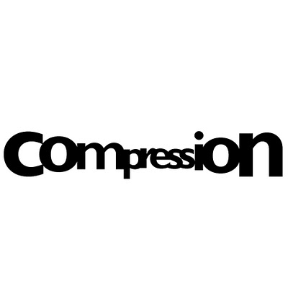
transition
contraction
addition
subtraction
disruption
repetition
elimination
migration
expansion

Evaluation
Category | Possible Marks
Originality/Concept development | 5
Design/Composition | 5
Craft/Execution | 5
Total | 15

