ENGLISH 10-1 MODULE SIX CHALLENGE THREE (M3C3)
CREATIVE RESPONSE TO R OMEO AND JULIET
TASK ONE: SOUNDTRACK
Music and sound design are crucial in any stage or film production. They combine with lighting and set design to develop and enhance the mood and atmosphere of the work and echo the action taking place on stage/screen. This contributes to the overall emotional effect experienced by the audience.
Create a soundtrack for a new movie version of Romeo and Juliet.
You may use music from any genre and time period.
You must have music for at least 10 scenes in the play. That works out to two scenes per act. Be sure to carefully consider what scenes are key/important and what mood and atmosphere and action need to be developed and reflected by the music.
Create a CD/album cover for your soundtrack.
Include lyrics, performers and composers/writers for each of your chosen songs (as applicable.)
Identify the scene with which each piece of music corresponds.
Include liner notes that explain why each song was chosen for each scene.
E.g.: “I Can’t Help Falling in Love with You” by Elvis Presley would be great for the beginning of the balcony scene. Its music is dreamy and slow and matches Juliet’s mood as she sighs and says “Ay, me” and “Wherefore art thou, Romeo?” The lyrics parallel the themes of fortune and fate: “Some things are meant to be” is reminiscent of “star-crossed lovers” and “some consequence yet hanging in the stars Shall bitterly begin his fearful date with this night’s revels.” Also, “Wise men say only fools rush in” has echoes of Friar Laurence counselling Romeo (“Wisely and slow, they stumble that run fast”), and of Romeo, himself (“O! I am fortune’s fool!”).
Illustrate /decorate your CD/album cover appropriately for the content.
Due to copyright laws, do not create an actual compilation of music for this assignment. Instead, hyperlink the songs with the Youtube link.
To hyperlink, type the name of the song and the artist(s)
Ex. Everything Is Awesome by Tegan and Sara ft the Lonely Island
Highlight the title and right click it
Select ‘Hyperlink’
Copy and paste the video url into the text box
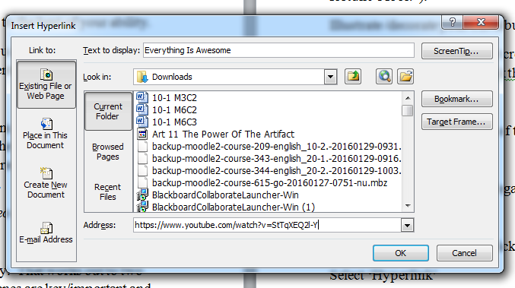

If it glows blue, and you click on it and it opens the right webpage, you have hyperlinked it!

