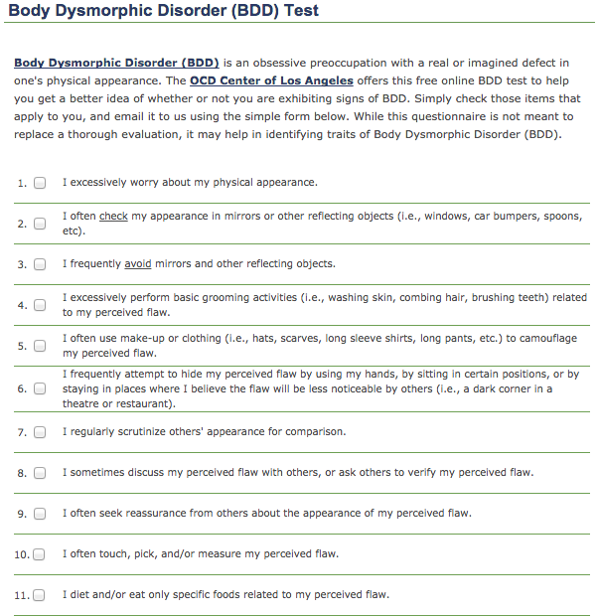
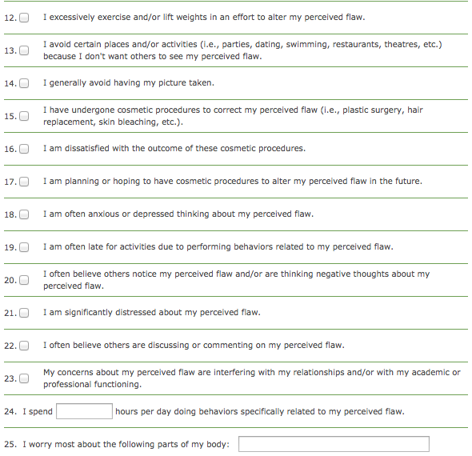
Results for our Body Dysmorphic Disorder test fall into three categories:
* 1 to 3 test items checked: There is a low probability that you have BDD. You may be more concerned about your body image than most people, but it is unlikely that these concerns significantly impact your life.
* 4 to 7 test items checked: There is a medium probability that you have BDD. You likely experience a moderately high amount of distress related to your body, and likely spend more time than most people obsessing about, and checking, your appearance.
* More than 7 test items checked: There is a high probability that you have BDD. You most likely have a great amount of distress related to what you perceive to be a significant flaw with your body. It is likely you spend a considerable amount of time checking your appearance, attempting to change and/or camouflage your appearance, and avoiding situations in which you fear others might observe your perceived body flaw.
The best treatment for Body Dysmorphic Disorder (BDD) is Cognitive-Behavioral Therapy (CBT), which has been found by research studies to be the most effective treatment for BDD.

