AB PSYCH Emojis and Emotions

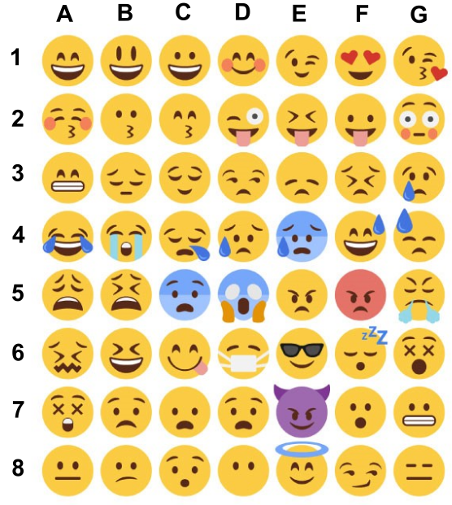

 | A | B | C | D | E | F | G
1
2
3
4
5
6
7
8

