**Notes on the Visual Reflection**

* The visual reflection assignment asks you to reflect upon and support your ideas regarding a photo, drawing poster, advertisement, etc.
* You must select a prose form (NOT poetry) and write a detailed response
* This is a MAJOR WRITING ASSIGNMENT and should have all the qualities of good writing – one main idea that is clearly stated and carefully proven with many, well chosen, well explained details. It should have an INTRODUCTION, BODY PARAGRAPH(S) and a CONCLUSION

**Interpreting a Visual Work in Five Steps**

**Writer’s Guide**

Use the following steps to develop a response to a visual work or other fine arts representation.

**Step 1: First impressions**

* List the first words that come to your mind when you look at the work.

**Step 2: Description of work**

* Describe exactly what is in the work. Be objective. Do not include your reactions or opinions at this stage.

**Step 3: Analyze**

* What colours, textures, shapes, contrasts, movement, and patterns has the artist or photographer used in the work?
* What effect do these techniques have on the work?

**Step 4: Crisscross Method**

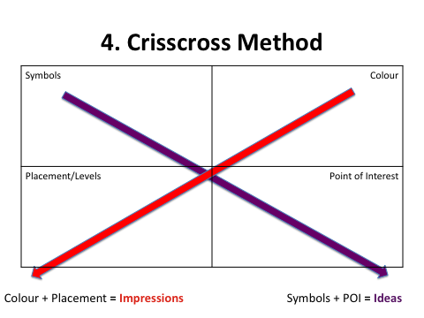

**Step 5: Make an informed interpretation**

* Review your notes from the previous four steps. Provide support for your views in a four paragraph response.
* This is where you should be developing the main idea of this image.

**The Assignment** (will always be something like)

|  |
| --- |
| **What ideas and impressions does the picture/poster/drawing etc suggest to you? Consider the context and develop your response by referring to the Visual.** |

You have THREE options in your approach to the Visual

|  |  |
| --- | --- |
| **Option 1:**  **Respond Personally** | **Introduction**   * A good introduction begins with some kind of ‘grabber’ * Then state what the picture is about. This should include a mood or attitude (the overall feeling conveyed by the picture, such as happiness, sadness, confusion). For example, the photographer may show how exciting it can be to master something difficult * Always provide a detailed answer to the assignment question presented ie. “In this picture we see …” or “The photographer shows us…” (ONE sentence) * Introduce personal experience that you will be discussing in the response   **Body**   * In a detailed, interesting, descriptive way tell of your personal experience * Make connections to the picture   **Conclusion**   * Sum up your personal experience and connections to the picture * Restate the answer to the assignment question * Closure – a more general comment |

|  |  |
| --- | --- |
| **Option 2:**  **Respond Critically** | **Introduction**   * **Motivator**: Capture the reader’s attention – Often a general statement on the central conflict or topic of the photo. * **Transition**: Include a reference to the photo you are responding to in the assignment. * **Thesis**: In one sentence identify the central message that the photo suggests.   **Body Paragraphs (Two – Impressions and Ideas)**   * **Topic Sentence**: The central idea that the paragraph is developing. * **Three points of support**: Each support must have direct reference to the photo (details from the photo). * **Summative Sentence**: Summarize the main idea from that paragraph in one sentence.   **Conclusion**   * **Reword Thesis**: Remind the reader of the point you were making - do not simply restate your thesis, make sure it sounds confident. * **Summarize** the main points from the body to show how you made your argument. * **Concluding statement** on the topic. |

|  |  |
| --- | --- |
| **Option 3:**  **Respond Creatively** | Write a short story, script, memoir, monologue, newspaper article, personal journal, letter, diary   * Make sure you answer the assignment question and always have this answer in mind as you write your creative response * Use the following acronym to help you plan your response:   **R**ole- What perspective are you writing from?  **A**udience – Who are you writing for?  **F**ormat – What format will your response take?  **T**opic – What is your topic (be sure it relates to the ideas and impressions from the visual)  **S**trong Emotion – What emotion will you develop in your response? |