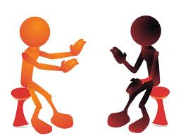

**Communication**

Communication is a two way street; we receive messages and we send messages. All of us have different skills in both sending and receiving information. Consider the following ways we communicate.

**Input**

reading (books, magazines, e-mails, texts, signs, etc.)

listening (voice mail, audio clips, in person, cell phone, music, songs, plays, concerts, recorded books, etc.)

viewing (plays, videos, dance performances, television, concerts, etc. ?

**Output**

writing (poetry, letters, e-mail, texts, stories, reports, etc.)

speaking (audio clips, in person, cell phone, voice mail, songs, etc.)

representing ( drawings, sculpture, graphics, music, etc.)

**Step one** – In the space below rate your skills in each area on a scale of 1 to 5. A rating of 1 would mean you have very little skill in that area and a rating of 5 would mean that this is a very strong skill for you. Change the colour to show your rating.

|  |  |  |  |  |  |
| --- | --- | --- | --- | --- | --- |
| reading | 1 | 2 | 3 | 4 | 5 |
| writing | 1 | 2 | 3 | 4 | 5 |
| speaking | 1 | 2 | 3 | 4 | 5 |
| listening | 1 | 2 | 3 | 4 | 5 |
| representing | 1 | 2 | 3 | 4 | 5 |
| viewing | 1 | 2 | 3 | 4 | 5 |

Name

**Step 2 –** Choose one area that you consider to be the greatest challenge to you in communication. This will likely be one that you rated with a 1 or 2 above. State three strategies you could use to improve that area.