**English 10-2 Final Assignment**

**Please read the following. When you have finished, please read the assignment portion and then read the speech one more time. When you are finished, complete the assignment and either put it in the dropbox or email it to me at** [**aforer@rvschools.ab.ca**](mailto:aforer@rvschools.ab.ca)**. Thank you.**

**Lou Gehrig, “Farewell to Baseball Address”**

**July 4, 1939; Yankee Stadium**

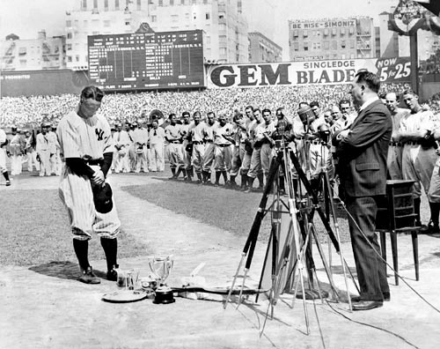

It seemed as if the luminous career of Lou Gehrig would go on forever. The Yankee’s first baseman and prodigious slugger was nicknamed the Iron Horse for his durability and commitment to the game. Sadly, his record for suiting up for 2,130 consecutive games came to an end when at age 36, Gehrig was stricken with the crippling disease that now bears his name. On July 4, 1939, the Yankees held a ceremony to honor their teammate and friend. They retired Gehrig’s number, spoke of his greatness, and presented him with various gifts, plaques, and trophies. When Gehrig finally addressed the crowd, he did not use the opportunity to wallow in pity. Instead, he spoke of the things he was grateful for and what a lucky guy he was.

**The Speech**

Fans, for the past two weeks you have been reading about a bad break I got. Yet today I consider myself the luckiest man on the face of the earth. I have been in ballparks for seventeen years and have never received anything but kindness and encouragement from you fans.

Look at these grand men. Which of you wouldn’t consider it the highlight of his career to associate with them for even one day?

Sure, I’m lucky. Who wouldn’t consider it an honor to have known Jacob Ruppert – also the builder of baseball’s greatest empire, Ed Barrow – to have spent the next nine years with that wonderful little fellow Miller Huggins – then to have spent the next nine years with that outstanding leader, that smart student of psychology – the best manager in baseball today, Joe McCarthy!

Sure, I’m lucky. When the New York Giants, a team you would give your right arm to beat, and vice versa, sends you a gift, that’s something! When everybody down to the groundskeepers and those boys in white coats remember you with trophies, that’s something.

When you have a wonderful mother-in-law who takes sides with you in squabbles against her own daughter, that’s something. When you have a father and mother who work all their lives so that you can have an education and build your body, it’s a blessing! When you have a wife who has been a tower of strength and shown more courage than you dreamed existed, that’s the finest I know.

So I close in saying that I might have had a tough break – but I have an awful lot to live for!

**Final Assignment:**

1. **What is Lou Gehrig’s Disease and what does it do to the human body? (5 marks)**
2. **Why is Lou Gehrig an important figure in the history of humankind? (5 marks)**
3. **Write a five paragraph personal essay responding to the following question: ( 25 marks)**

**What is Lou Gehrig’s message to humankind and what might this message mean to you now or in the future?**

**Be sure to proofread your essay and develop a strong thesis statement in the first paragraph.**

**End of Assignment**