Name: Date:
Unit 6

Mind Map: Connections to the Past

Ancestors:

Exploration:

Connections to the Past

Immigrants:

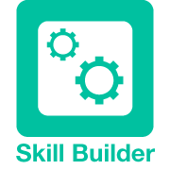
Skill Builder
How to complete a mind map. You can access the Skill Builder from the online course.


Save Your File
When you are finished, save your file to your Documents folder.

