Assignment Submission
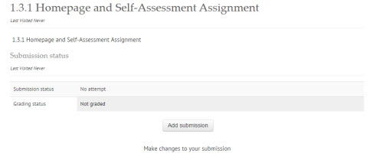
To submit a file(s), complete the following steps:
- Click “Add submission”.

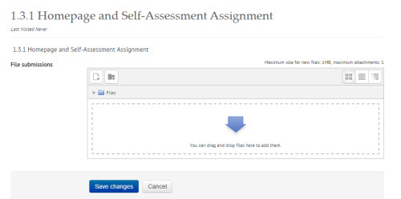
Drag and Drop
- Drag and drop the file(s) into the File submission area.
Add file icon
- Or click the “Add icon” to add your assignment
- Click “Save changes”.

- A Submission status page will appear.
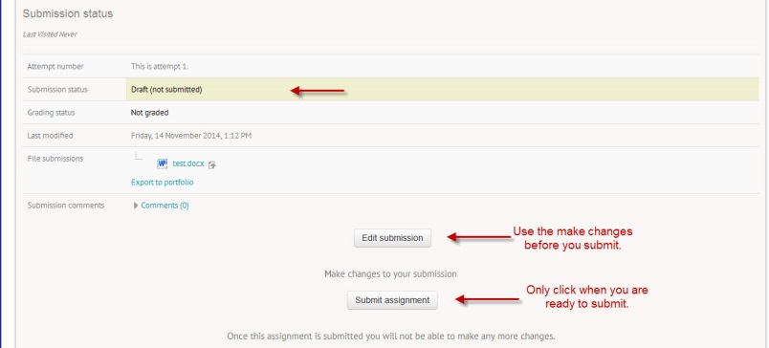
- Note that your assignment is in DRAFT form.
- You can click the “Edit submission” and make changes, and “Save changes” multiple times until you feel your assignment is ready to be submitted.
- Click “Submit assignment”.

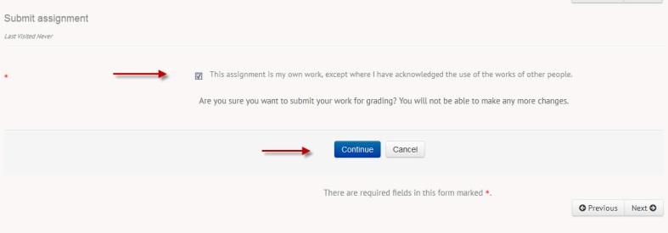
- Next, check the box to state this is your own work and that you are ready to submit.
- Click “Continue”.

Your Assignment is now submitted for marking. Continue your course work by clicking the NEXT button.

