Romeo and Juliet & Modern Genre

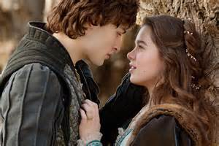

There are many movies, plays, writings etc from modern day that follow the plot lines of Shakespeare’s plays. For example, “The Lion King” is based on the play “Hamlet”. The movie, “Kiss Me Kate” is based on Shakespeare’s “Taming of the Shrew”.

For this assignment, you may select any movie, book, play, poem, or any other genre that you wish to choose that directly relates to the plot of Romeo and Juliet.

Once you have made your selection, compare and contrast the original play and the genre you have chosen.

Create a chart and use point form. You may use pictures, specific lines from your choices etc. This is very “wide open” in terms of how you wish to respond.

Each comparison or contrast, explained well, is worth four marks. You must use at least TEN different examples.

Please make sure that you detail the genre you have selected in order that it can be referenced for grading purposes.

Total assignment points are 40.