Romeo and Juliet

A Picture Says a Thousand Words

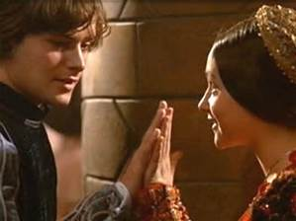

Choices

The focus of Unit Three is the choices we make. There are many “choices” that Romeo and Juliet make throughout the course of the play.

In five to seven paragraphs, discuss the photo above in relation to the choices that Romeo and Juliet made throughout the course of the play. You may use a single act or scene, or multiple. This is up to you. Use direct quotes from the play to support your response indicating the scene and line of the quote used.

This assignment is very “flexible” in nature. You decide the direction of the response. You could use something like the following, but you are allowed to take your own direction.

Ex: Romeo and Juliet were too young to make the responsible choice to be married.

Or

If Romeo and Juliet had decided to wait to be married they may have been able to convince their parents of their intent and secured their parents’ blessing.

Grading:

The Literary Response Rubric will be used to grade this assignment.

It is worth 100 marks.