*Am I Native Enough Yet?*  
Kerry Potts

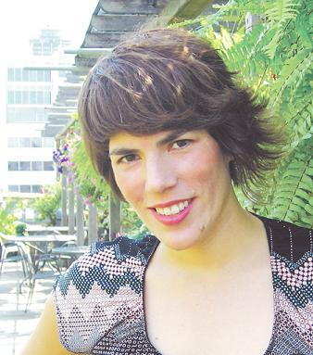A self-declared Aboriginal-arts activist, Kerry Potts is a proud Teme-Augama-Anishnaabe woman of mixed heritage who has worked in urban Aboriginal communities in Ottawa, Toronto and Chiang Mai, Thailand. Involved with initiatives that include working with Aboriginal social service organizations coordinating women’s and youth programming, and working with street-involved youth to delver anti-discrimination workshops, she is also formerly the Assistant Manager to Juno Award winning singer-songwriter Susan Aglukark. Kerry has recently completed her film Love on the Streets, exploring themes of love with people who are homeless, and is now the Managing & Development Director at the imagine Native Film and Media Arts Festival.

A while ago, a friend asked me to read some poems on her native-focused radio show. “Do they have to be by native authors?” I asked. “Yes, because it’s a native show,” was her response. This didn’t bother me at the time. As I pondered its deeper implications, however, it occurred to me it was an example of the narrow understanding people seem to hold about what qualifies as native.

I’m not sure that I know what it means to be native. What I do know, is that it bothers me that I question it.

My position is that if you are a native person – that is, have native ancestry – then whatever you do is native.

Many people have moved off-reserve and forgotten their languatge4 and traditions. Does this mean they are not acting native? Some would say yes. I think it only means they have lost some hold on traditional native ways. Ideally, all native people would know their language and practices their culture.

However, this is not the reality of today. Our definitions must expand or we will continue to perpetuate stereotypes that native people have fought throughout history. I’ll use myself as an example. I wear Vans, have several piercings, dye my hair and dance to funk. On the surface, it may not be obvious that I am native. But I also go to pow-wows, smudge regularly, participate in sweat lodges, and keep up-to-date on Aboriginal issues.

I don’t put any great effort into expressing my heritage in obvious terms. I think those who do are completely justified in their positive cultural expression, but I refuse to change my looks or habits because someone thinks I don’t look native enough, or to fit some stereotyped of an Indian princess.

I attended the recent First Nations Day celebrations at Harbourfront Centre in Toronto and found it completely amusing when a group of native children got up on stage and began swing dancing. They were totally awesome, I must say, but it was an unexpected move away from conventional methods of exhibiting what is native.

Some might think that I’m advocating the adoption of non-native ways in order to better ourselves. That’s not it at all. Instead, I think we simply have to open our eyes to the fact that not all native cultural expressions are spawned from tradition, and that we can open our arms to doing other things while retaining our heritage.

So is it relevant to read a non-native person’s poem on a native radio show? Of course it is, because native people also relate to that which is not traditionally considered native.

Native cultural expression doesn’t have to be only that which talks about healing, spirituality, anger about residential schools, and other common themes.

Native movies can involve native people living off reserves. Native people can dance to funk as well as the heartbeat of the drum.

Be proud of your native heritage, for it is a beautiful culture with many powerful elements. Be proud of who you are, inside and out.

But don’t let people tell you that being an Indian only means living on a reserve and wearing a headdress. This will only limit you.

Remember and practise your heritage. And be who you want to be.