**Guidelines to Success**

**Read the content as you will need the information to answers the questions**

**from the ‘Introductory Assignment’ link.**

**Submit your questions and answers to the U1 Course Intro folder, in Moodle.**

**Teacher: J. in’tVeld**

**Phone: 403-948-4360 (ext. 5305)**

**Email:** [**jintveld@rvschools.ab.ca**](mailto:jintveld@rvschools.ab.ca)

**Teaching Hours: Tuesdays and Thursdays 9:00-3:30  
Email your teacher to establish contact. Email and course announcements are our main form of communication, so check your RVS email account daily!**

**Email -**Manners and clarity: When emailing your teachers remember we receive and answer dozens of emails every day.  For this reason, begin your email with a polite salutation (ex: Hi Mrs. in’tVeld).  Then identify the course subject, the current unit of study and the lesson that you are inquiring about.  This makes communication much clearer.

Note: Be sure to email your teacher from your RVLC email account. Emails from other accounts may be filtered as junk email.

**Assignments –**

Getting Started: It is important that you copy and paste the assignment description into every assignment. This will help ensure that you accurately complete the assignment and all of the components.

Staying on Track: The course has been organized into four units and due dates are posted on the home page. It is very important that you adhere to the due dates and do not submit your assignments in bulk at the end of the term. There are several reasons for this:

* When you submit assignments you will receive feedback that is important to your development as a learner
* When assignments (NOT tests or quizzes) are submitted on time you will be given the opportunity to re-do it to improve your mark
* Bulk submissions might result in missed assignments
* When students put off work until the end of the term often times the quality of work is reduced because students are rushing to complete it

Submitting Assignments: When submitting assignments into Moodle you must use one of the following formats- **PDF, Word of RTF**. **Pages and zip files will NOT be accepted.**

Labeling**:** Correctly label all assignments as follow the unit#_lesson#_last name.  
Ex labelling for Social 20, Unit One, Lesson 3 = U1L3intveld

**Assignment Feedback - Click on Assignments (located in the right column of course home page).   
(See image, below)**

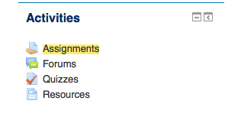

**From within the Assignments page, check the feedback in your folders regularly by looking in the Grade column and clicking on any assignments that you have submitted. (see image below)**

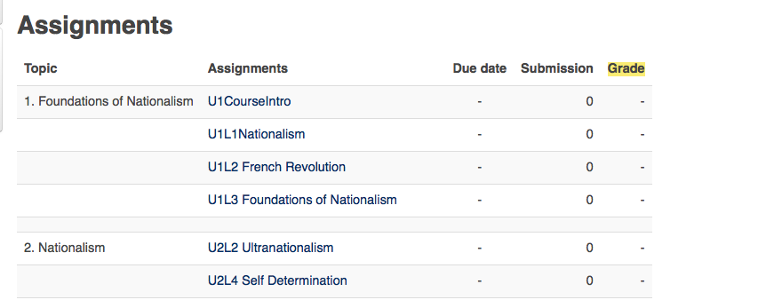

**You can also see which assignments are still outstanding by looking in the Submission column. (see image above)**

**Grades-**

Although you can see the grade you receive on each assignment in Moodle, for accurate and official grades, please look in Powerschool. Moodle does not take into account category weighting or missing assignments.

**Exam Procedure -**Tests and quizzes are password protected and each WeConnect supervisor has access to them. Unit tests are to be written at your school and supervised by your WeConnect coordinator. Once you have completed the necessary lessons please make arrangements with them to write it.

**COMPLETING THE COURSE:**

**Due Dates -** Go to your course home page and look at the calendar for the due dates for each unit. Due dates can also be found in Powerschool.

**Assignment submission - Complete the work outlined in the *LESSON* section by the due date listed in the course *home page*. As soon as you have completed the assignment, submit your work to the correct assignment folder (located underneath the lesson (see image, below).    
Submit all assignments immediately after completing them, do NOT wait to submit assignments in bulk)**

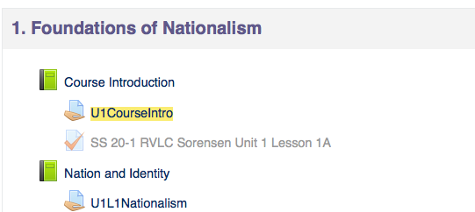

**Unit exams -** are to be completed after each unit. To be eligible for a unit exam, all lessons and assignments, from that unit, need to be handed in. Please email me to schedule a time when all required material is complete**.**

**When you are unsure of something, whether it is course work or online learning issues, it is important that you ask your teacher for assistance immediately.    
  
All of your teachers are here to help you and want to see you succeed.  By following the steps outlined above and keeping in regular contact with your teacher, you will improve your chances of succeeding immensely! Never hesitate to ask for help, and have a great semester! :-)**