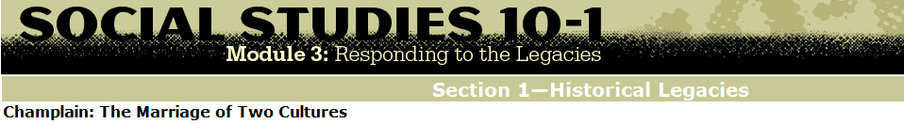

". . . The conclusion was that sieur de Champlain said to them: "When that great house shall be built, then our young men will marry your daughters, and we shall be one people." They began to laugh, answering: " Thou always sayest something cheering to rejoice us. If that should happen, we would be very happy. . ."

*The Jesuit Relations: and Allied Documents Travels and Explorations of the Jesuit Missionaries in New France 1610—1791*,   
ed. Reuben Gold Thwaites (Cleveland: The Burrows Brothers Company, 1898).

Over time, diverse understandings of Métis identity (i.e., the definition and acknowledgement of a distinct identity that reflects both European and First Nations heritages) have developed. Some of the historical terms, such as *half-breed*, have become outdated or inappropriate for use in society today. Individuals may prefer one term over another in identifying themselves in relationship to their ties to both cultural heritages. Examine the different names and definitions.

* During Canada’s early history, descendants chose to align with First Nation parentage or were baptized as French Canadians.
* Half-breed was a common reference in records and documents from the Hudson’s Bay Company and the early Canadian government.
* Section 31 of The Manitoba Act in 1870 also referred to the Métis people as half-breed.
* This is from the 1932 L’Association des Métis de l’Alberta et les Territoires du Nord-ouest, later renamed as the Métis Association of Alberta.   
    
  “Anyone with any degree of Indian ancestry who lives the life ordinarily associated with the Métis”
* The 1934 Alberta government commission report provided this definition of Métis.   
    
  “a person of mixed white and Indian ancestry having not less than one quarter Indian blood and including either Status Indians or non-Status Indians as defined in the Indian Act”
* This is the Métis National Council (www.Metisnation.ca) definition.   
    
  Métis means a person who self-identifies as Métis, is of historic Métis Nation Ancestry, is distinct from other Aboriginal Peoples and is accepted by the Métis Nation.  
    
  Defined Terms in National Definition of Métis   
    
  WHEREAS on September 27, 2002 the Métis Nation adopted a national definition of Métis; and   
    
  WHEREAS within the definition there are defined terms;   
    
  THEREFORE BE IT RESOLVED that the Métis Nation adopts the following defined terms for its national definition of Métis;  
    
  “Historic Métis Nation” means the Aboriginal people then known as Métis or Half-Breeds who resided in Historic Métis Nation Homeland;  
    
  “Historic Métis Nation Homeland” means the area of land in west central North America used and occupied as the traditional territory of the Métis or Half-Breeds as they were then known;  
    
  "Métis Nation” means the Aboriginal people descended from the Historic Métis Nation, which is now comprised of all Métis Nation citizens and is one of the “aboriginal peoples of Canada” within s.35 of the Constitution Act of 1982

Métis National Council (www.Metisnation.ca)

* These are Métis Settlements Act definitions.  
    
  “… a person of Aboriginal ancestry who identifies with the Métis history and culture.”  
  (i) the applicant has Canadian aboriginal ancestry, describing the facts on which the declaration is based, and   
  (ii) the applicant identifies with Métis history and culture
* This is the definition from Section 35 of the 1982 Constitution.  
    
  **AND WHEREAS** section 35(2) of the *Constitution Act, 1982*, states that the “Aboriginal peoples of Canada” includes the Indian, Inuit and Métis peoples of Canada