Mathematics 20-2: Glossary Terms

Each lesson will provide terms that should be included in your glossary. You may also choose to add other terms to help you understand the math you are studying.

In the first column, write the term.

In the second column, write the definition.

The third column is for you to provide anything that you think would help you to remember the definition. You can insert additional text, formulas, photographs, video clips, or hyperlinks in this column.

Examples are provided.

Module 2
Term | Definition | Examples/Notes
Lesson 1
personal strategy | Explain using words or mathematical processes your individual approach to a situation or problem. Developing a personal strategy involves  - thinking about the situation or problem  - planning how you will try to solve the problem or situation  - carrying out your plan  - evaluating your solution  The key is to be creative. Use diagrams, look for patterns, and don’t be afraid to try. | 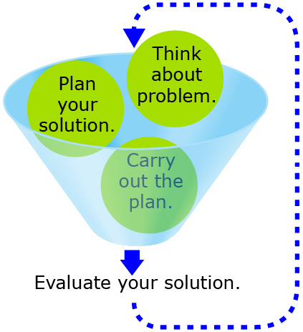
Lesson 6
transversal | A line that intersects two (or more) parallel or non-parallel lines. | 