Mathematics 20-2: formula sheet

Throughout the course, you will come across formulas that should be included in your formula sheet. You may also choose to add other formulas to help you understand the math you are studying.

In the first column, write the formula.

In the second column, write the terms in the formula as well as a description of each term.

The third column is for you to provide a diagram.

Examples are provided.

Formula | Terms | Diagram
Area
 | A  area of the interior of the rectangle   length of the rectangle  w  width of the rectangle | 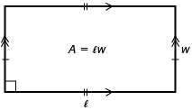
Trigonometry
 | Sin   ratio of the length of the side opposite of  to the length of the hypotenuse in a right triangle  side opposite to   length of side opposite to   hypotenuse  length of side opposite the right angle | 