Mathematics 10-3: glossary terms

Save a copy of this document in your course folder. This glossary contains all of the terms defined in this module. You will come across the terms as you work through the lessons.

Each time you come across a new term, open the copy of this document that you saved in your course folder. Then add notes, examples, drawings, and so on to the third column.

By the end of the module, you will have your own personal glossary.

Module 1
Term | Definition | Examples/Notes
Lesson 1
metre | the base unit of length (or linear measure) in SI
Lesson 2
area | a measurement of how many square units a surface can be divided into  For example, if your living room carpet can be divided into 10 square metres, its area is 10 m².
hectare | the area of a square 100 m on each side  The symbol for one hectare is 1 ha.  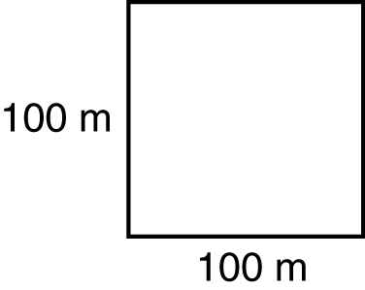
Lesson 3
capacity | a measurement of how much a container can hold  Commonly, capacity refers to the amount of liquid that can be poured into a container, but capacity can also be used to refer to an amount of solid that can be placed into a container.
litre (L) | the capacity of a container having a volume of 1000 cm³  Since 1 L = 1000 mL, 1 mL = 1 cm³.  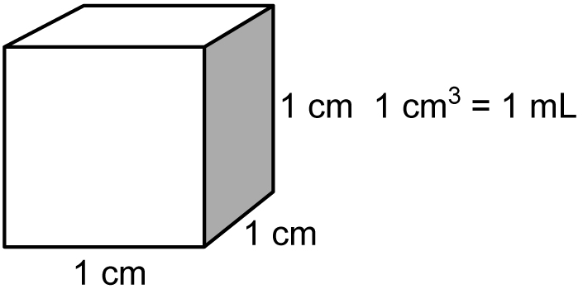
prism | in geometry, a 3-D object that has two congruent and parallel faces (the top and bottom bases) and lateral faces that are parallelograms  Such a 3-D object is also known as a rectangular box.  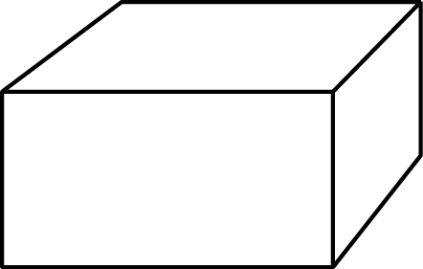
volume | a measurement of how many cubic units into which an object or space may be divided  For example, if your living room is  5 m long by 3 m wide by 3 m high, its volume is 5 m × 3 m × 3 m = 45 m³.  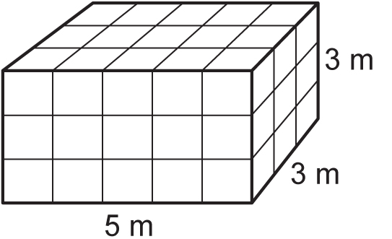
Lesson 4
kilogram (kg) | the base unit of mass in the metric system  A kilogram is equal to the mass of a certain cylinder of platinum-iridium alloy kept at the International Bureau of Weights and Measures in France.
mass | a measure of the quantity of matter in an object
tonne (t) | a unit of mass equal to a 1000 kg  That is, 1 t = 10³ kg.
weight | a measure of the force of gravity on an object
Lesson 5
Celsius | a temperature scale commonly used in every major country throughout the world, except the United States

