prism data table

Visual Representation of Prism | Prism Dimensions | Product of Dimensions | Volume
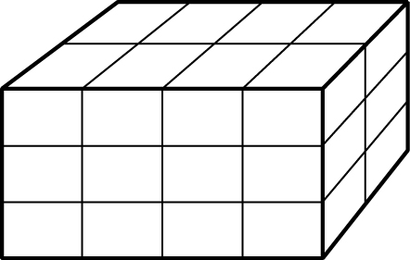 | 2 wide,  3 high,  4 long | 2× 3× 4 = 24 | 24 cubes

