Mathematics 20-1: glossary terms

In each lesson there is a list of suggested terms for your glossary. You need to develop a good understanding of at least the terms listed. Feel free to add more terms and definitions to your glossary as you come across other new words or concepts.

Find definitions in these places or elsewhere:

- the lesson
- the textbook
- the Internet
- your parents, teacher, or classmates
- reference materials, such as dictionaries or specialized handbooks

Using your own words to describe the concept is a great way to make sure you will understand what you have written. You should also double check definitions you find, especially when you find them on the Internet.

An example is provided.

Module 1
Term | Definition | Examples/Notes
Lesson 1
coefficient | a number and/or variable used to multiply another variable | http://www.learnalberta.ca/content/memg/index.html?term=Division03/Coefficient/index.html (Math Glossary Definition)  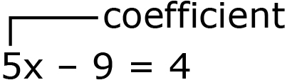
Lesson 2
Lesson 3
Lesson 4
Lesson 5
Lesson 6

