Mathematics 20-3: Formula sheet

Throughout Mathematics 20-3 you will come across formulas that should be included in your formula sheet. You may also choose to add other formulas to help you understand the math you are studying. Add rows when needed.

In the left column, write the formula.

Write the terms in the formula as well as a description of each term in the middle column.

The third column is provided for you to insert a diagram.

An example is provided for each column.

Formula | Terms | Diagram
Example Module “x”
A  lw | A  area of the rectangle’s interior  l  length of the rectangle  w  width of the rectangle | 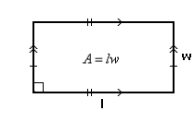  REPLACE WITH m20_3_m2_001
Module 1
Module 2
Module 3

