Mathematics 30-3: glossary terms

In each lesson there is a list of suggested terms for your glossary. You need to develop a good understanding of at least the terms listed. Feel free to add more terms and definitions to your glossary as you come across other new words or concepts.

Find definitions in these places or elsewhere:

- the lesson
- the textbook
- Learn Alberta Mathematics Glossary (http://www.learnalberta.ca/content/memg/index.html)
- the Internet
- your parents, teacher, or classmates
- reference materials, such as dictionaries or specialized handbooks

Using your own words to describe the concept is a great way to make sure you will understand what you have written. You should also double-check definitions you find, especially when you find them on the Internet.

An example is provided.

Term | Definition | Examples/Notes
Module 1
transformation | a change made to an object or graph of a relation so that the object or graph is changed in position, size and/or shape | 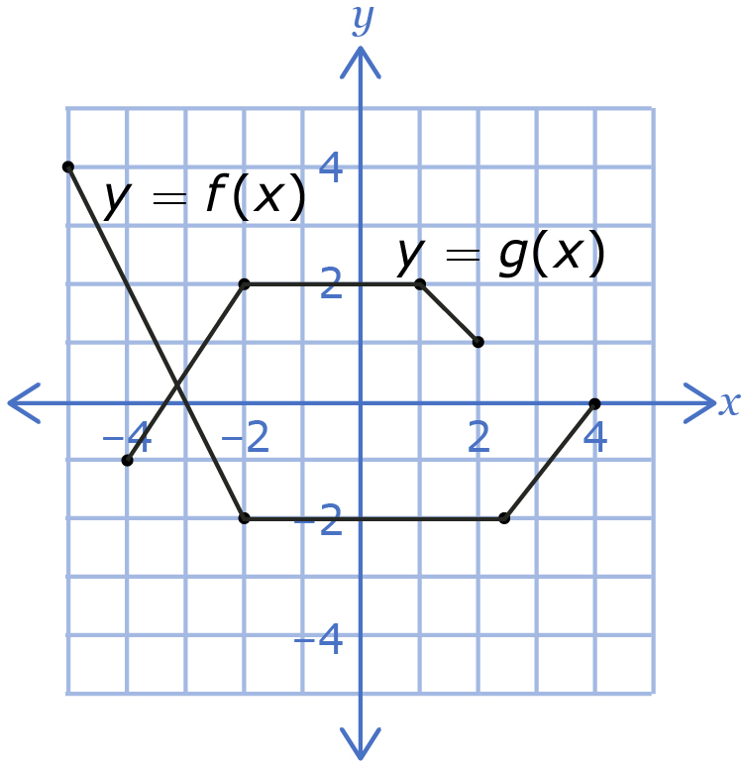  The function f(x) is transformed into the function g(x).
Module 2
Module 3
Module 4
Module 5
Module 6

