Module 1: Lesson 7 ASSIGNMENT

This Module 1: Lesson 7 Assignment is worth 29 marks. The value of each assignment and each question is stated in the left margin.

(29 marks) | Lesson 7 Assignment—The Nerve Impulse—Transporting the Message  You have a choice between doing Part 1—Action Potential OR Part 2—Action Potential. Both parts are worth 12 marks. Part 3—Reflect and Connect is not optional; you must do this part for 17 marks.

(12 marks) | Part 1—Action Potential  View the graph. In the appropriate spaces below the graph, name the four phases indicated by the numbers on the graph. Then, explain in detail what is happening in each phase. The correct labels are worth 1 mark each, and the correct explanations are worth 2 marks each for each of the four phases.  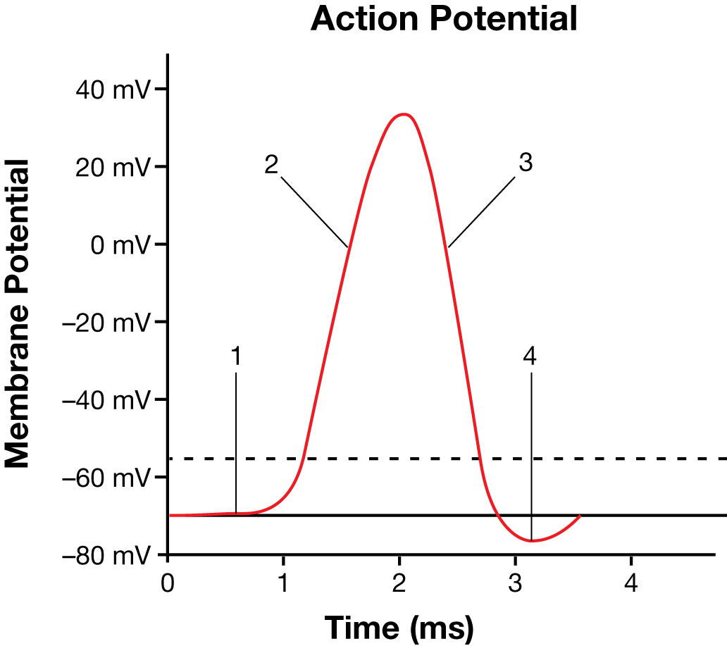  Inquiry into Biology (Whitby, ON: McGraw-Hill Ryerson, 2007), BLM 11.1.10A. Reproduced by permission.

Answer:
Phase 1 Name:

Phase 1 Explanation:

Phase 2 Name:

Phase 2 Explanation:

Phase 3 Name:

Phase 3 Explanation:

Phase 4 Name:

Phase 4 Explanation:

(12 marks) | Part 2—Action Potential  Create a flow chart to illustrate and describe each step in the initiation of an action potential of a neuron. Your flow chart must include 4 stages (1 mark each) and a point-form explanation of each stage (2 marks each).
Answer:

(17 marks) | Part 3—Reflect and Connect  Use the following information to answer the next question:  Analyze the data and answer the following questions:
  In a classic experiment, the strength of a neural stimulus and the resulting muscle contraction are compared. A single motor neuron that sends a message to a muscle fibre is suspended. One end is attached to the muscle fibre, and the free end of the muscle fibre is attached to a mass. If an electrical stimulus is sufficient to cause an impulse in the neuron, the muscle will contract and lift the mass. The following data were obtained from the experiment.
  Strength of Stimulus (mV) | Mass Lifted by Muscle (g)
  1 | 0
  2 | 10
  3 | 10
  4 | ?

(3 marks) | 1. | a. | Define threshold potential and illustrate your definition with a specific example. What is the minimum stimulus required to reach the threshold potential for this neuron?

Answer:

(3 marks) | b. | Explain the all-or-none response. Predict the mass that could be lifted at  4 mV of stimuli. Explain your answer.

Answer:

(4 marks) | c. | Choose a specific example of a sensory receptor, and explain the neural stimulation and impulses for that sensory pathway in terms of the threshold potential and the all-or-none response.

Answer:

Use the following information to answer the next two questions.
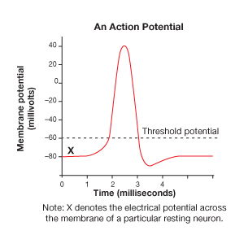

(1 mark) | 2. | Which of the following statements is true of the threshold potential?  - It is the same electrical potential for all neurons.  - It is the depolarization required to generate an action potential.  - It determines the time it takes for an action potential to be completed.  - It determines the time it takes for an impulse to travel along the axon.

Answer:

(1 mark) | 3. | Relative to the inside of a neuron, the extracellular fluid immediately outside a resting neuron’s cell membrane is  - positive and the sodium ion concentration is less  - negative and the sodium ion concentration is less  - positive and the sodium ion concentration is greater  - negative and the sodium ion concentration is greater

Answer:

Use the following information to answer the next two questions.

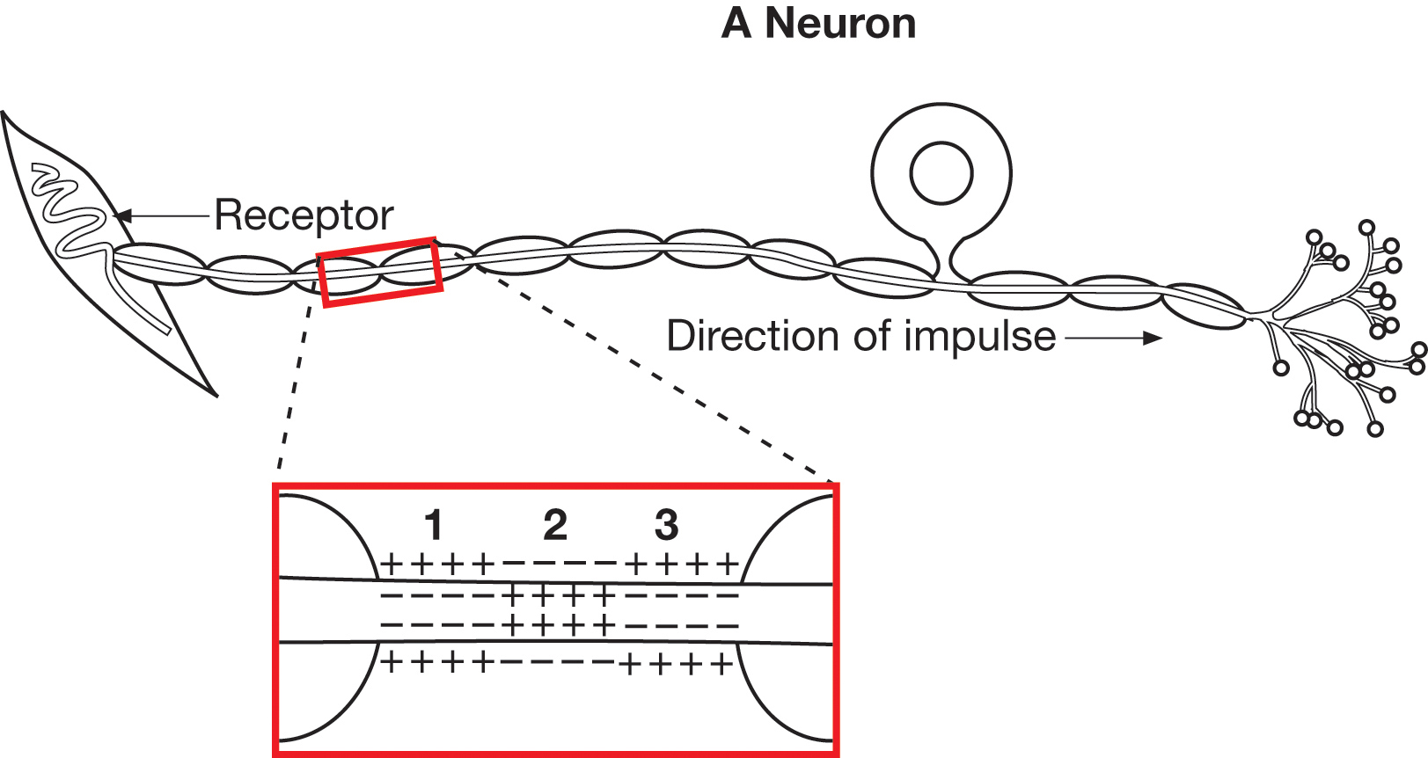

(1 mark) | 4. | This neuron transmits an impulse from a receptor to the central nervous system; therefore, it is  - a motor neuron  - a sensory neuron  - an autonomic neuron  - an association neuron

Answer:

Numerical Response

(1 mark) | 5. | In the diagrammed neuron, which numbers represent segments of the axon that are, respectively, polarized, repolarized, and depolarized, during normal neural impulse conduction?

Answer:
________ _________ __________
polarized repolarized depolarized

Use the following information to answer the next question.

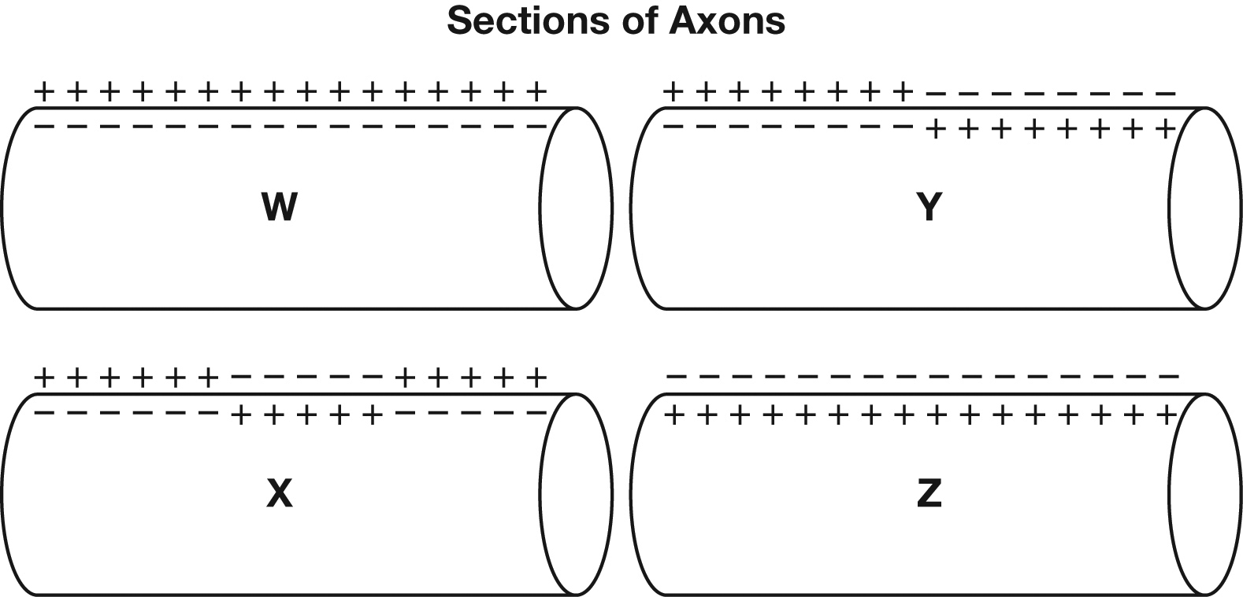

(1 mark) | 6. | The resting axon is labelled  - W  - X  - Y  - Z

Answer:

Use the following information to answer the next question.

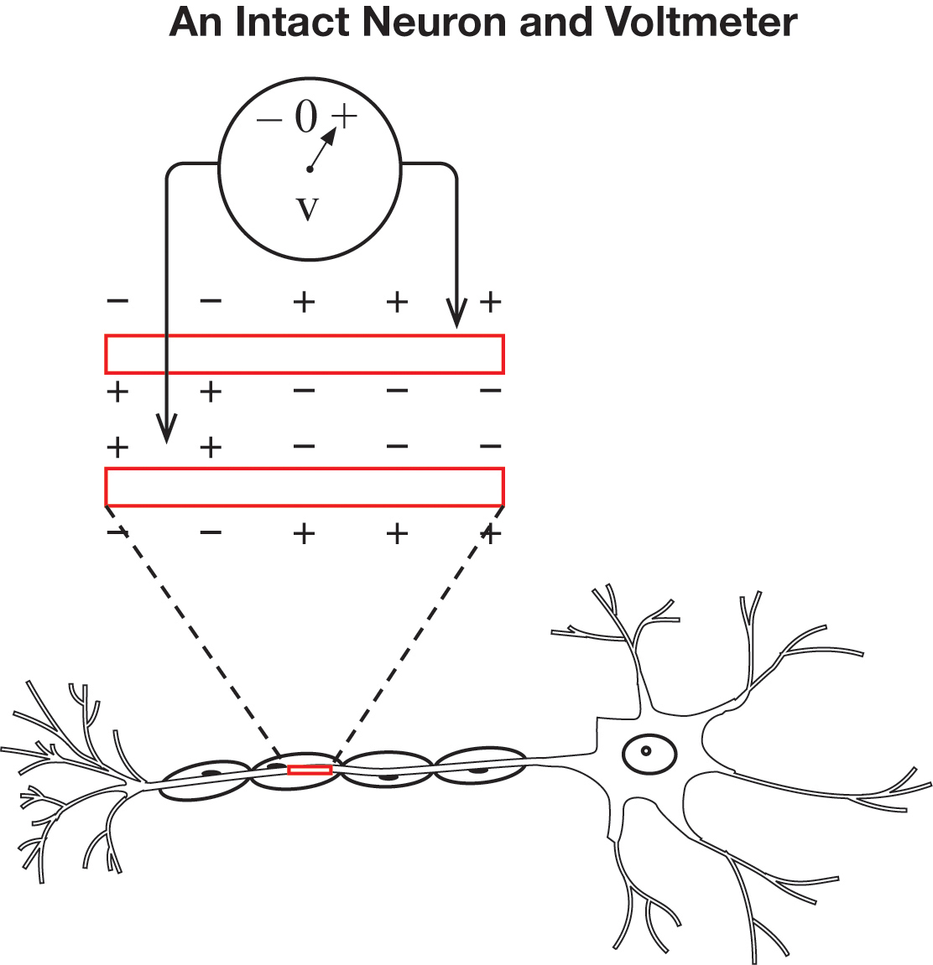

(1 mark) | 7. | The voltage polarity is positive when  - the neuron is resting  - an impulse is being transmitted  - an impulse dies out before reaching the axon  - the neuron has a high concentration of K⁺ ions

Answer:

(1 mark) | 8. | When a 1.5-V electric current was applied to a person’s tongue, the person sensed a strong taste. When the electric current was removed, the taste disappeared. The electric current apparently  - stimulated motor impulse transmission  - opened potassium gates in the neuron, allowing depolarization  - reached the threshold potential of sensory cells  - caused depolarization by directly stimulating olfactory centres in the brain

Answer:

Once you have completed all of the questions, submit your work to your teacher.

