Module 1: Lesson 8 ASSIGNMENT

This Module 1: Lesson 8 Assignment is worth 30 marks. The value of each assignment and each question is stated in the left margin.

(30 marks) | Lesson 8 Assignment—Synaptic and Neuromuscular Transmission—Crossing the Divide

(15 marks) | Part 1—Drug Research  Use the information that you gained from exploring the effect of drugs on neurons and synapses, the table on page 383 in your textbook, the Internet, and any other sources available to you to create a pamphlet, a poster, essay, comic strip, graphic novel, a multimedia presentation, or a slideshow presentation about three drugs of your choice.  Make sure that your presentation includes an example of both an excitatory and an inhibitory drug. Be sure to include the following in your document or presentation:  - a detailed explanation of how the drug affects the nervous system and other bodily functions  - hazards to the nervous system and to the entire body resulting from short-term and long-term use of the drug  - outline the possible mechanism that explains the drug’s addictive characteristic  After you have completed your document or presentation, share it with one or two classmates, discuss it, make any necessary changes, and resave your document. If possible, place your project in the space provided below; otherwise, submit it with your completed Module 1: Lesson 8 Assignment when instructed to do so later in this lesson.

Answer:

Rubric for Marking Each Drug

Score | Scoring Criteria
5  Excellent | - Clearly illustrates how drug affects nervous system and body.  - Outlines mechanism of action.  - Identifies part of brain affected.  - Details short- term effects.  - Details long- term effects.  - Describes why drug is addictive/kills/paralyzes, etc.  - Shows adequate detail.  - Presentation is well-illustrated.  - Shows detail.
4  Proficient | - Clearly illustrates how drug affects some parts of nervous system and/or body.  - Outlines mechanism of action.  - Does not clearly identify part of brain affected.  - Details some short-term and/or long-term effects.  - Attempts to describe why drug is lethal, addictive, etc.  - Presentation is somewhat illustrated.  - Presented reasonably well.  - Missing some detail.
3  Satisfactory | - Illustrated some aspects of how drug affects some parts of nervous system and/or body.  - Attempts to outline mechanism of action but details/specifics not there.  - Does not clearly identify part of brain affected.  - Details only some short and/or long term effects.  - Attempts to describe why drug is lethal, addictive, etc.  - Not illustrated well.  - Presentation mediocre.  - Missing detail.
2  Limited | - Attempts to discuss how drug affects nervous system and/body.  - Limited attempt to outline mechanism.  - Omits to identify part of brain affected.  - Identifies only one or two effects.  - Limited attempt to describe why drug is lethal, addictive, etc.  - No illustrations.  - Presentation hard to follow.  - Limited detail.
1  Poor | - Limited attempt to discuss how drug affects nervous system/body.  - Mechanism poorly outlined or missing.  - Omits to identify part of brain affected or does so very generally.  - Identifies one or two effects or omits entirely.  - Limited attempt to describe why drug is lethal, addictive, etc.  - No illustrations.  - Presentation hard to follow.  - Limited research is evident.

(15 marks) | Part 2—the Synaptic Gap  To help you apply your understanding of the concepts in this lesson and connect your understanding to other lessons, answer the following questions in complete sentences.  Study the diagram of a synapse between a sensory neuron and a motor neuron in a simple reflex arc involving only two neurons. Use the information provided by the diagram to answer the questions.  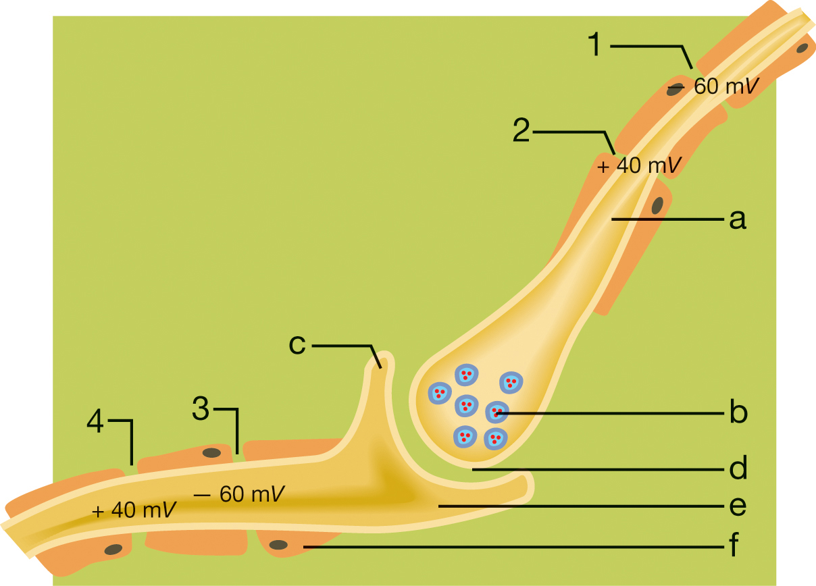

(2 marks) | 1. | If the neurotransmitter substance was acetylcholine, describe two places where this synapse might be found in the body.

Answer:

(2 marks) | 2. | From the diagram, identify where receptors for the neurotransmitter would be located. Explain your answer.

Answer:

(2 marks) | 3. | Which letter indicates the axon of the sensory neuron? Justify your answer.

Answer:

(2 marks) | 4. | Identify where an action potential is occurring. Justify your answer.

Answer:

(3 marks) | 5. | What structure is represented by the letter F? What is the function of F? What effect does F have on the transmission of action potentials along the neuron?

Answer:

(2 marks) | 6. | In certain diseases, the motor neurons are progressively damaged. Suggest two ways in which a person with such a disease may be affected.

Answer:

(2 marks) | 7. | Explain how the action of an inhibitory neurotransmitter might affect this synapse.

Answer:

Once you have completed all of the questions, submit your work to your teacher.

