(25 marks) | Module 2: Lesson 1 ASSIGNMENT  This Module 2: Lesson 1 Assignment is worth 25 marks. The value of each assignment and each question is stated in the left margin.

(15 marks) | Lesson 1 Assignment—Structure and Organization of the Endocrine System  Lab 1—Student Stress  Procedure

(2 marks) | 1. | Record your data in the data table below.

Answer:
 | Blood Pressure | Pulse
Reading 1
Reading 2
Reading 3
Reading 4

Analysis

(2 marks) | 2. | Did the pulse and blood pressure change while taking the test? If so, how? How long did it take for the subject’s pulse and blood pressure to return to the resting values?

Answer:

(2 marks) | 3. | In addition to pulse and blood pressure, list at least two other physiological changes that may have occurred in the subject while writing the stress test.

Answer:

(2 marks) | 4. | How would the physiological changes that you identified in question 3 be useful responses to a life-threatening situation?

Answer:

(4 marks) | 5. | List six or more stressful situations that people in modern societies may experience. Which of these are truly dangerous? Which, if any, might be considered positive?

Answer:

Conclusion

(3 marks) | 6. | What conclusion can you make from this lab as to how a stressful situation affects pulse and blood pressure? Which parts of the nervous and endocrine systems were involved? What can you conclude about the body’s ability to recover from stressful situations? How were the nervous and endocrine systems involved in this recovery? Write a couple of paragraphs to address these questions.

Answer:

(10 marks) | Reflect and Connect  For each question below, choose the correct answer and write a statement indicating why it is correct.

(1 mark) | 7. | Damage to which of the following endocrine glands would most affect the reaction of the body to an emergency that stimulates the sympathetic nervous system?  - thyroid gland  - adrenal gland  - anterior pituitary gland  - posterior pituitary gland

Answer:

(1 mark) | 8. | Which of the following hormones is secreted by the gland indicated by X in the diagram below?  - cortisol  - glucagon  - calcitonin  - antidiuretic hormone  .  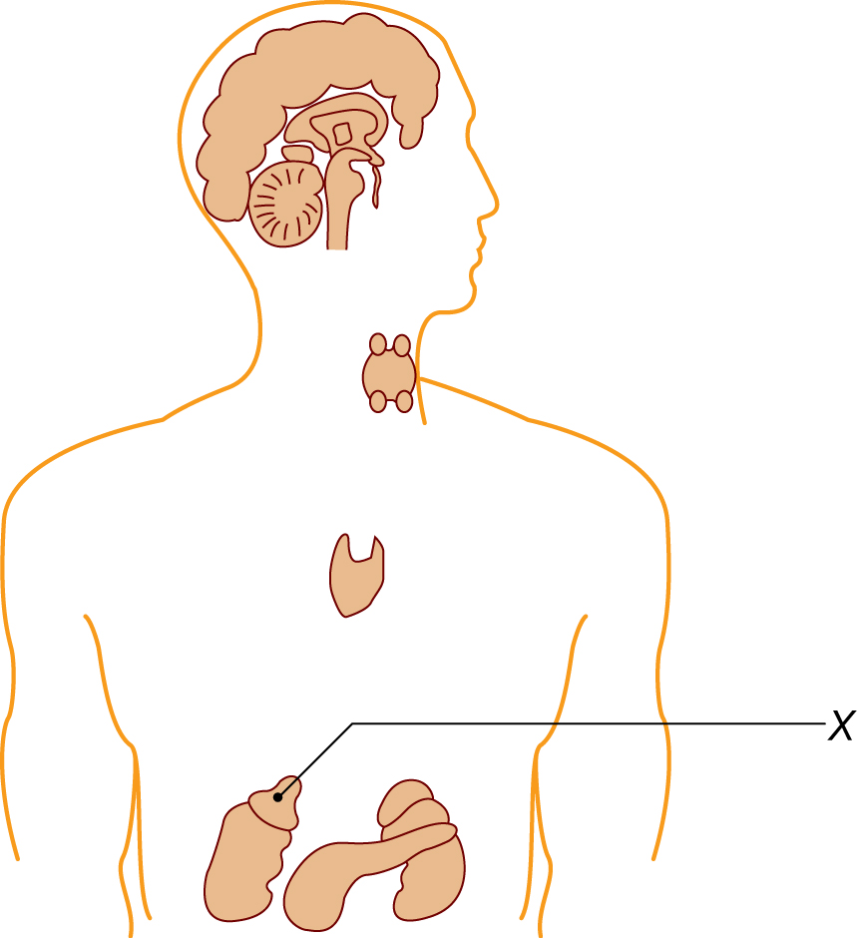

Answer:

(1 mark) | 9. | Growth of the long bones and the skeleton is promoted by a hormone secreted by the  - adrenal cortex  - adrenal medulla  - anterior pituitary gland  - posterior pituitary gland

Answer:

(1 mark) | 10. | Increasing the levels of aldosterone in blood would result in  - increased blood volume  - decreased blood pressure  - increased urine production  - less reabsorption of water

Answer:

(1 mark) | 11. | Which of the following rows correctly matches the endocrine gland to the hormone it secretes and the effect/response of the hormone?
  Row | Endocrine Gland | Hormone Secreted | Effect
  A. | posterior pituitary | ADH | increases water absorption
  B. | adrenal cortex | epinephrine | fight or flight
  C. | pancreas | insulin | raises blood glucose
  D. | anterior pituitary | oxytocin | initiates childbirth

Answer:

(1 mark) | 12. | Which of the following is an example of a tropic hormone?  - cortisol  - insulin  - thyroid stimulating hormone  - antidiuretic hormone

Answer:

(1 mark) | 13. | Which pair consists of antagonistic hormones?  - TSH and thyroxine  - cortisol and epinephrine  - calcitonin and parathormone  - ACTH and cortisol

Answer:

(1 mark) | 14. | Which of the following statements is true?  - Exocrine glands secrete chemical messengers called hormones directly into the bloodstream, which transports the hormones throughout the body.  - Compared to the actions of the nervous system, the hormones of the endocrine system have faster and longer-acting effects on a broader range of cell types.  - The concentration of hormones in the blood remains constant to maintain homeostasis.  - When a hormone binds to its receptor, it triggers other reactions in the target cell.

Answer:

(1 mark) | 15. | Parathyroid hormone acts to ensure that  - calcium levels in the blood never drop too low  - sodium levels in urine are constant  - potassium levels in the blood don’t drop too low  - the concentration of water in the blood is sufficient

Answer:

(1 mark) | 16. | Which hormone stimulates the adrenal cortex to produce several of its hormones?  - TSH  - releasing hormone from the hypothalamus  - adrenocorticotropic hormone  - ADH

Answer:

Once you have completed all of the questions, submit your work to your teacher.

