Module 2: Lesson 3 ASSIGNMENT

This Module 2: Lesson 3 Assignment is worth 29 marks. The value of each assignment and each question is stated in the left margin.

(29 marks) | Lesson 3 Assignment—the Adrenal Gland

(15 marks) | 1. | Use this flow chart to answer the following questions.  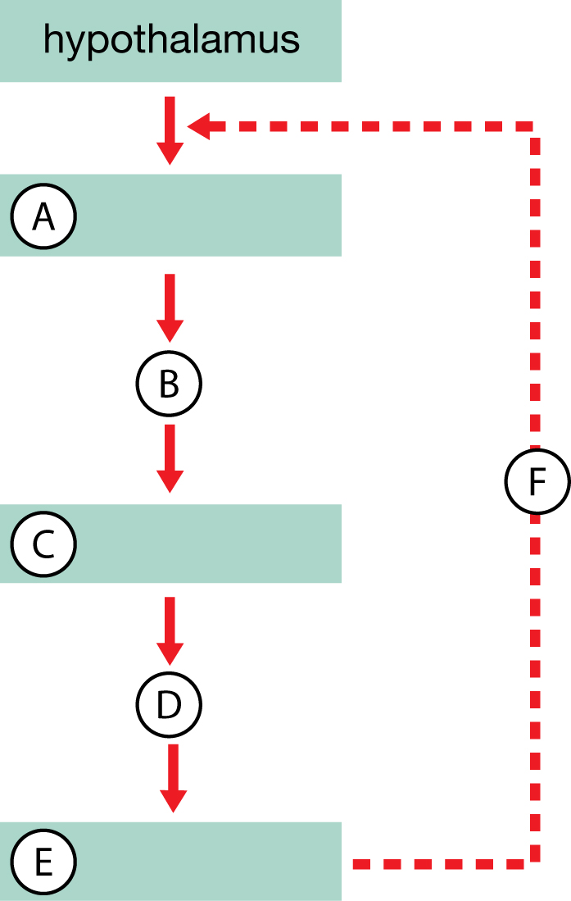

(1 mark) |  | a. | Identify the letter on the flow chart that represents the pituitary gland.

Answer:

(2 mark) | b. | Identify the name of the hormone that is released from the pituitary gland and the letter on the flow chart that represents it.

Answer:

(2 mark) | c. | Identify the endocrine gland that is targeted by this pathway and identify which letter on the flow chart represents this gland.

Answer:

(2 mark) | d. | As a result of this regulatory pathway, identify two hormones that are released from this endocrine gland.

Answer:

(4 mark) | e. | Describe the effects of these two hormones on the body systems and tissues.

Answer:

(4 mark) | f. | Explain how the production of these hormones is regulated.

Answer:

(6 marks) | 2. | Complete one of the following two choices.  Choice 1: Distinguish between the structure and function of the adrenal medulla and the adrenal cortex by completing the table below.  Answer:  Choice 2: Draw a Venn diagram that compares the structure and function of the adrenal medulla and adrenal cortex. If possible, paste your answer into the space provided below.
  Characteristics | Adrenal Medulla | Adrenal Cortex
  Location in Gland
  Composition of Cells in Gland
  Hormones Secreted
  Effects of Secreted Hormones
  Duration of Effect
  Stimulated By

Answer:

(8 marks) | 3. | Complete the following flow chart that outlines both the short- and long-term stress responses.  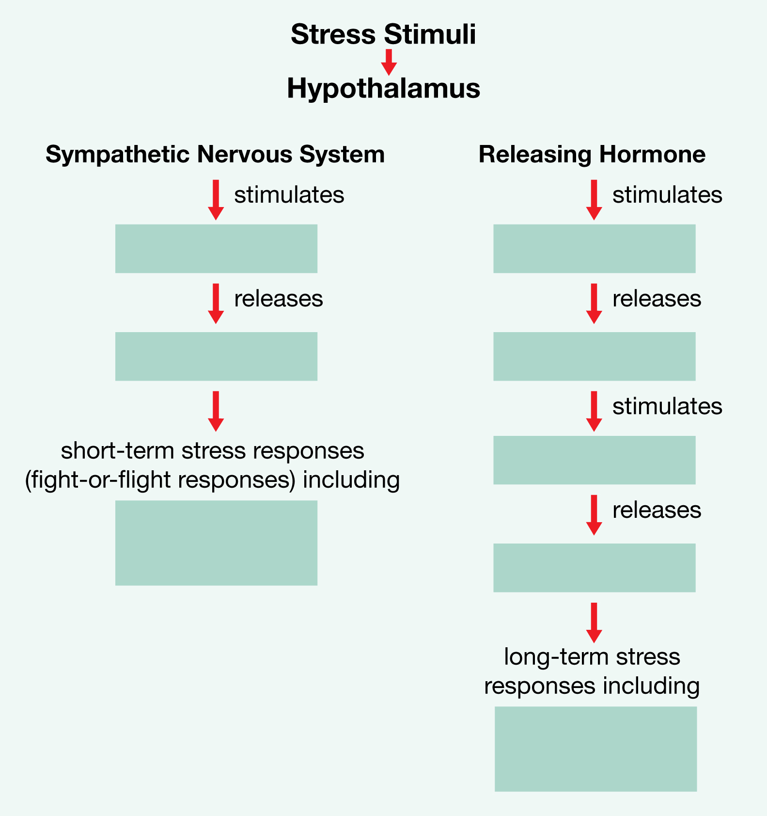

Answer:

Once you have completed all of the questions, submit your work to your teacher.

