Module 2: Lesson 4 ASSIGNMENT

This Module 2: Lesson 4 Assignment is worth 20 marks. The value of each assignment and each question is stated in the left margin.

(20 marks) | Lesson 4 Assignment—the Thyroid and Parathyroid Glands  Closed Written Response  Use the information below to answer the following questions.
  George’s family was very concerned about his health. George was lethargic and just wanted to sleep all the time. He was losing clumps of hair and his skin and nails were becoming dry and brittle. His family noticed an ever-enlarging growth on his neck. George consulted his family doctor, who determined that George’s symptoms were related to a malfunctioning thyroid gland.
  The following questions are based on the doctor’s investigation of George’s symptoms.

(2 marks) | 1. | a. | Identify the hormones produced by the thyroid gland.

Answer:

(1 mark) |  | b. | Based on George’s symptoms, the doctor identified the hormone most likely responsible for his condition. Identify the hormone.

Answer:

(4 marks) |  | c. | State two symptoms that may have led the doctor to suspect that George was suffering from a thyroid hormone deficiency. Give the physiological reasons for each symptom.

Answer:

Use this additional information to answer the following questions.

A sample of tissue was taken from George’s thyroid gland, and a stained section was prepared for viewing under the microscope. This was compared with a similarly prepared section taken from a healthy human. Drawings of parts of these sections are shown below.

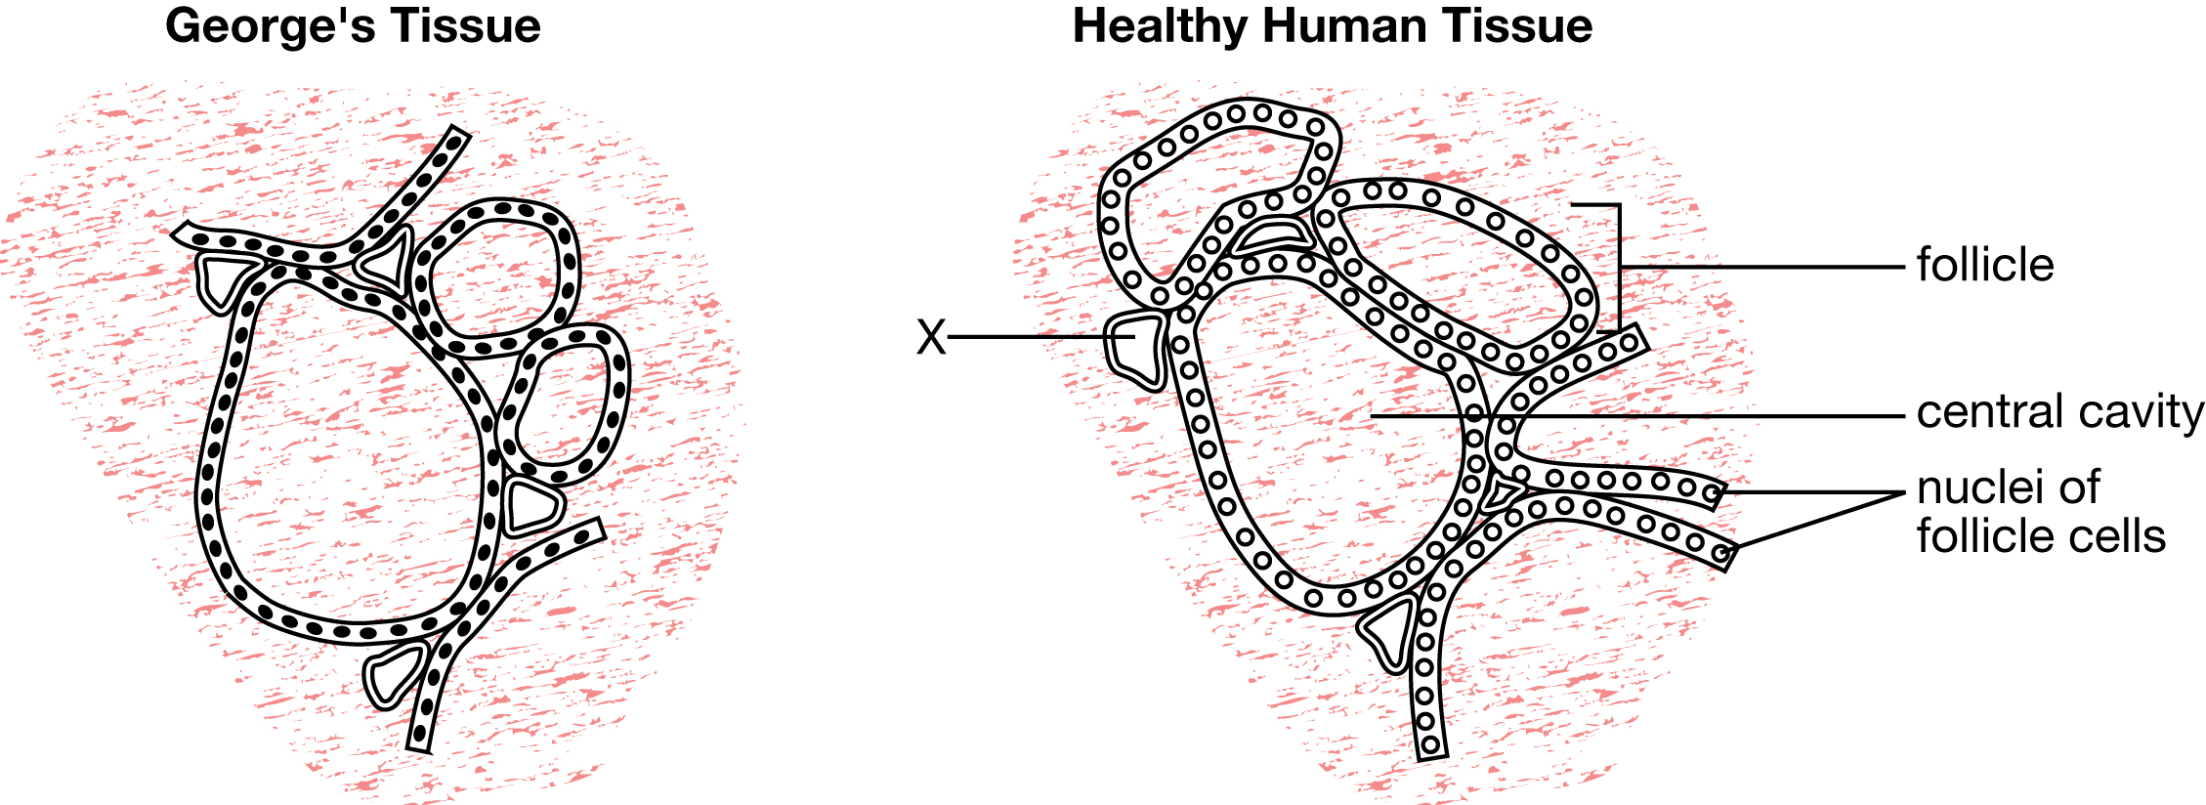

(1 mark) | 2. | a. | Suggest a function for the central cavity of the follicle.

Answer:

(1 mark) |  | b. | Identify the tubular structure on the diagram that is labelled X.

Answer:

(2 marks) |  | c. | Explain why there should be many such tubular structures in thyroid tissue.

Answer:

(1 mark) |  | d. | The doctor hypothesized that George’s symptoms could also be the result of a lack of iodine in his diet. Explain why this element is required for healthy thyroid function.

Answer:

Use this additional information to answer the following questions.

The doctor set up a diagnostic test for George in which he received a low dosage of radioactive iodine compounds. The results of the levels of radioactive iodine in his blood were then compared to the levels of radioactive iodine in the blood of a healthy human. The results are shown in the graph below.

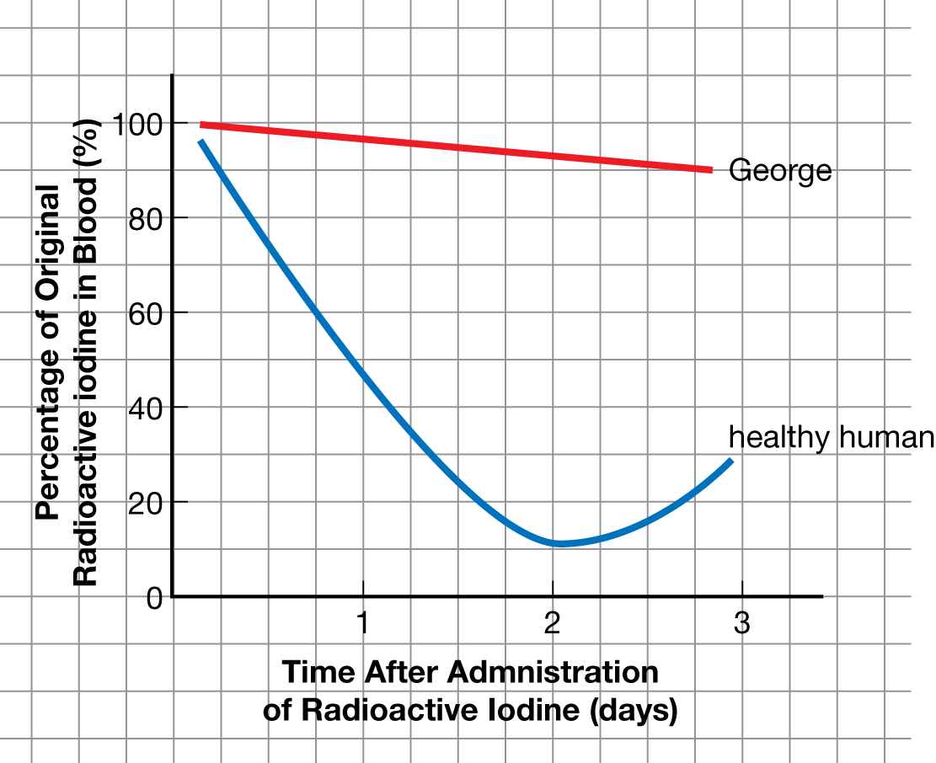

(3 marks) | 3. | a. | Write the hypothesis the doctor was investigating with this test.

Answer:

(1 mark) |  | b. | What was the purpose of giving a healthy human radioactive iodine compounds in this experiment?

Answer:

(2 marks) |  | c. | Do the results shown in the graph support the hypothesis? Explain your answer.

Answer:

(1 mark) |  | d. | Suggest why the graph for the healthy human rose after approximately two days.

Answer:

(1 mark) |  | e. | Outline one treatment that might enable George to recover.

Answer:

Once you have completed all of the questions, submit your work to your teacher.

