Label the numbered structures on the following diagram.

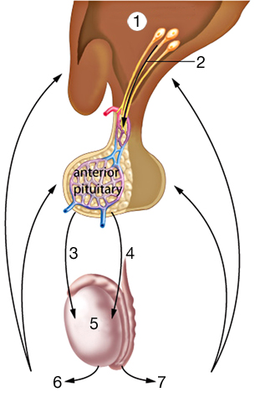
Inquiry into Biology (Whitby, ON: McGraw-Hill Ryerson, 2007), BLM14.3.1 Reproduced by permission.

