Module 4: Lesson 1 ASSIGNMENT

This Module 4: Lesson 1 Assignment is worth 64 marks. This assignment involves the following:

- Lab: Comparing Embryonic Structures on page 519 of textbook
- Reflect and Connect

The value of each assignment and each question is stated in the left margin.

(31 marks)  (5 marks) | Lab—Comparing Embryonic Structures  Problem (Purpose)  How do embryonic structures of humans and other animals compare?  Materials  blank paper  pencil  microscopy images of stages of embryo development (provided)  Procedure  Part 1: Observing Embryonic Structures

 | 1. | View the microscopy images of the different stages of embryonic development. Be aware of the magnification power given and the name of the development stage.  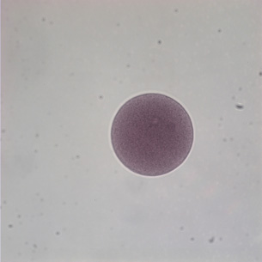  Microscopy: Arbacia, zygote, 200X  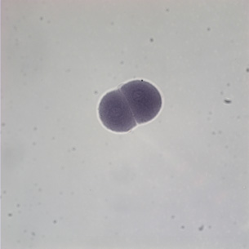  Microscopy: Arbacia, cleavage, two-cell stage, 400X  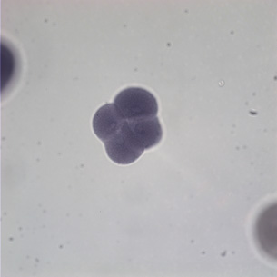  Microscopy: Arbacia, cleavage, four-cell stage, 400X  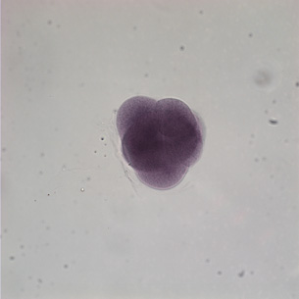  Microscopy: Arbacia, cleavage, eight-cell stage, 400X  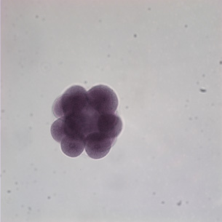  Microscopy: Arbacia, morula, 400X  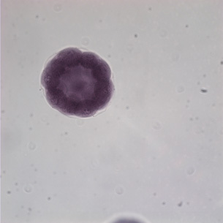  Microscopy: Arbacia, blastula, 400X  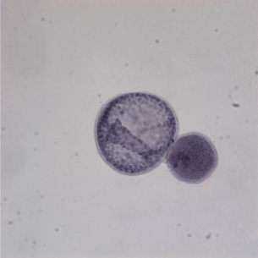  Microscopy: Arbacia, gastrula, 400X
 | 2. | Sketch the main features that you observe in the cleavage at the four-cell stage, the blastula stage, and gastrula stage. Add labels to identify all the features that you recognize. If possible, paste your diagram into the answer space provided below. If you are unable to attach your diagram here, contact your teacher for submission guidelines.

Answer:

The following rubric will help you develop your work for assessment:

Scoring Rubric

Score | Scoring Criteria
5  Excellent | Part 1  - Three diagrams are drawn on paper or in a digital illustration, following proper biological drawing format, with labels for as many structures as possible.  - A figure title, with magnification of the image, is provided.
4  Proficient | Part 1  - Three diagrams are drawn on blank paper or done electronically, following proper biological drawing format; some items are properly labelled.  - A figure title is given; magnification may be missing.
3  Satisfactory | Part 1  - Two diagrams are drawn on blank paper OR done electronically, following proper biological drawing format; some items are properly labelled.  - A figure title, with no magnification, is given.
2  Limited | Part 1  - Only half or fewer of the diagrams required were drawn; proper biological drawing format not followed.  - No labels are given for any structures, or wrong labels are given.
1  Poor | - Only one of the bullets is addressed at a 2 or 3 level.

(26 marks)  (4 marks) | Part 2: Comparing Extra-embryonic Structures  Observations

(4 marks) | 1. | On page 519 of the textbook, "Comparing Embryonic Structures," examine the diagrams of extra-embryonic membranes of an embryonic chick and an embryonic human. Complete Part 2: questions 2, parts a and b. Make notes on which extra-embryonic membranes the human and the chicken embryos have in common.

Answer:
a.

b.

(22 marks) | Analysis

(1 mark) | 1. | Complete Analysis question 1 on page 519 of the textbook.

Answer:

(2 marks) | 2. | Complete Analysis question 2 on page 519 of the textbook.

Answer:

(1 mark) | 3. | Complete Analysis question 3 on page 519 of the textbook.

Answer:

(2 marks) | 4. | Complete Analysis question 4 on page 519 of the textbook.

Answer:

(8 marks) | 5. | Complete Analysis question 5 on page 519 of the textbook.

Answer:

(a. = 2 marks  (b. = 6 marks) | 6. | Complete Analysis question 6 on page 519 of the textbook.

Answer:
a.

b.

Going Beyond

- Numerous cells and tissues support the developing embryo. What changes would be necessary in these cells and tissues if the mother is a litter-bearing animal such as cat, dog, or mouse?

Answer:

(33 marks) | Reflect and Connect

(19 marks)  (graph = 2 marks  1. = 1 mark  2. = 2 marks  3. = 4 marks  4. = 6 marks  5.a. = 2 marks  5.b = 2 marks) | 1. | Complete the Procedure and Analysis questions of the “Launch Lab” on page 507 of the textbook.

Answer:

(2 marks each = 8 marks) | 2. | Complete “Applying Concepts” questions 18, 20, 21, and 23 on page 536 of the textbook.

Answer:

(2 marks each = 6 marks) | 3. | Complete “Making Connections” questions 24, 25, and 26 on pages 536 and 537 of the textbook.

Answer:

Once you have completed all of the questions, submit your work to your teacher.

