Module 8: Lesson 1 ASSIGNMENT

This Module 8: Lesson 1 Assignment is worth 45 marks. The value of each assignment and each question is stated in the left margin.

( 45 marks) | Lesson 1 Assignment: Hardy-Weinberg Principle—the Gene Pool

( 27 marks) | Part A

(14 marks) | 1. | Determining Frequencies  The following graphics illustrate the gene pool of the same population of ten field mice sampled five years apart. B symbolizes the dominant black allele, and b symbolizes the recessive white (albino) allele.  2000  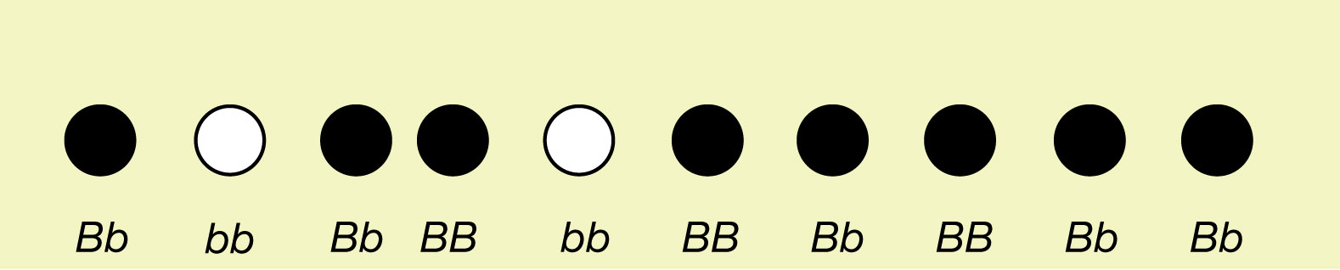  2005  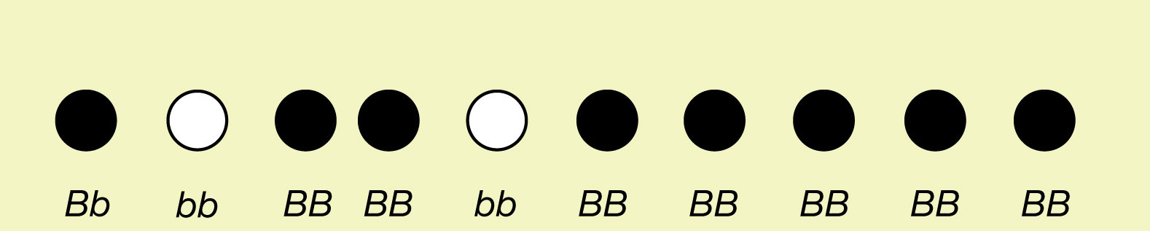  Record your answers to the following questions in the table below.

 |  | a. | Calculate the change in phenotype frequencies of black and white mice from 2000 to 2005.  Example:

 | b. | Calculate the change in genotype frequencies from 2000 to 2005.  Example:

 | c. | Calculate the change in allele frequencies from 2000 to 2005.  Example:

2000 2005
Phenotype Frequencies
f(black)
f(white)
Genotype Frequencies
f(BB)
f(Bb)
f(bb)
Allele Frequencies
f(B)
f(b)

 | 2. | Data Analysis  Using the information from the table in question 1, answer the following questions.

(1 mark) | a. | Did the phenotype frequencies change over time? In what way?

Answer:

(2 marks) | b. | Did the genotype frequencies change over time? In what way?

Answer:

(2 marks) | c. | Did the allele frequencies change over time? In what way?

Answer:

(1 mark) | d. | Think of a possible reason why this change might have occurred.

Answer:

 | 3. | Frequency Calculation  In a population of 80 rabbits, 20 are homozygous dominant, 40 are heterozygotes, and 20 are albino homozygous recessive.

(5 marks) | a. | Provide the frequencies of each genotype and the frequencies of each allele in the gene pool. Use proper notation (for example, f(AA)).

Answer:

(2 marks) | b. | Why do the frequencies add up to 1?

Answer:

(18 marks) | Part B

 | 4. | Hardy-Weinberg Equilibrium  A population is in Hardy-Weinberg equilibrium (HWE) if the allele frequencies are not changing over time. Refer to the calculations you made from the table in question 1 of Part A of this lesson 1 assignment.

(2 marks) | a. | Is this population in Hardy-Weinberg equilibrium? What evidence do you have to support your decision?

Answer:

(1 mark) | b. | Review the five conditions for Hardy-Weinberg equilibrium. From what you know about this population, what is one reason it could not be in HWE?

Answer:

(15 marks) | 5. | Illustrating HWE  Illustrate the five conditions of the Hardy-Weinberg equilibrium.  You will be marked on the following content:  - Have you identified each concept? (5 marks)  - Have you illustrated each mechanism? (5 marks)  - Does the illustration show comprehension, creativity, and insight? Feel free to use humour or a unique presentation. (5 marks)  Note: You will not be marked on artistic ability or complexity of the illustration.

Answer:

Marking Rubric for Part B
Score
5  Excellent | - Clearly identifies all the concepts in HWE.  - Illustrations clearly describe the mechanism.  - Illustrations creatively and insightfully depict the mechanism.
4  Proficient | - Identifies all the concepts in HWE.  - Illustrations describe the mechanism.  - Illustrations show creativity.
3  Satisfactory | - Identifies most of the concepts.  - Illustrations depict the mechanism in general.  - Illustrations show little creativity.
2  Limited | - Identifies less than half of the concepts of HWE.  - Illustrations do not correspond to the mechanisms.  - Little if any creativity.
1  Poor | - Addresses only one of the bullets at a 2 or 3 level.

Once you have completed all of the questions, submit your work to your teacher.

