Module 8: Lesson 9 ASSIGNMENT

This Module 8: Lesson 9 Assignment is worth 16 marks. The value of each assignment and each question is stated in the left margin.

(16 marks) | Lesson 9 Assignment—Measuring Growth

A major moose population survey was completed in 1993–94 to determine moose numbers, densities, and sex and age ratios. In Wildlife Management Area 6 (see diagram below), 46 Wildlife Management Units (WMUs) were surveyed by field biologists who counted the moose from airplanes as they circled over the WMU. The counts were done in winter so that the dark hide of the moose could be seen against the white snow.

From the entire survey area, the moose population for Area 6 was estimated at 81 000 animals. This number was considered to be near what the habitat could support. However, moose numbers in a few WMUs were significantly below that capacity, and the number of bulls in relation to the number of cows (bull : cow ratio) was lower than desired. The optimum ratio that will produce the most offspring is considered to be 40 bulls to every 100 cows.

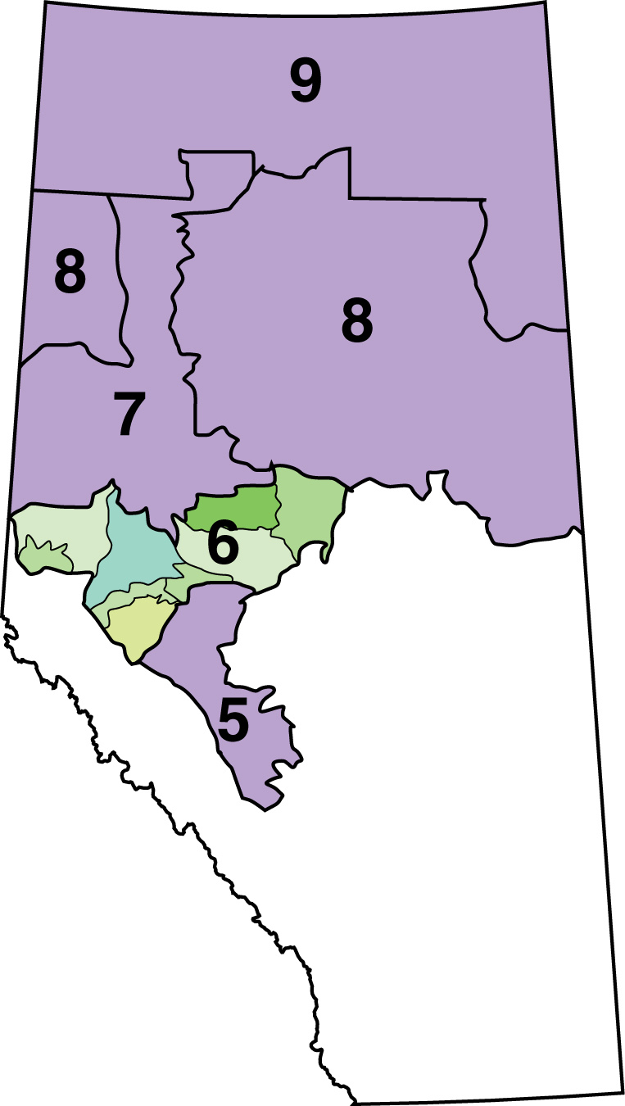

You will be provided with data regarding moose population counts in an area named “Wildlife Management Unit 350” found in Wildlife Management Area 6. You will analyze the data using your knowledge from Lesson 9.

(2 marks) | 1. | Moose Management Area 6, WMU 350  In 1993–94, aerial counts of moose populations in Wildlife Management Unit 350 showed a density of 0.45 moose/km² in the 5788 km² area surveyed. What was the total population size (N)?

Answer:

(2 mark) | 2. | Another population count of Moose Management Area 6, WMU 350 occurred in 1997–98.This time, the population size was estimated at 3204 moose. What was the population density (Dp)? One mark will be given for the correct formula, another for the correct answer.

Answer:

(6 marks) | 3. | Compare the two population sizes from the two counts of WMU 350 and determine the following variables. Show your work. One mark will be given for the correct formula, another mark for the correct answer.  ΔN:  Growth rate:  Per capita growth rate:

Answer:

(2 marks) | 4. | In the first population count, the bull : cow ratio was 23 : 100. In the second count, the number had risen slightly to 29 : 100. Is the ratio acceptable to wildlife managers? What are the consequences of this bull : cow ratio?

Answer:

(4 marks) | 5. | Wildlife managers use hunting “harvests” as a mechanism of addressing imbalances in population sizes and sex ratios. Every year wildlife managers create a set of hunting regulations that set hunting bag limits for each Wildlife Management Unit and for each species. Bag limits state how many animals a hunter may shoot, what age, and what sex. Given the problems with the moose population in WMU 50, state two recommendations you might make as a wildlife manager in terms of hunting regulations and bag limits for this area. Explain your reasons. One mark will be given for each recommendation and for each reason.

Answer:

Once you have completed all of the questions, submit your work to your teacher.

