Module 8: Lesson 10 ASSIGNMENT

This Module 8: Lesson 10 Assignment is worth 29 marks. The value of each assignment and each question is stated in the left margin.

(29 marks) | Lesson 10 Assignment—Growth Patterns

(12 marks) | Part A

Assume species A below was introduced into a new environment. Population counts produced the following data:
Species A:  Generation Number | Population Size (N)
1 | 2
2 | 3
3 | 4
4 | 8
5 | 15
6 | 31
7 | 32
8 | 33
9 | 33

Graph the data from the table into the answer box. Use the graph to answer the following questions.

Answer:

(3 marks) | 1. | Is the population in this example growing in a logistic or exponential pattern? Support your answer. What is the shape of the curve?

Answer:

(1 mark) | 2. | What is K (carrying capacity) in this population?

Answer:

(4 marks) | 3. | List four density-dependent factors that could have contributed to environmental resistance.

Answer:

(4 marks) | 4. | Provide two factors that could affect K (carrying capacity) of this environment. State whether each factor would increase or decrease K.

Answer:

(7 marks) | Part B  “Figure 20.22” on page 733 of your textbook illustrates the human population curve. Study the figure and complete the following questions.

(1 mark) | 1. | At approximately what year did the human population enter an exponential growth phase?

Answer:

(1 mark) | 2. | Prior to that time, what was the approximate carrying capacity of Earth?

Answer:

(3 marks) | 3. | State three significant technological developments that have acted to increase the carrying capacity of Earth’s environment since that time.

Answer:

(2 marks) | 4. | Provide two examples of density-dependent factors that are contributing to or have the potential to contribute to environmental resistance in human populations.

Answer:

(10 marks) | Part C  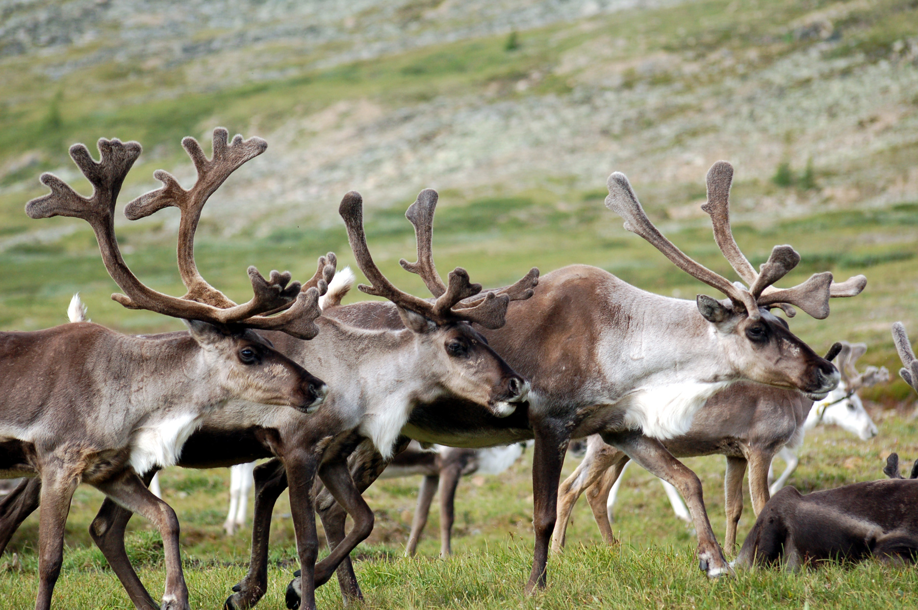  © Clément Billet/2296248/Fotolia  Caribou (reindeer) live in the arctic and subarctic tundra, feeding on lichens in the winter, and willows, grasses, and sedges in the summer. Their most important predator is the wolf. The winter migration takes the caribou from the open tundra to the protection of the boreal forests; in spring they return to the calving grounds of the tundra.  During the fall rut (breeding period) the most dominant male breeds with up to 15 to 20 females, with one calf born to each mother in the spring. The following data chart describes caribou reindeer population changes on St. Paul Island, Alaska from 1910 to 1950.  Graph the data from the table above into the answer box. Use the information from the graph to complete the following questions.
  Year (Y) | Population Size (N)
  1910 | 30
  1920 | 125
  1930 | 350
  1940 | 1200
  1950 | 0

Answer:

(3 marks) | 1. | Considering ONLY the information you were given in the introductory paragraph regarding reindeer reproductive habits and predation, would you predict that the population growth curve would be logistic or exponential? Support your answer.

Answer:

(2 marks) | 2. | Describe the growth pattern that existed from 1910 to 1950. Support your answer.

Answer:

(1 mark) | 3. | Provide a possible hypothesis explaining the changes in population between 1940 and 1950.

Answer:

(4 marks) | 4. | Using the information you have been given about caribou populations, state two factors that have limited the size of the caribou population. For each, indicate whether it is a density-dependent or density-independent factor.

Answer:

Once you have completed all of the questions, submit your work to your teacher.

