Module 1: Lesson 2 ASSIGNMENT

Read all parts of your assignment carefully, and record your answers in the appropriate places. If you have difficulty with an assignment, go back to the textbook and review the appropriate lesson. Be sure to proofread your answers carefully before submitting your Assignment Booklet.

Lesson 2 Assignment: How Much Energy?

Part 1—Lesson 2 Lab: Calorimetry

 | 1. | Use the multimedia presentation for this lab to complete the following table:
  mass of nut (g)
  mass of water (g)
  initial temperature of water (°C)
  final temperature of water (°C)

- Calculate how much energy was absorbed by the water.

 | 2. | The following questions appear on page 479 of the textbook.

- Calculate how much energy was absorbed by the water.

Answer:

- Where did the nut’s energy come from?

Answer:

- Calculate the quantity of energy produced per gram of fuel (nut) burned.

Answer:

- Compare this combustion reaction to the reaction that would happen if you were to eat the nut instead of burning it.

Answer:

- This experiment uses low-tech equipment. How can you improve on the technology and, therefore, improve on the certainty of the experimental results?

Answer:

Part 2—Evaluate the Design of a Solar Panel

Use the following diagram to answer the questions in this section.

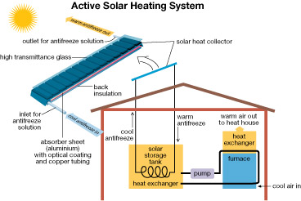

The solar panels found on the roofs of buildings within the Drake Landing Solar Community are part of an active solar heating system. The circulation of antifreeze solution through the system allows for the transfer of energy from the collector to the house, or to the borehole energy storage system.

Earlier in this lesson you learned about calorimeters, and you looked at the design of different calorimeters.

 | 1. | Examine the diagram of the solar panel. Identify similarities and differences between the design of the solar panel shown and the calorimeters you learned about in this lesson.

Answer:

 | 2. | The antifreeze ethylene glycol is used in the solar collector instead of water. State two advantages and two disadvantages of using ethylene glycol instead of water. Support the advantages and disadvantages you identify by making reference to the physical properties, safety concerns, or chemical reactivity of both ethylene glycol and water.

Answer:

Submit your completed Assignment Booklet to your teacher
at the end of this lesson.

