Module 6: Lesson 6 ASSIGNMENT

Read all parts of your assignment carefully, and record your answers in the appropriate places. If you have difficulty with an assignment, go back to the textbook and review the appropriate lesson. Be sure to proofread your answers carefully before submitting your Assignment Booklet.

Lesson 6 Assignment

You have learned about the following types of chemical reactions that involve organic molecules:

- addition
- combustion
- elimination
- esterification
- substitution

Answer the following questions for each of the following organic molecules, numbered 1–5:

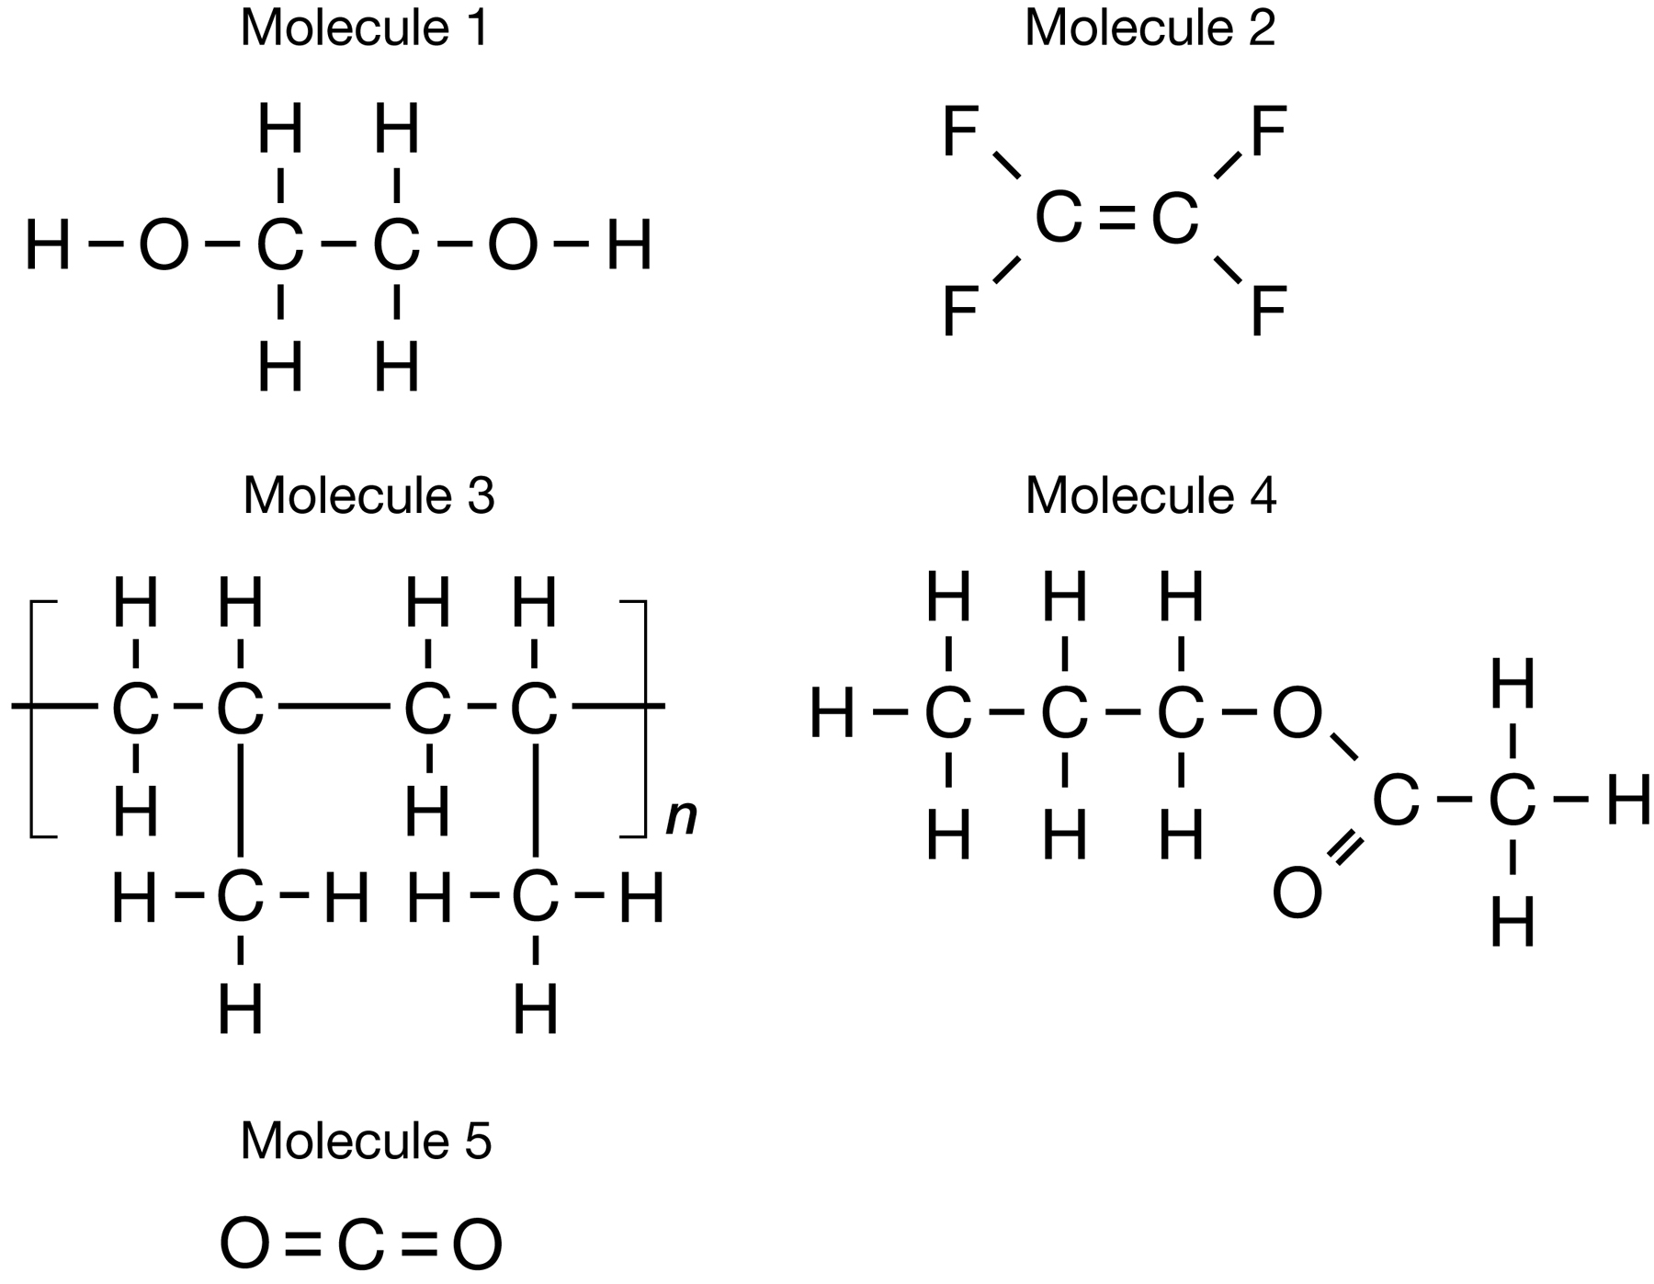

- Identify a reaction type that could be used to produce each molecule.

Answer:

- Write the balanced chemical equation for the production of each molecule using the reaction type identified in question 1.

Answer:

- Write the name of the reactants and products developed in your answer to question 2.

Answer:

Submit your completed Assignment Booklet to your teacher
at the end of this lesson.

