Module 1: Lesson 2 ASSIGNMENT

This Module 1: Lesson 2 Assignment is worth 21 marks. The value of each assignment and each question is stated in the left margin.

(21 marks) | Lesson 2 Assignment: Impulse: Changing Momentum

(3 marks) | A 1. | An arrow gains a momentum of 94.3 kg∙m/s [W] in 0.400 s. Determine the magnitude and direction of the average unbalanced force that acted on the arrow.

Answer:

(3 marks) | A 2. | An artillery shell is accelerated from rest and gains a momentum of 2.00 x 10³ kg∙m/s [E]. If the average net force acting on the shell was 8.50 x 10³ N [E], then calculate the time interval that this net force acted on the shell.

Answer:

(1 mark) | A 3. | A high school football player hits and pushes a tackling dummy during practice. The following graph shows the amount of force that acts on the player.  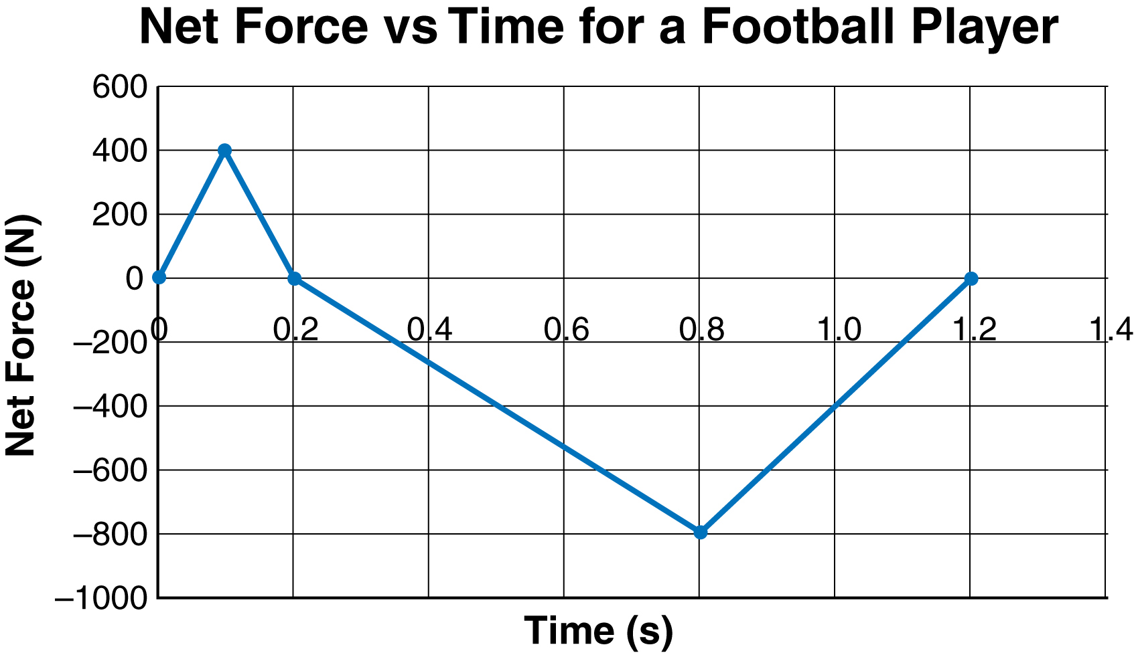  - What happens to the player’s forward velocity during the first  0.20 s?

Answer:

(1 mark) |  | - What happens to the player’s velocity from 0.20 to 1.20 s?

Answer:

(3 marks) |  | - What is the impulse that acts on the football player?

Answer:

(3 marks) |  | - If the 60 kg player is running forward at 7.0 m/s when she makes contact with the dummy, what is the player’s velocity at the end of the 1.20 s impact?

Answer:

(3 marks) | A 4. | The following illustration shows two ways of providing impulse to change the momentum of a vehicle. In the top illustration, the vehicle collides with a massive concrete barrier. In the bottom illustration, the vehicle collides with water-filled barrels.  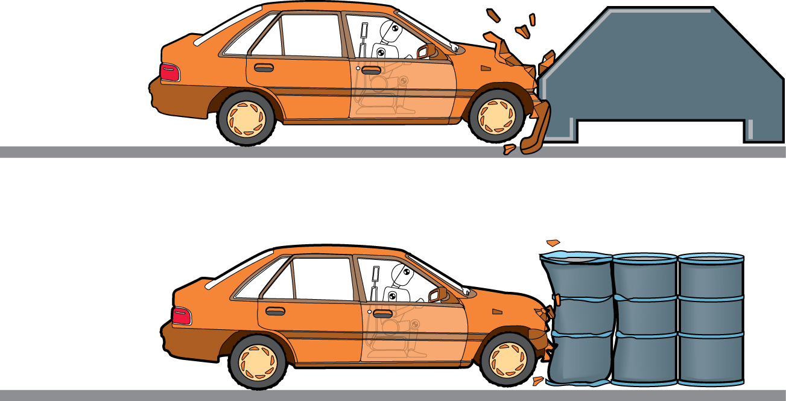  Explain which type of crash barrier would likely produce less damage to the vehicle and less injury to the occupants.

Answer:

(4 marks) | D 2. | Post your findings to the discussion area, and compare your findings with those of other students. How do their findings differ from yours? Are the arguments made to support these views consistent with the information you researched? Did other students find additional information unknown to you? Has your opinion of bicycle helmets changed since you started? Explain.

Answer:

Once you have completed all of the questions, submit your work to your teacher.

