Module 2—The Conservation of Momentum

Project: Case File

This Module 2 Project is worth 11 marks. The value of each assignment and each question is stated in the left margin.

Throughout this module you will work on the analysis of the collision between Kathy Johnson and Bill Peterman described in the Big Picture section. Parts of the project can be solved in each lesson. As you complete each lesson add to your analysis of the collision in the answer boxes.

Lesson 1

The mass of the truck is 3200 kg, and the mass of the car is 2800 kg. Based on the length of the skid marks at the scene and the mass of the vehicles, police estimate that the combined mass was moving at 7.0 m/s just after impact. From this point, the two vehicles slid and came to rest at the corner of the intersection.

- Determine the magnitude of the momentum just after the collision. (Analytic)
- Is this the same as the magnitude of the momentum just before the collision? Explain why or why not. (Holistic)

Lesson 2

Using the principle of conservation of momentum, the police determined that Bill’s truck was travelling at 2.3 m/s before the collision, and Kathy’s car was travelling at 15 m/s before the collision.

- What is the kinetic energy of the vehicles before and after the collision? (Analytic)
- Is kinetic energy conserved? If kinetic energy is not conserved, what does this tell us about the type of collision? (Holistic)

Lesson 3

The two momentum vectors before the collisions are represented in blue. The momentum after the collision is in red. Adding the two momentum vectors before the collision equals the momentum after the collision, according to the law of conservation of momentum.

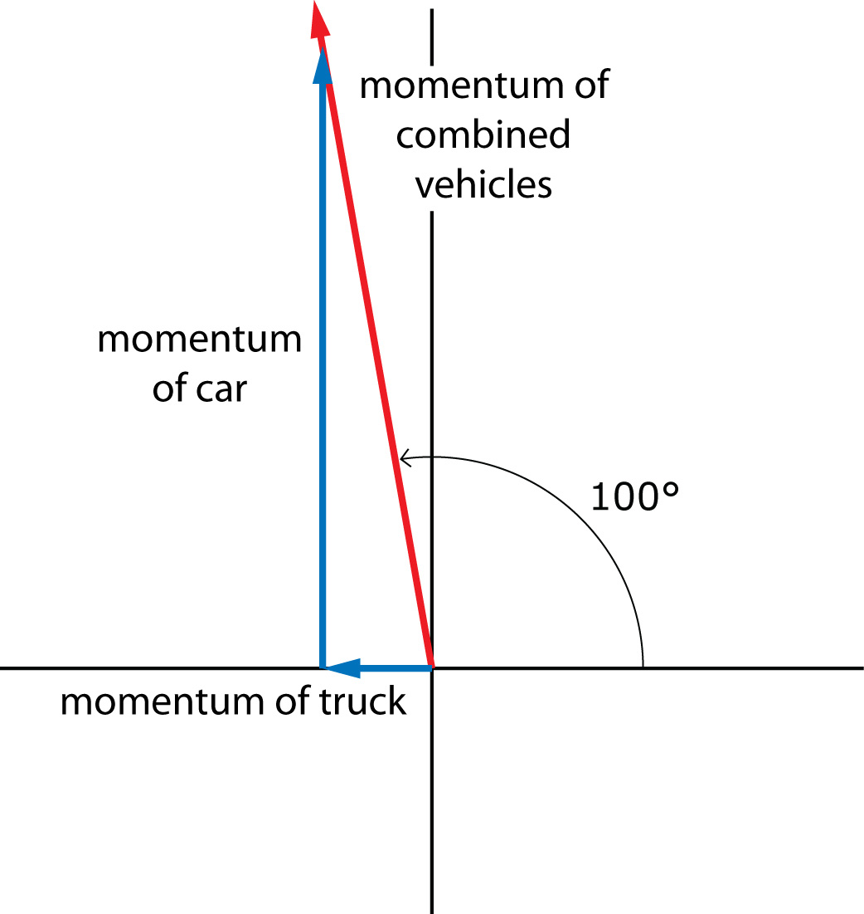

While the photo suggests a much more complex collision than the given diagram, assume that the diagram shows exactly what happened.

- Using this vector diagram and your calculated value for the momentum of the combined vehicles, verify the police calculations and determine the momentum and velocity of Bill’s truck just before the collision. (Analytic)
- Using this vector diagram and your calculated value for the momentum of the combined vehicles, verify the police calculations and determine the momentum and velocity of Kathy’s car just before the collision. (Analytic)
- Does your analysis prove, beyond a reasonable doubt, that Kathy was, in fact, travelling at the speed limit of 50 km/h just prior to the accident? What assumptions did you make in your solution to determine this? (Holistic)

(6 marks) |  | Analytic Answer  - Determine the magnitude of the momentum just after the collision.  - What is the kinetic energy of the vehicles before and after the collision?  - Using this vector diagram and your calculated value for the momentum of the combined vehicles, verify the police calculations and determine the momentum and velocity of Bill’s truck just before the collision.  - Using this vector diagram and your calculated value for the momentum of the combined vehicles, verify the police calculations and determine the momentum and velocity of Kathy’s car just before the collision.

Answer:

(5 marks) |  | Holistic Answer  - Is this the same as the magnitude of the momentum just before the collision? Explain why or why not.  - Is kinetic energy conserved? If kinetic energy is not conserved, what does this tell us about the type of collision?  - Does your analysis prove, beyond a reasonable doubt, that Kathy was, in fact, travelling at the speed limit of 50 km/h just prior to the accident? What assumptions did you make in your solution to determine this?

Answer:

Remember before submitting this to your teacher to make sure that you check the marking guides for assistance.

Once you have completed all of the questions, submit your work to your teacher.

