Module 2: Lesson 2 ASSIGNMENT

This Module 2: Lesson 2 Assignment is worth 22 marks. The value of each assignment and each question is stated in the left margin.

(22 Marks) | Lesson 2 Assignment: Kinetic Energy and Collisions

(5 marks) | LAB 1. | In the following chart, record the initial velocity and final velocity for each object. Calculate the initial and final momentum and energy for each object using the mass and velocity values.  Do not worry about what e represents—this will be discussed in detail in the next section. The value of e will be listed with the other information on the simulation and must be recorded for each collision.

Collision 1 e = ____
Object | Mass  (kg) | (m/s) | (m/s) | (kg·m/s) | (kg·m/s) | E_{k} initial  (J) | E_{k} initial  (J)
blue | 5.0
green | 5.0
total | _____ | _____ | ____

Collision 2 e = ____
Object | Mass  (kg) | (m/s) | (m/s) | (kg·m/s) | (kg·m/s) | E_{k} initial  (J) | E_{k} initial  (J)
blue | 5.0
green | 5.0
total | _____ | _____ | ____

Collision 3 e = ____
Object | Mass  (kg) | (m/s) | (m/s) | (kg·m/s) | (kg·m/s) | E_{k} initial  (J) | E_{k} initial  (J)
blue | 5.0
green | 5.0
total | _____ | _____ | ____

Collision 4 e = ____
Object | Mass  (kg) | (m/s) | (m/s) | (kg·m/s) | (kg·m/s) | E_{k} initial  (J) | E_{k} initial  (J)
blue | 5.0
green | 5.0
total | _____ | _____ | ____

Collision 5 e = ____
Object | Mass  (kg) | (m/s) | (m/s) | (kg·m/s) | (kg·m/s) | E_{k} initial  (J) | E_{k} initial  (J)
blue | 5.0
green | 5.0
total | _____ | _____ | ____

(1 mark) |  | - Is there a relationship between the changes in velocity of the blue mass and the green mass? If yes, describe the relationship.

Answer:

 | LAB 2. | Answer the following questions using the data collected in the collision tables.

(2 marks) |  | - Is momentum conserved in each collision?

Answer:

(2 marks) |  | - Is kinetic energy conserved in each collision?

Answer:

 | A 1. | Complete the data table below by doing the following.

(5 marks) |  | - Record the total E_{k} initial, total E_{k} total and e for each collision from the lab data tables.  - Calculate the percentage of loss in kinetic energy for each collision using:

Collision | e | Total E_{k} Initial  (J) | Total E_{k} Final  (J) | Loss in E_{k}  (%)
1
2
3
4
5

(2 marks) | A 2. | Using the same data table above, compare the percentage of total kinetic energy lost during each collision to the value of e. What is the relationship between percentage of loss in kinetic energy and e?

Answer:

(5 marks) | A 3. | Design an experiment that would let you answer the following problem: is the collision between a ball pendulum and a block pendulum elastic, inelastic, or completely inelastic?  The following four diagrams give you a starting point for your experiment.  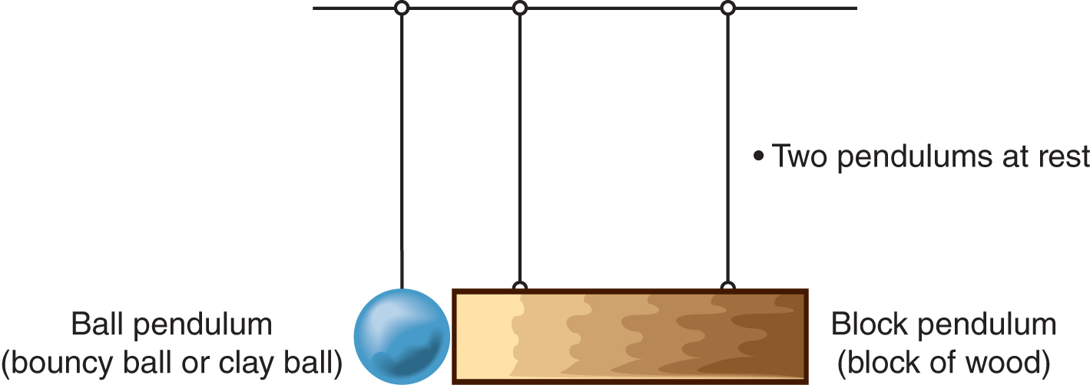  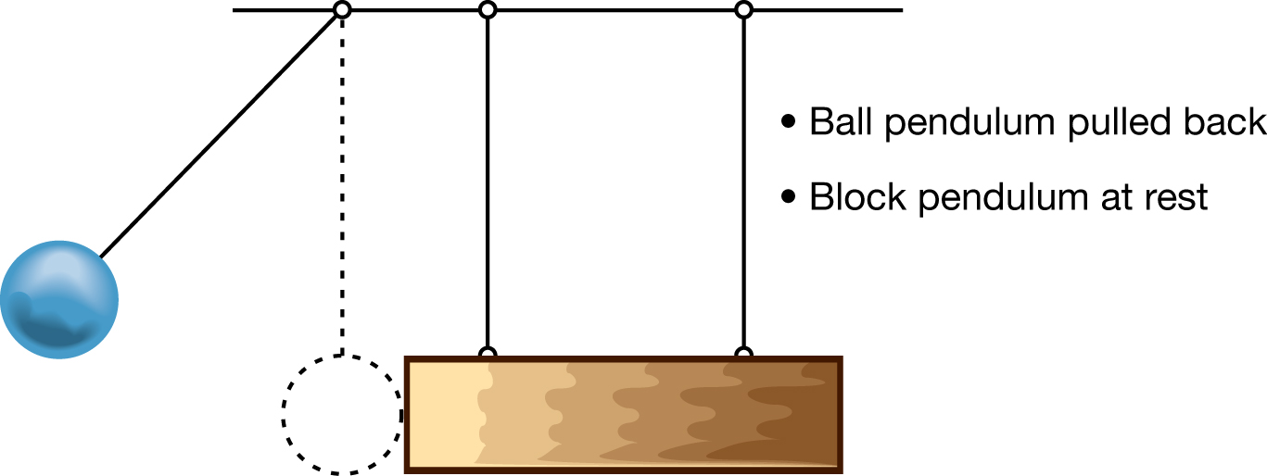  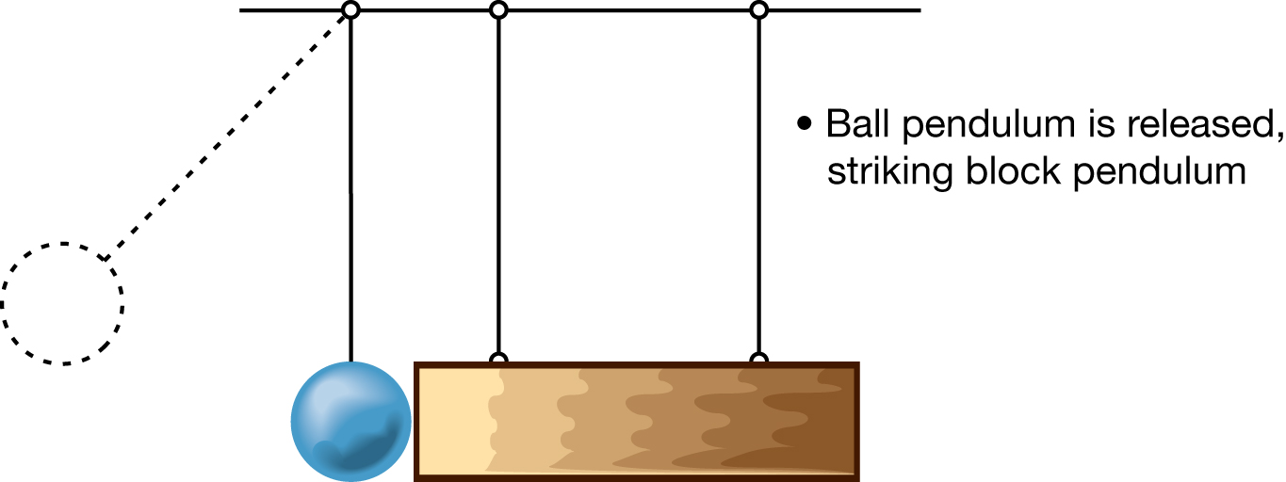  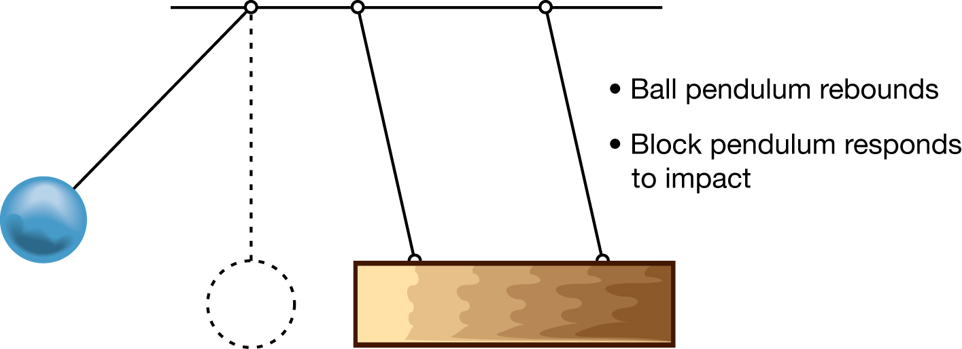

Answer:

Once you have completed all of the questions, submit your work to your teacher.

