(21 marks) | Module 3: Lesson 4 ASSIGNMENT  This Module 3: Lesson 4 Assignment is worth 21 marks. The value of each assignment and each question is stated in the left margin.

Lesson 4 Assignment: Electric Fields

(4 marks) | A 1. | Calculate and illustrate the electric field strength at a distance of 8.25 m from a +6.50 μC charged particle. Use the simulation to verify your field diagram.
(3 marks) | A 2. | Calculate how far from a -5.00 μC charged particle the electric field strength 7.2×10⁷ N/C is toward the charge.

(4 marks) | A 3. | Point P is collinear with a +2.80 μC and a -8.50 μC as shown in the following diagram. Point P is 10 cm to the left of the positive charge and 20 cm to the left of the negative charge. What is the electric field at point P?  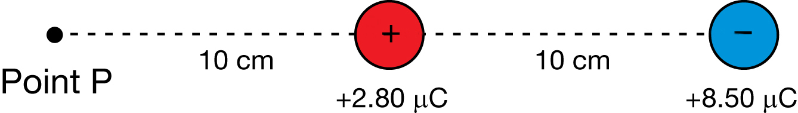

(6 marks) | A 4. | The following diagram shows two charged spheres arranged to the right of a point in space labelled P. Use the information on the diagram to calculate the magnitude and direction of the net electric field at point P.  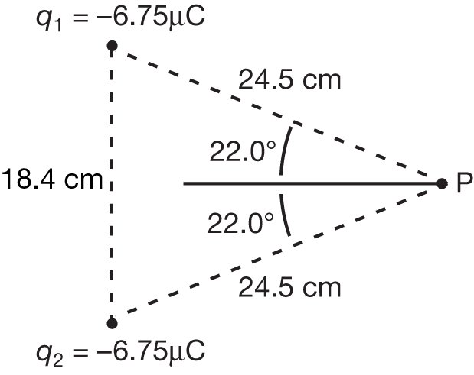

Answer:

D 1. Use the information presented in this lesson to explain why St. Elmo’s fire is observed at the ends of sharply pointed exterior surfaces of aircraft such as wing tips and propellers. Be sure to explain why St. Elmo’s fire is not observed on surfaces that are flat or on interior parts of the aircraft.

D 2. Post your summary to the discussion area set up by your teacher. Compare your summary to at least one other explanation produced by another student. Identify similarities and differences between your work and the work of other students.

D 3. If you were to update your explanation of St. Elmo’s fire, what changes would you make?

(4 mark) | D 4. | Use your answers to D 1, D 2, and D 3 and those of the other responses to revise your explanation of why St. Elmo’s fire occurs on sharply pointed projections of aircraft and not on flat exterior surfaces or interior surfaces.

Answer:

Once you have completed all of the questions, submit your work to your teacher.

