(29 marks) | Module 3: Lesson 6 ASSIGNMENT  This Module 3: Lesson 6 Assignment is worth 29 marks. The value of each assignment and each question is stated in the left margin.

Lesson 6 Assignment: The Motion of Charges in Uniform Electric Fields

(2 marks) | LAB 1. | Summarize what you have learned from this simulation by stating what will happen when  - a positive particle has an initial velocity opposite to the direction of the electric field  - a positive particle has an initial velocity in the same direction as the electric field

Answer:

(2 marks) | LAB 2. | Use physics principles to explain the motion you described in LAB 1.

Answer:

(2 marks) | LAB 3. | Describe the motion of a positive particle when the direction of its initial velocity is perpendicular to the direction of the electric field.

Answer:

(2 marks) | LAB 4. | Use physics principles to explain the motion you described in LAB 3.

Answer:

(2 marks) | LAB 5. | Describe the motion of a negatively charged particle when the direction of its initial velocity is perpendicular to the direction of the electric field.

Answer:

(2 marks) | LAB 6. | Use physics principles to explain the motion you described in LAB 5.

Answer:

(1 mark) | LAB 7. | Explain the circumstances that enable a particle to move un-deflected, with uniform motion, through an electric field, if it is given an initial velocity perpendicular to the electric field. Assume the electric field is the only field present.

Answer:

(12 marks) | A 1. | In your Module 3: Lesson 6 Assignment, diagrams show the initial position and the velocity vector of a charged particle within a uniform electric field. For each diagram, follow each of these steps:  - Sketch a free-body diagram showing the net force that acts on the particle.  - Sketch the path of the particle.  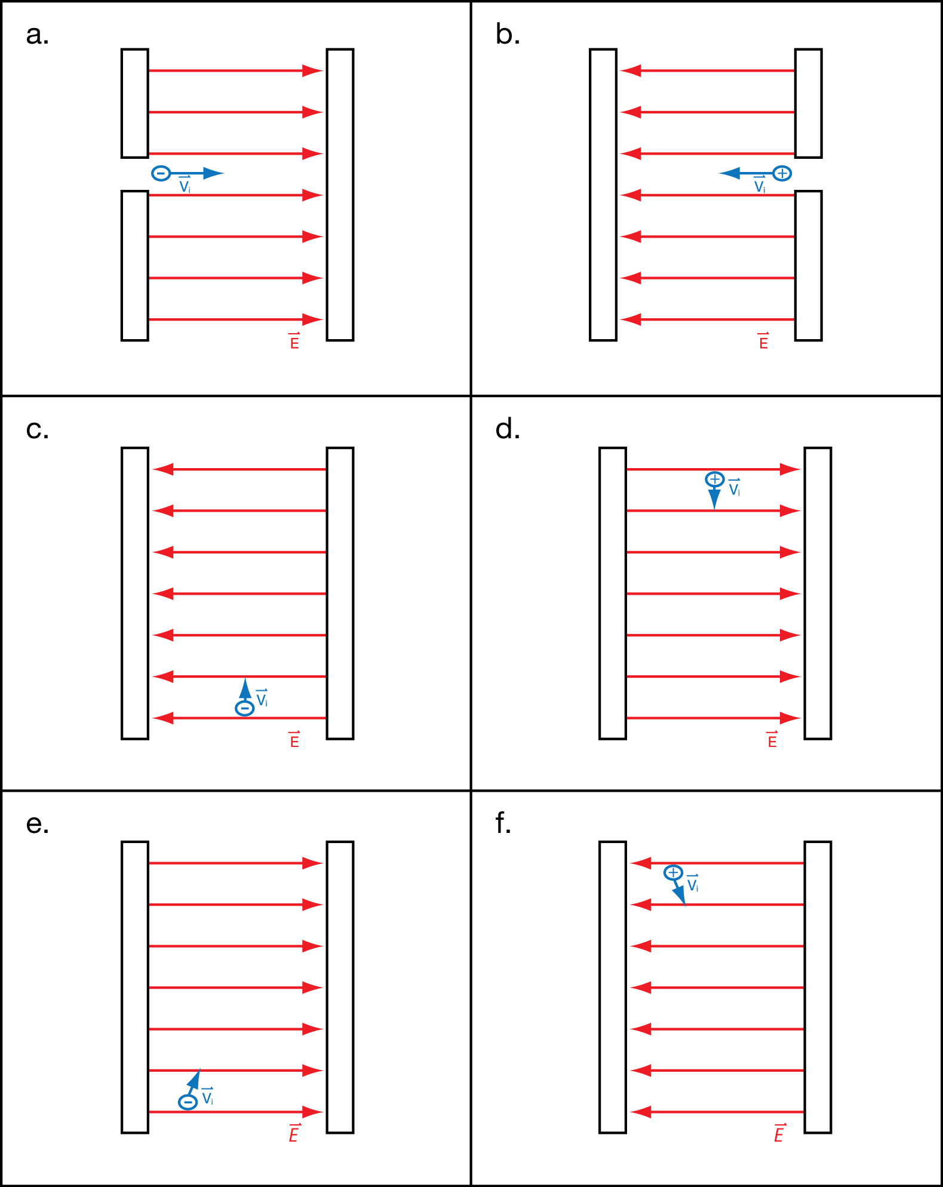

Answer:

(4 marks) | A 2. | The following diagram shows a proton entering the region between two oppositely charged plates. The plates are 45.0 mm long and 17.5 mm apart.  A potential difference of 0.208V generates an electric field between the plates.  The proton is given an initial velocity of 1.35 x 10⁴ m/s, in the positive x direction. Use this information to determine the y-component of the displacement of the proton when it leaves the region between the plates. (This displacement is how  far the proton has moved above or below the x-axis the instant it leaves the region between the plates.)  Be sure to begin your solution with a free body diagram and an analysis of the physics principles that apply.  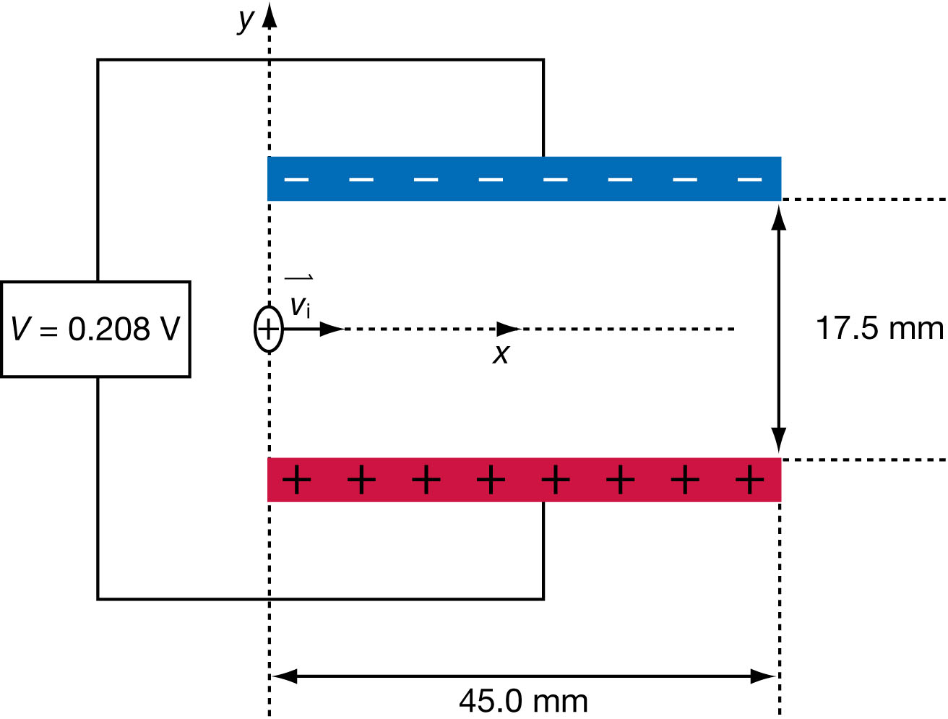

Answer:

Once you have completed all of the questions, submit your work to your teacher.

