Module 4: Lesson 1 ASSIGNMENT

This Module 4: Lesson 1 Assignment is worth 30 marks. The value of each assignment and each question is stated in the left margin.

(30 marks) | Lesson 1 Assignment: Magnetic Fields

(5 marks) | A 1. | Using the diagrams below, indicate the direction of the magnetic field associated with the wire when the current is flowing in the direction indicated. (Electron current flows from negative to positive.)  a. b. 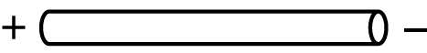  c.  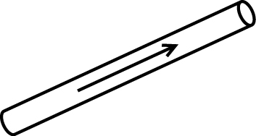  d. e.   

(3 marks) | A 2. | Using the diagrams below, indicate the direction of electron flow if the associated magnetic field is in the direction indicated.  - 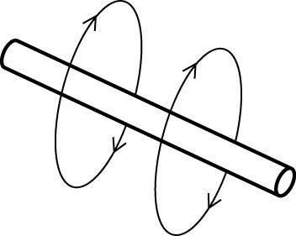  - 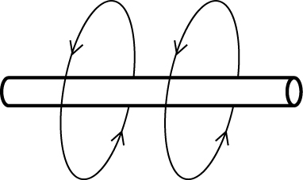  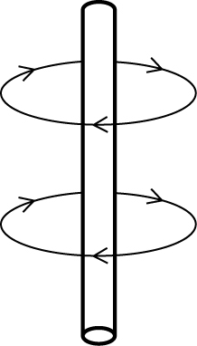

(2 marks) | A 3. | Given the diagrams below indicate whether a dot or an “x” should be placed in each circle. (Note that current is the direction of the electrons, e- flow.)  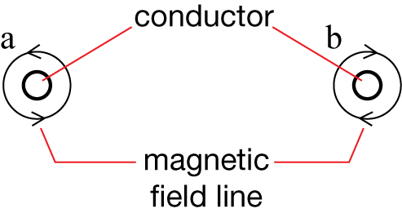

(6 marks) | A 4. | Given the diagrams below, indicate the path of the current (e- flow) that produces magnetic poles as indicated.  - 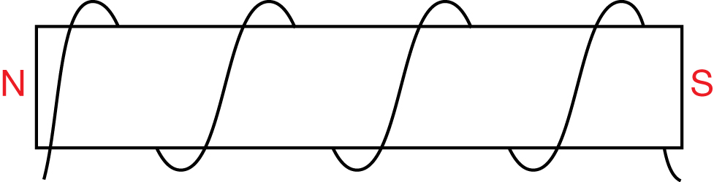  - 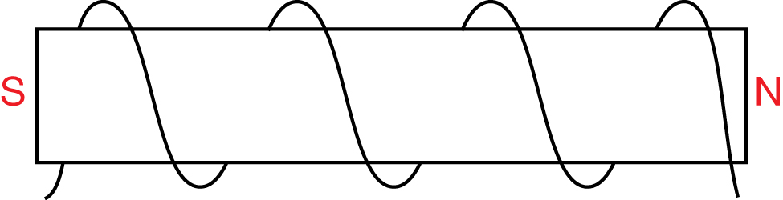  - 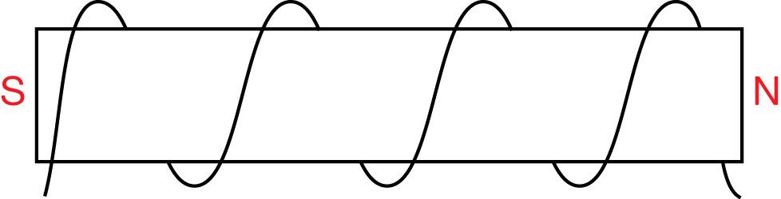

(10 marks) | A 5. | Given the diagrams below, indicate the direction of the magnetic field created by the current (e- flow) flowing through the solenoid.  - 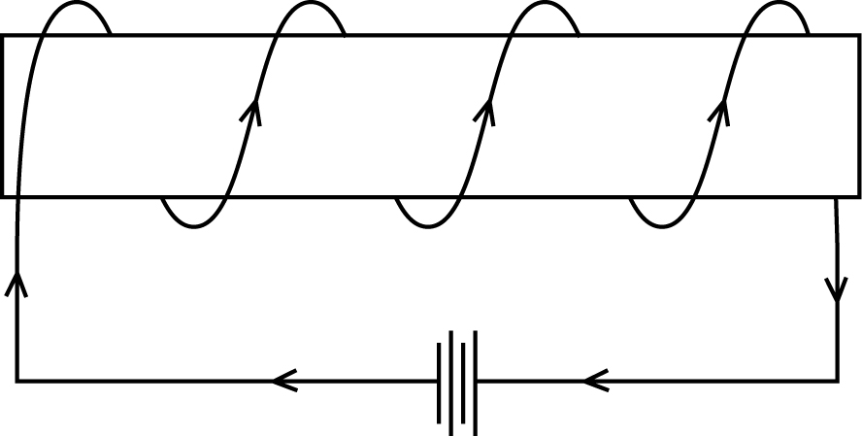  - 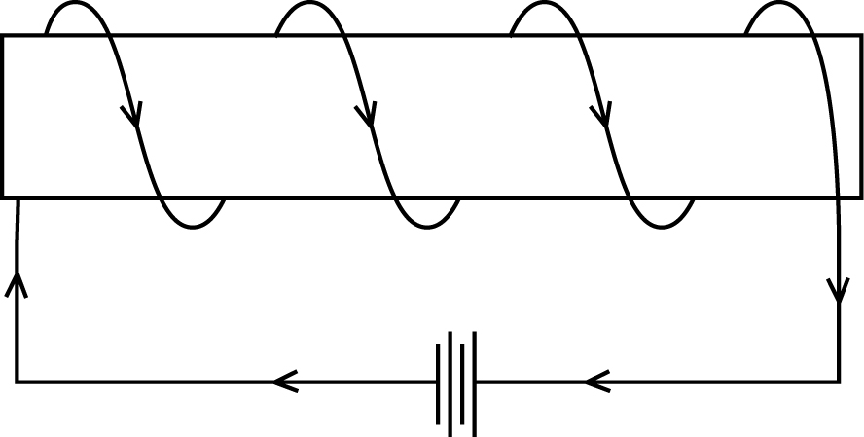  - 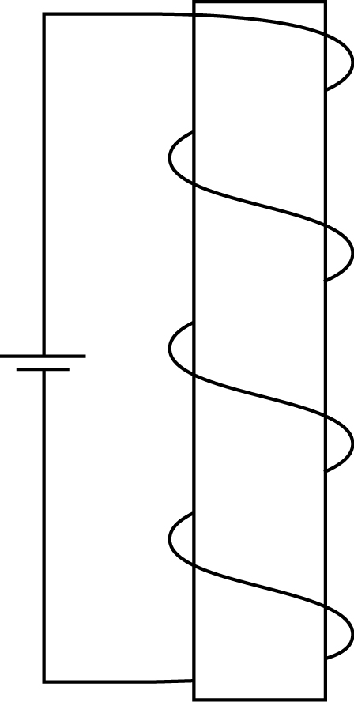  - 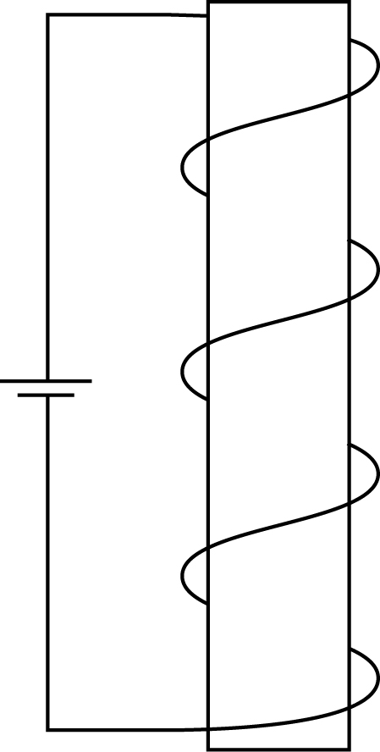  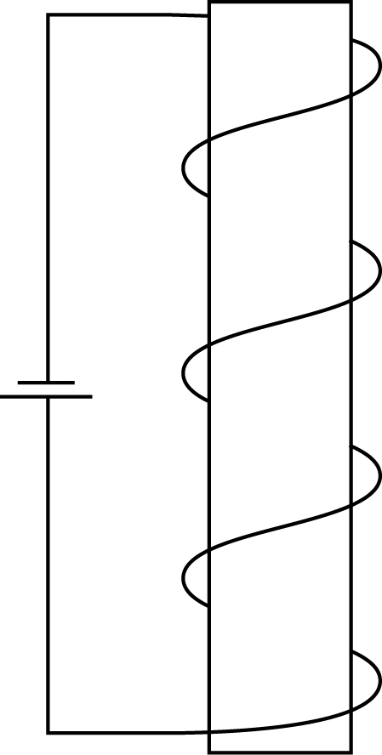

 | D 1. | Research the Sun’s magnetic field and respond with a few paragraphs to address the following items:  - Explain the role of the magnetic field in producing sunspots.  - Explain how both poles of the magnetic field are observed in sunspots.  - Explain why it is important to understand the nature of sunspots and the Sun’s magnetic field in general.  - Explain, in terms of the study of physics, why you believe that the sources you found on the Internet are reliable.

(4 marks) | D 3. | Revise your response to D 1 using the additional information from your readings of other students’ work and comment on how reading their work improved your own.

Answer:

Once you have completed all of the questions, submit your work to your teacher.

