(30 marks) | Module 4: Lesson 2 ASSIGNMENT  This Assignment Booklet is worth 30 marks. The value of each assignment and each question is stated in the left margin.  Read all parts of your assignment carefully, and record your answers in the appropriate places. If you have difficulty with an assignment, go back to the textbook and review the appropriate lesson. Be sure to proofread your answers carefully before submitting your Assignment Booklet.

Lesson 2 Assignment: Moving Charges in Magnetic Fields

(4 marks) | A 1. | As a review, draw the inward force on the following diagrams. The first one has been completed as an example.  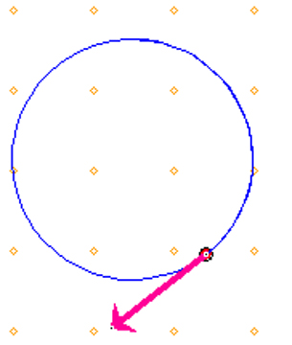  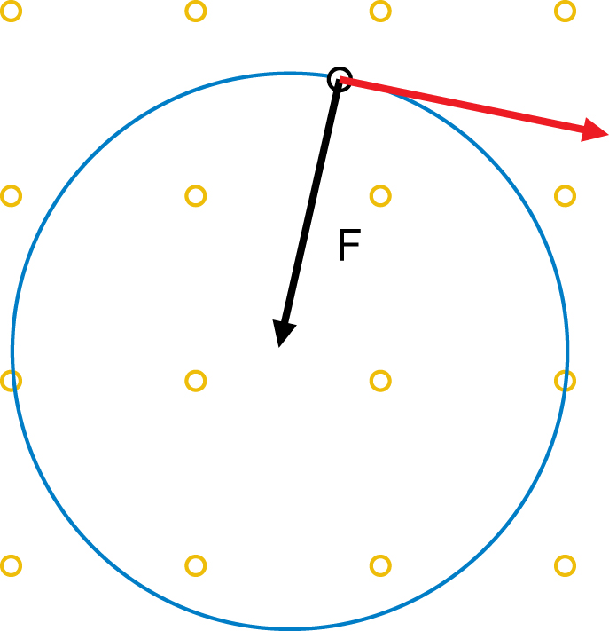  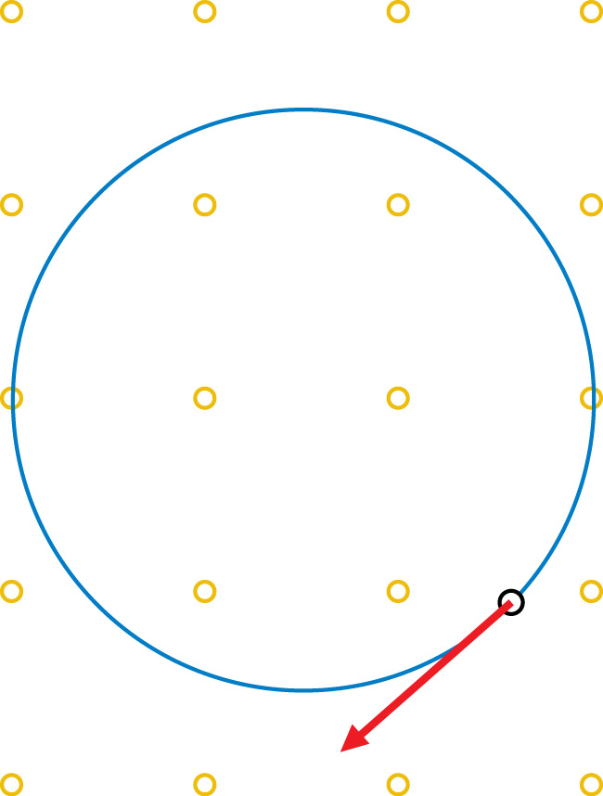  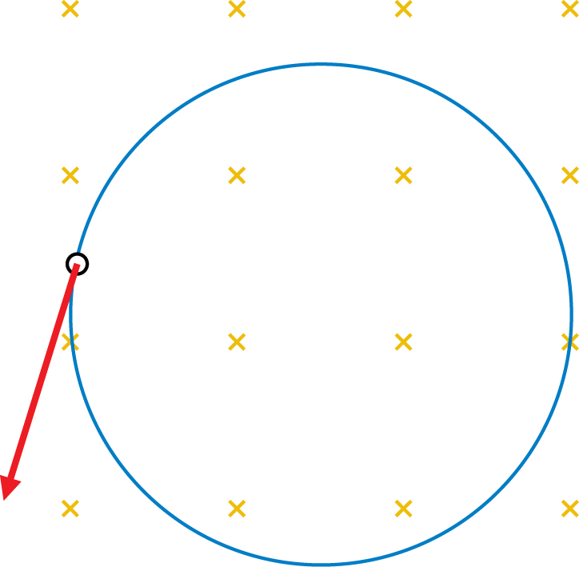  - c.

(8 marks) | A 2. | Predict, draw, and verify the magnetic force on each diagram below. Verify your answers using the simulation.  - positive charge    - positive charge    - negative charge  - negative charge

(4 marks) | A 3. | An electron experiences a downward magnetic force of 7.15  10^{–14} N when it is travelling at 3.00  10⁵ m/s south through a magnetic field. Calculate the magnitude of the magnetic field and determine its direction using the right-hand rule.

Answer:

(3 marks) | A 4. | A charged particle is travelling west through a downward magnetic field and it experiences a magnetic force directed to the north. Using the hand rule, determine whether the charge is negative or positive.

Answer:

(4 marks) | A 5. | Calculate the magnitude and the direction of the magnetic force acting on an alpha particle that is travelling upwards at a speed of 3.00  10⁵ m/s through a 0.525-T west magnetic field.

Answer:

(3 marks) | A 6. | An electron (m = 9.11  10^{–31} kg) enters a downward magnetic field of  5.00  10^{–1} T with a velocity of 6.50  10⁶ m/s West. Calculate the radius of the circular path it will follow once it is travelling within the magnetic field.

Answer:

 | D 1. | Research Thomson’s work on the charge-to-mass ratio and answer the following:  - If both an electric field and a magnetic field exert a force on a moving electron, could they be arranged in such a manner that each force cancels the other out, allowing the electron to pass through a CRT without being deflected? Sketch the orientation of the electric and magnetic fields to show that an electron travelling west could pass through each field simultaneously without being deflected. Label your diagram.  - In order for an electron to pass through both the electric and magnetic fields without being deflected, the magnetic force () must be identical in magnitude to the electric force (). Derive an expression for the velocity of the electron when these two forces are equal to one another.  - If the electric field is turned off, what kind of motion will result from the application of only the magnetic field?  - If the magnetic force () is an inward force () when acting alone, determine an expression for the charge-to-mass ratio of an electron (q/m) by first equating Fm and Fin.  - Why was determining the charge-to-mass ratio of an electron considered important?

(4 marks) | D 3. | Revise your responses to D 1 and include comments on what you learned from reading other students’ responses.

Answer:

Once you have completed all of the questions, submit your work to your teacher.

