(27 marks) | Module 4: Lesson 3 ASSIGNMENT  This Assignment Booklet is worth 27 marks. The value of each assignment and each question is stated in the left margin.  Read all parts of your assignment carefully, and record your answers in the appropriate places. If you have difficulty with an assignment, go back to the textbook and review the appropriate lesson. Be sure to proofread your answers carefully before submitting your Assignment Booklet.

Lesson 3 Assignment: Electromagnetic Induction

 | A 1. | A compact fluorescent light bulb draws a current of 0.10 A for one hour.

(2 marks) |  | a. | How much charge flows through the bulb in one hour?

Answer:

(2 marks) |  | b. | How many electrons flow through the light bulb in the hour? Remember the charge of one electron is the elementary charge on your physics data sheet.

Answer:

(2 marks) | A 2. | A motor uses a coil of wire in a magnetic field to generate force. The motor draws a current of 9.50 A through the coil of wire and has a magnetic field of 1.75 T. If the motor is designed to generate 800 N, how long is the wire in the coil, assuming that all of the wire creates force?

Answer:

(2 marks) | A 3. | What would happen to the direction of the magnetic force if the loop of wire were to undergo one half-turn without reversing the direction of the current in the loop?

Answer:

(6 marks) | A 4. | Fill in the "?" with the missing information in each of the following diagrams. In the diagrams a magnet is either dropped down or pulled up through a cylinder encircled by a coil conductor. Remember that current is e– flow.  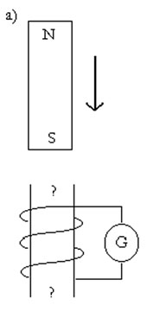  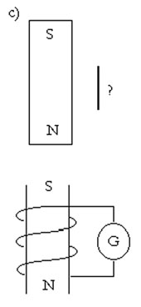  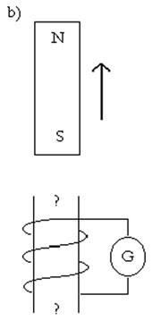  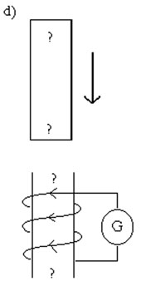  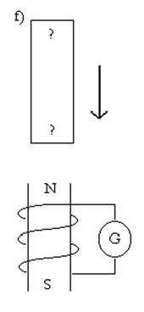  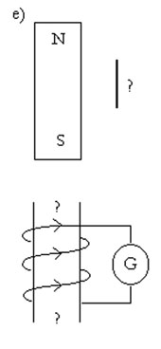

(1 mark) | LAB 1. | “Pickup” coil: how does the direction of the movement of the magnet affect the direction of the deflection on the voltage meter?

Answer:

(1 mark) | LAB 2. | “Light bulb”: how does the speed of the magnet or coil affect the light?

Answer:

 | LAB 3. | “Generator”: describe how each of the following factors influences the magnitude of the deflection:

(2 marks) |  | a. | strength of the magnetic field

Answer:

 |  | b. | speed of the magnet passing the coil (adjusted by changing the water flow)

Answer:

 |  | c. | the number of loops

Answer:

 |  | d. | the loop area

Answer:

(1 mark) | LAB 4. | Explain why the generator effect would occur in the same way if the wire were moved rather than the magnet.

Answer:

(2 marks) | LAB 5. | Summarize the factors that determine the magnitude and direction of the induced current when there is relative motion between a magnetic field and a conductor.

Answer:

(2 marks) | LAB 6. | Describe the change in the direction (sign) of the voltage as the magnet spins. Note that this “flip” in direction does not happen with a battery (direct current, or DC, voltage source). This generator, therefore, is not generating direct current! It is an AC (alternating current) generator.

Answer:

 | D 1. | Would two parallel wires carrying a current in opposite directions repel or attract one another?

(4 marks) | D 3. | Based on the other students’ responses, revise your answer to D 1 and comment on the other students’ answers.

Answer:

Once you have completed all of the questions, submit your work to your teacher.

