Module 5: Lesson 3 ASSIGNMENT

This Module 5: Lesson 3 Assignment is worth 31 marks. The value of each assignment and each question is stated in the left margin.

(31 marks) |  | Lesson 3 Assignment: Reflection  Predicting the path of the reflected light, for both regular and irregular reflection is based on the law of reflection. A reflection simulation will be used to explore the law of reflection.  - Following the instructions in the lesson, open the reflection simulation, and select mode.  - Click the “Show Calcs” button, . A box with the θin and θout values will appear.
(2 marks) | LAB 1. |  | The mirror angle can be adjusted using the angle slider (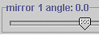). The mirror position can be adjusted by clicking and dragging the mirror on the screen.  Adjust the position and/or angle of the mirror. Record the values for θ_{in} and θ_{out} for five different rays when the mirror is at various angles or positions. Record your observations.

Answer:
θ_{in} | θ_{out}

(1 mark) | LAB 2. | The law of reflection is one of the most basic of all laws in optics. It relates the angle of incidence to the angle of reflection. On the basis of the investigation that you just performed, state the law of reflection.

Answer:

(6 marks) | LAB 3. | Open the Thin Lens simulation and select “Mirror” from the drop-down menu.  Click the object arrow, and move it to various locations on the principal axis. Using the simulation as a guide, draw diagrams and describe the image characteristics when the object is located at the positions listed in Table 1. For image characteristics, record real or virtual, attitude, magnitude, and position relative to mirror surface.

Table 1: Using Ray Diagrams to Predict Image Characteristics: Converging Mirror

Object Position | Ray Diagram | Image Characteristics
very far away (very left side) | 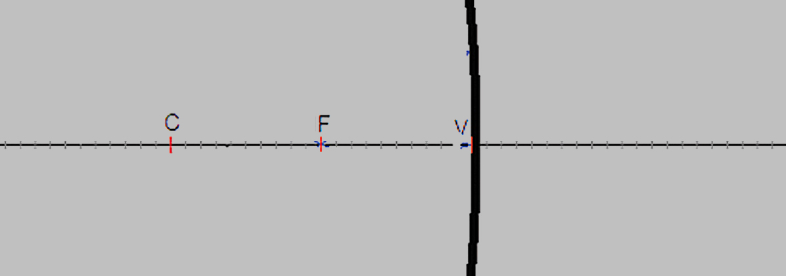
outside C
at C
between C and F
at F
inside F

(2 marks) | LAB 4. | Switch the mirror in the simulation to a diverging, convex mirror by making the focal length negative (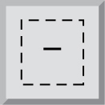). Complete Table 2. For image characteristics, record real or virtual, attitude, magnification, and position relative to mirror surface.

Table 2: Using Ray Diagrams to Predict Image Characteristics: Diverging Mirror

Object Position | Ray Diagram | Image Characteristics
very far away (very left side) | 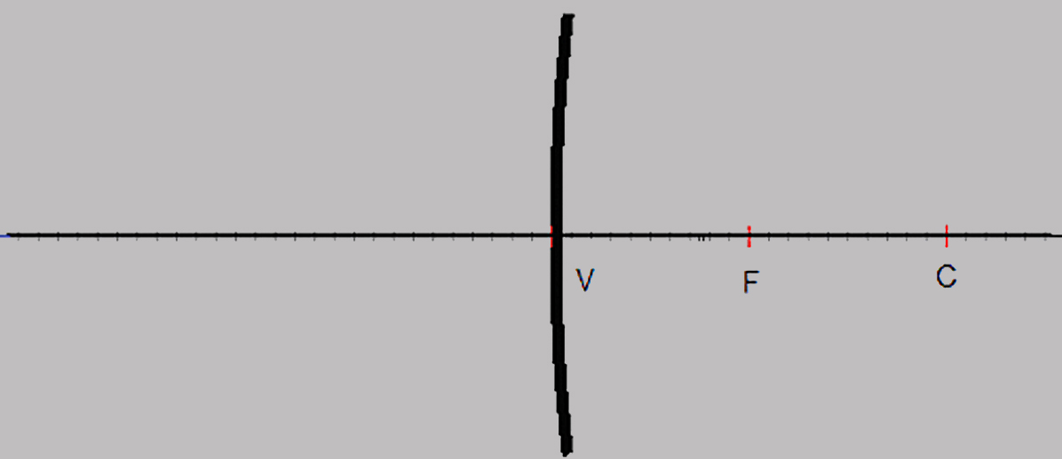
close to the mirror

(4 marks) | A 1. | Complete “Concept Check” questions 1 and 2 on page 662 of the textbook.

Answer:
1.

Answer:
2.

(3 marks) | A 2. | A converging mirror has a focal length of 20 cm. The object is placed 30 cm in front of the mirror. Where will the image appear?

Answer:

(3 marks) | A 3. | A diverging mirror has a focal length of 0.12 m. The image is located 0.070 m from the mirror. Where is the object located?

Answer:

(3 marks) | A 4. | A student places a 5.0-cm-tall object 15 cm away from a converging mirror. The image is 12 cm from the mirror. What is the height and orientation of the image?

Answer:

(3 marks) | A 5. | A 1.5-cm-tall object is placed 12 cm away from a converging mirror. The image is magnified to four times its original height and is inverted. What is the mirror’s focal length?

Answer:

(4 marks) | D 1. | Work with another student to determine where, exactly, the secondary mirror should be placed so that the telescope produces a clear image of the distant object. Use a ray diagram to answer this question, and design an experiment to determine the focal length of the large, primary mirror. Your design should include the problem, prediction, materials, procedure, and analysis required to answer the problem.

Answer:

Once you have completed all of the questions, submit your work to your teacher.

