Module 5: Lesson 4 ASSIGNMENT

This Module 5: Lesson 4 Assignment is worth 28 marks. The value of each assignment and each question is stated in the left margin.

Lesson 4 Assignment: Refraction

(1 mark) | LAB 1. | - When light travels from a low-index medium (fast) into a high-index medium (slower), does the ray bend toward or away from the normal.

Answer:

(1 mark) |  | - When light travels from a high-index (slower) medium into a low-index (fast) medium, does the light ray bend toward or away from the normal?

Answer:

(3 marks) | LAB 2. | Set up the Light Refraction simulation with two refractive layers. You will need to vary the refractive index for each layer and the angle of the light ray in order to complete Table 2. Select “Show Calcs” () to assist in recording angles. Get as close to the θ_{i} as you can, but record the actual value that you use.  Table 2: Refraction Data
  n₁ | θ_{in} | n₁sin θ _{in} | n₂ | θ _{out} | n₂sin θ _{out}
  1.20 | 45° |  | 1.40
  1.30 | 32° |  | 1.66
  1.45 | 45° |  | 1.23
  1.51 | 40° |  | 1.00
  1.65 | 45° |  | 1.80

According to your data in Table 2, which two values are always equal to each other?

Answer:

(4 marks) | LAB 3. | Use the Water Refractions diagram and the Ethanol Refractions diagram to gather data regarding water refractions and ethanol refractions. Record your data in the tables provided.  Water Refractions  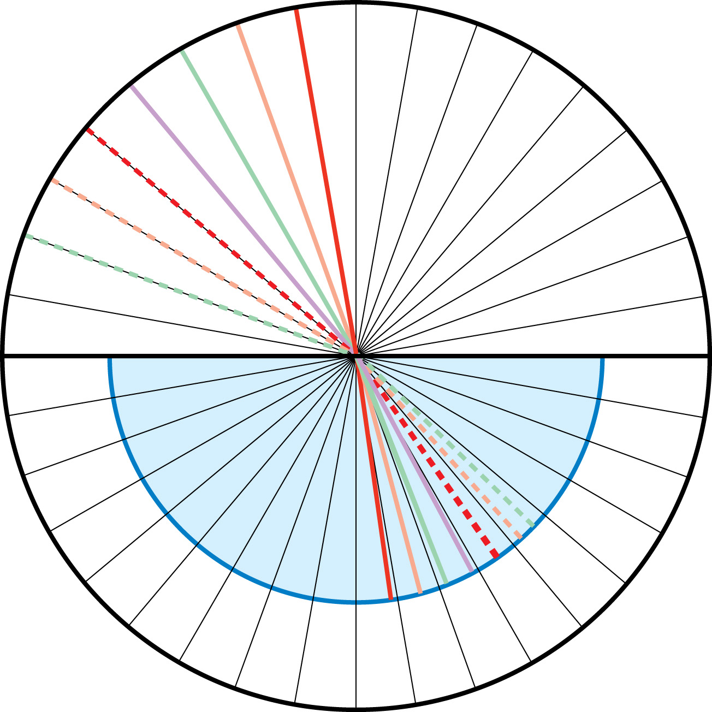  Ethanol Refractions  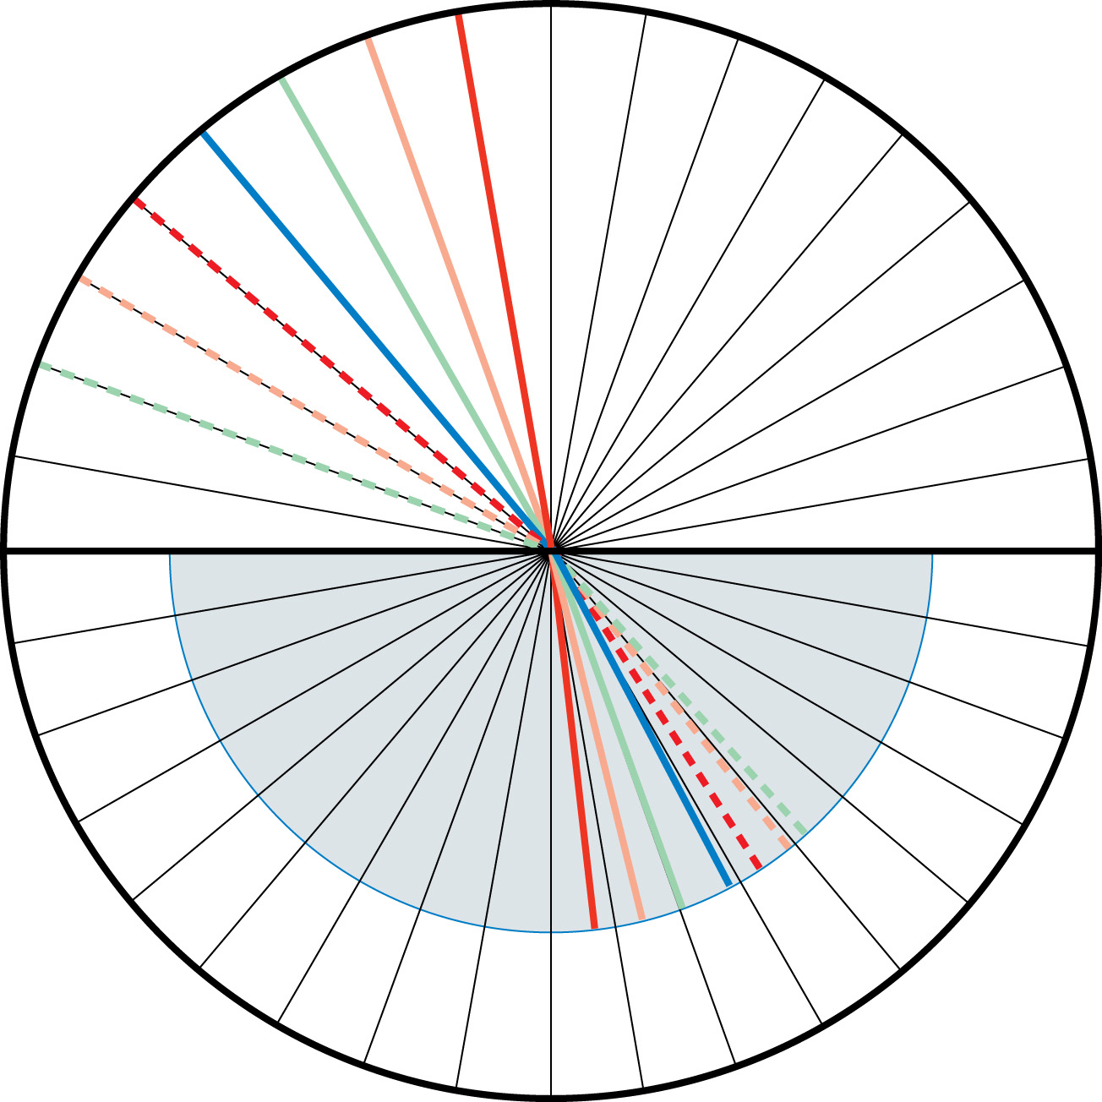
  θ ₁ | θ ₂ | sin θ ₁ | sin  θ ₂
  10
  20
  30
  40
  50
  60
  70
  θ _{incidence} | θ _{refraction} | sin θ _{incidence} | sin  θ _{refraction}
  10
  20
  30
  40
  50
  60
  70

(4 marks) | LAB 4. | Plot a graph of sine angle of incidence versus sine angle of refraction. Plot a line for water and a line for ethanol. Calculate the slope of each line on this graph.

Answer:

 | LAB 5. | Complete “Analysis” questions 3–8 on page 671 of your textbook.

(1 marks) |  | “Analysis” question 3

Answer:

(1 marks) |  | “Analysis” question 4

Answer:

(1 marks) |  | “Analysis” question 5

Answer:

(1 marks) |  | “Analysis” question 6

Answer:

(1 marks) |  | “Analysis” question 7

Answer:

(1 marks) |  | “Analysis” question 8

Answer:

 | LAB 6. | Using the Light Refraction simulation, set the refractive index of the top layer to equal 1.00 and the refractive index of the bottom layer to equal 1.33. Position the laser pointer in the bottom layer near the left side and project it upward.

(2 marks) |  | - Complete Table 3 by rotating the laser pointer to the angles specified and calculating the angle of refraction using Snell's Law. (It has been manipulated to solve for the angle of refraction.) Note: Refraction will not occur for all the angles in the table.  Table 3: Total Internal Reflection Data
  θ₁ |  | θ₂
  35°
  40°
  45°
  50°
  55°

(2 marks) |  | - What is the maximum possible angle of incidence that still causes refraction? Describe what happens to the ray of light if the angle of incidence exceeds this value.

Answer:

(5 marks) | LAB 7. | Consider white light entering an equilateral prism at a 50° angle with respect to the normal of one of its faces. If the index of refraction is 1.66 for blue light and 1.62 for red light, how far apart, in degrees, will the two rays emerge? Trace the path of the blue and red light on each prism. Sketch and label all angles and determine the angular separation between the blue and red rays as they leave the prism. Use the Prism simulation to verify your answer.  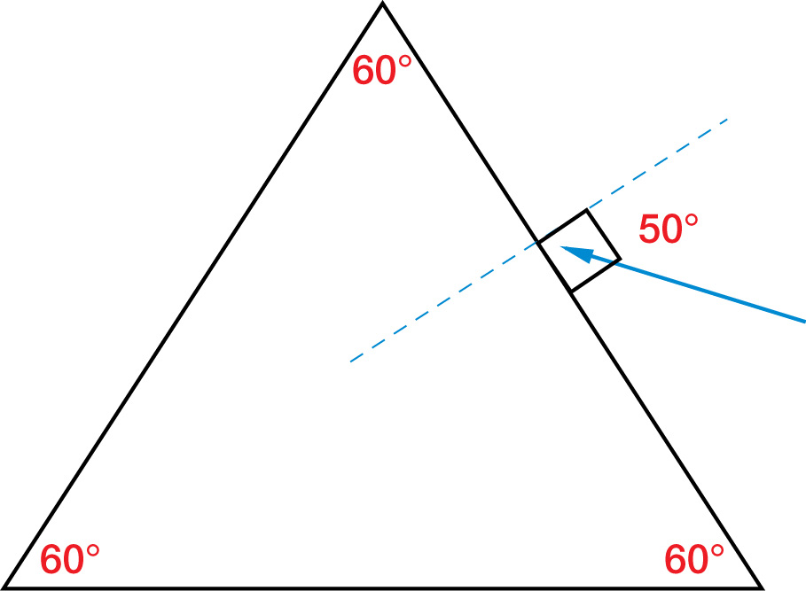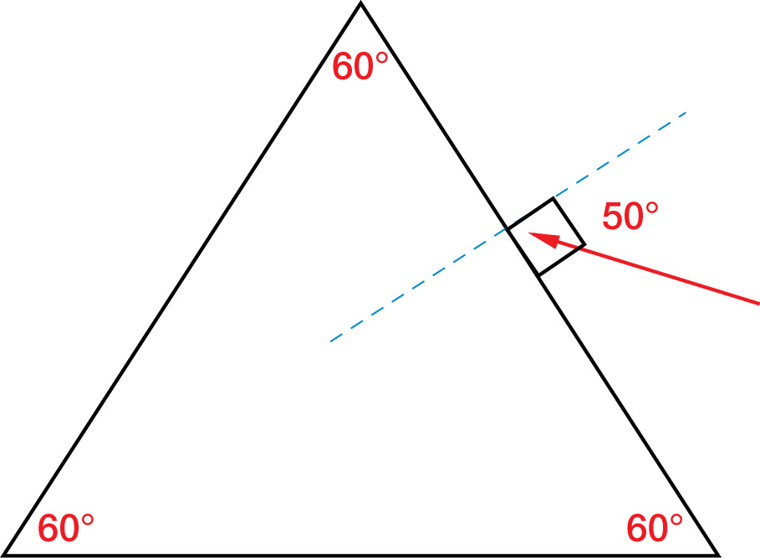

Answer:

Once you have completed all of the questions, submit your work to your teacher.

