Module 5: Lesson 5 ASSIGNMENT

This Module 5: Lesson 5 Assignment is worth 30 marks. The value of each assignment and each question is stated in the left margin.

Lesson 5 Assignment: Optical Systems Refraction

(5 marks) | LAB 1. | Open the Thin Lens simulation and select “Lens” from the drop-down menu (if needed).  Click the object arrow and move it to various locations on the principal axis. Using the simulation as a guide, draw ray diagrams and describe the image characteristics when the object is located at the positions listed in Table 1. The first one is done as an example.

Table 1: Using Ray Diagrams to Predict Image Characteristics—Converging Lens

Object Position | Ray Diagram | Image Characteristics  (real or virtual,  attitude, magnification,  position relative to lens)
very far away | 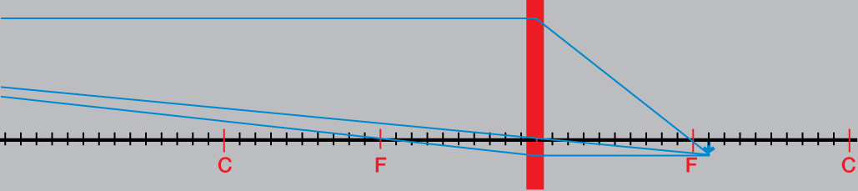 | The image is real, inverted, much smaller than the object, and is located at F.
outside C | 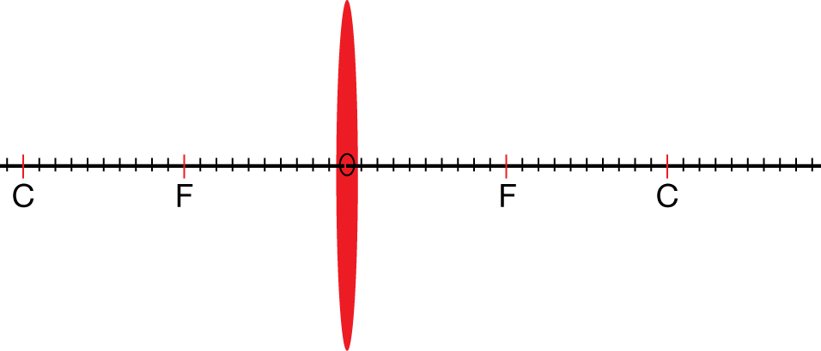
at C
between C and F
at F
inside F

(5 marks) | LAB 2. | Switch the lens in the simulation to a diverging lens by making the focal length negative (). Complete Table 2.

Table 2: Using Ray Diagrams to Predict Image Characteristics—Diverging Lens

Object Position | Ray Diagram | Image Characteristics  (real or virtual,  attitude, magnification,  position relative to lens)
very far away | 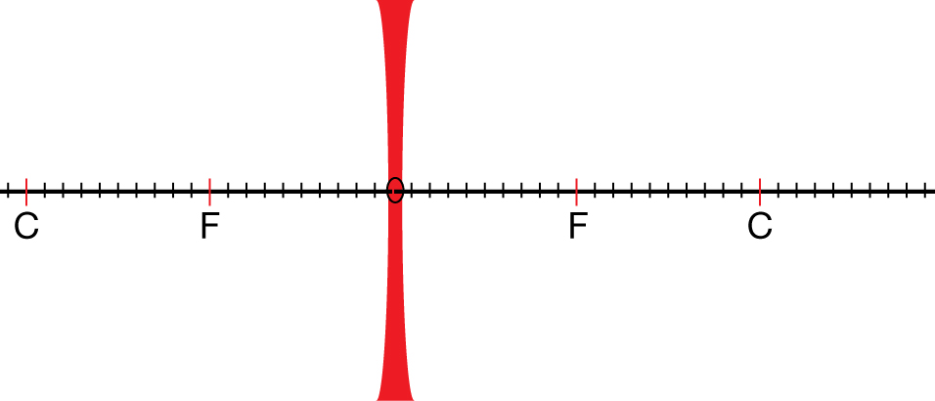
outside C
at C
between C and F
at F
inside F

 | A 1. | A converging lens with a focal length of 5.0 cm is placed 12 cm away from an 8.0-cm-tall object.

(3 marks) |  | a. How far from the lens is the image?

Answer:

(2 marks) |  | b. How tall is the image?

Answer:

(1 mark) |  | c. Describe the image characteristics: real/virtual, inverted/erect, enlarged/smaller.

Answer:

 | A 2. | A scientist uses a converging lens, with a 17 cm focal length, to focus light to create a holograph. The lens is 30 cm from the 25-cm-tall image.

(3 marks) |  | - How far from the lens is the object?

Answer:

(2 marks) |  | - What is the height of the object?

Answer:

(1 mark) |  | - Describe the image characteristics: real/virtual, inverted/erect, enlarged/smaller.

Answer:

 | A 3. | A student is given the challenge of determining the focal length of the lens in an LCD projector. The projector creates an image 600 cm tall, 12 m from the lens. The object is 12 cm tall.

(2 marks) |  | - What is the distance to the object?

Answer:

(2 marks) |  | - What is the focal length of the lens?

Answer:

 | D 1. | Using the simulation, you can explore ray diagrams for a magnifying glass by positioning the object inside the focal point of a converging lens on the simulation. Compare different positions to find how they relate to the object’s magnification and image characteristics. Also, adjust the focal length on the simulation, which defaults to 10.0 units of length.

 | D 2. | Create rules to describe the relationship between the object distance and image distance relative to the focal point and real/virtual images. Post your rules and read the rules of other students in your discussion forum.

(4 marks) | D 3. | Now that you have seen other students’ rules, reflect on your rules and improve them. What are your new rules, and how did reading the other students’ rules help you to improve your own understanding?
Answer:

Once you have completed all of the questions, submit your work to your teacher.

