Module 6: Lesson 2 ASSIGNMENT

This Module 6: Lesson 2 Assignment is worth 30 marks. The value of each assignment and each question is stated in the left margin.

While conducting research into the design of a light sensor, scientists measure the kinetic energy of photoelectrons that have been ejected from an unknown metal surface. The metal is exposed to various frequencies of EMR and the stopping voltage is measured to obtain the kinetic energy of the photoelectrons. The following data is obtained.

Incident EMR Frequency  (× 10¹⁴ Hz) | Kinetic Energy of Photoelectrons (eV)
6.0 | 0.38
7.0 | 0.80
8.0 | 1.20
9.0 | 1.63
10.0 | 2.04

(3 marks) | A 1. | Using this data, plot a kinetic energy versus frequency graph and use it to answer questions A 2 to A 5.

Answer:

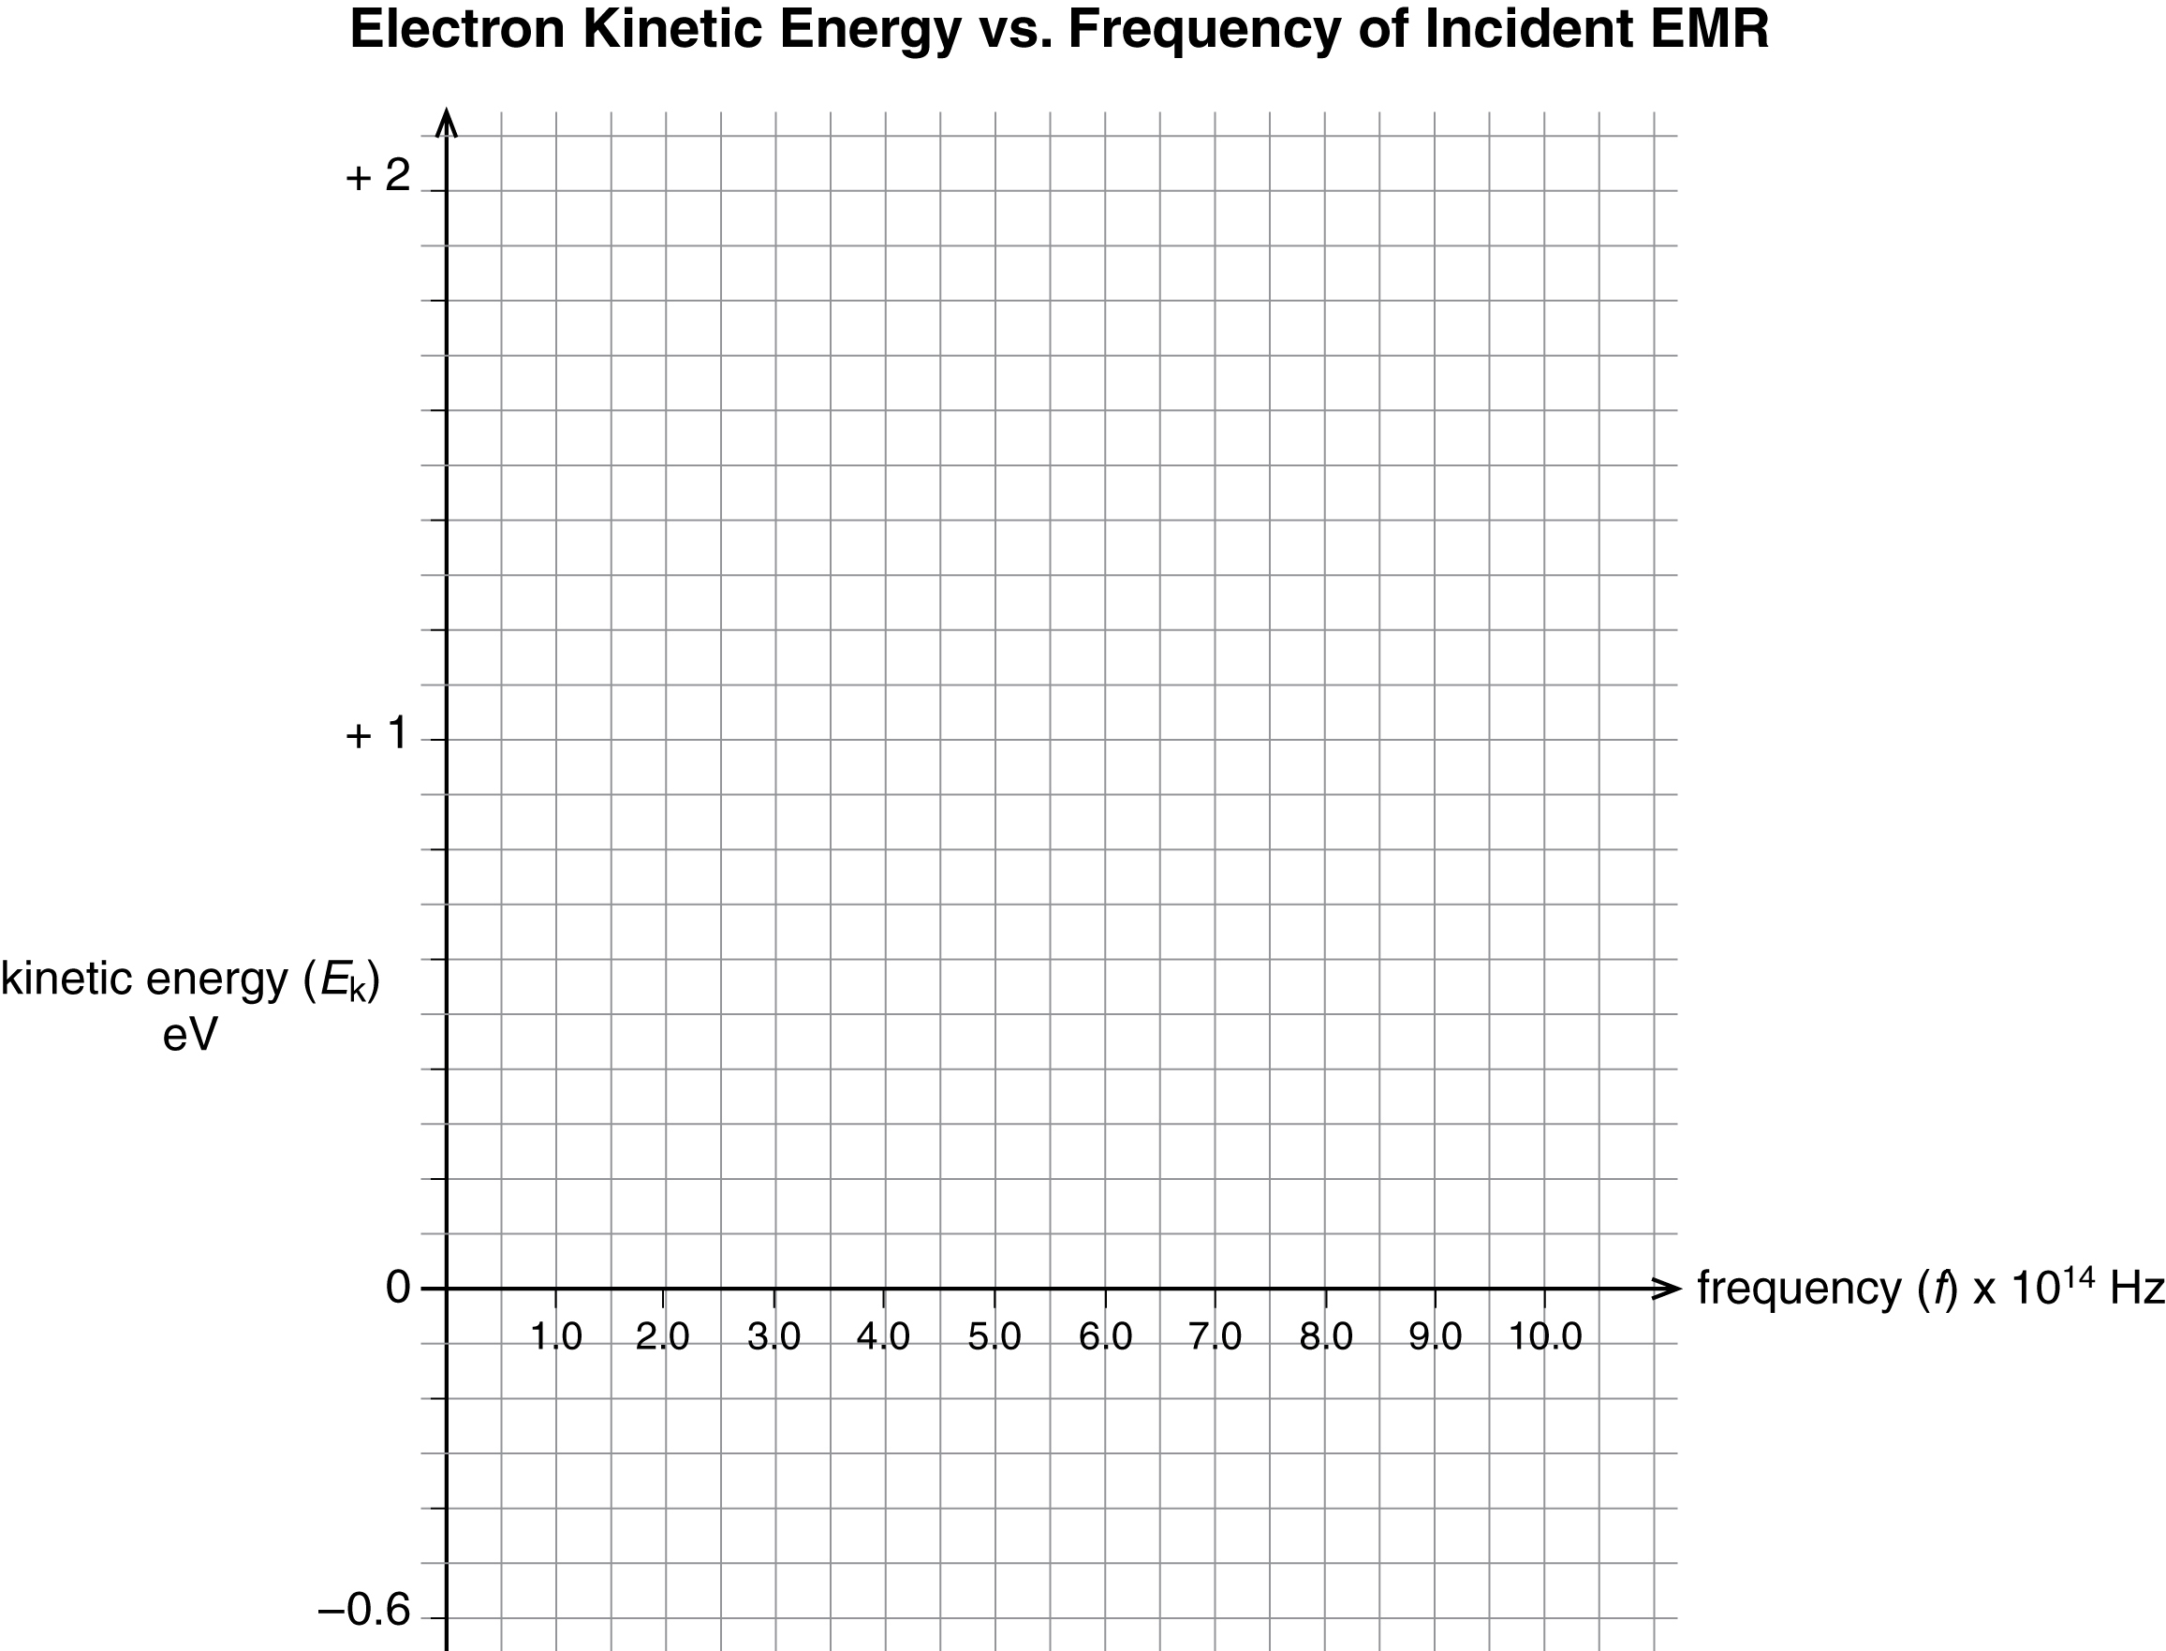

(2 marks) | A 2. According to your graph, what is the threshold frequency of the unknown metal? Label it on your graph.

Answer:

(3 marks) | A 3. | Determine the work function of the unknown metal.

Answer:

(1 marks) | A 4. | Using Table 14.1 on page 712 of your textbook, identify the unknown metal.

Answer:

(2 marks) | A 5. | Using your graph, determine the experimental value for Planck’s constant (in eV•s). Label this value on your graph.

Answer:

(3 marks) | A 6. | What is the energy of a photon that has a wavelength of 460 nm?

Answer:

(3 marks) | A 7. | A photoelectric surface has a work function of 2.00 eV. What is the threshold frequency of this surface?

Answer:

(3 marks) | A 8. | A photon of frequency 8.2 × 10¹⁵ Hz is incident upon a photoelectric apparatus containing a metal whose threshold frequency is 3.6 × 10¹⁵ Hz. What is the stopping voltage?

Answer:

(3 marks) | A 9. | Electrons are ejected from a photoelectric cell with a maximum kinetic energy of 1.20 eV. If the incident light has a wavelength of 410 nm, what is the work function of the cell?

Answer:

(3 marks) | A 10. | Light with a wavelength of 425 nm falls on a photoelectric surface that has a work function of 2.0 eV. What is the maximum speed of any emitted photoelectrons?

Answer:

D 1. You are asked to explain the photoelectric effect in terms of energy to a student who missed the class. In your explanation, start with the energy of the incident EMR photons and finish with the energy of the stopping voltage. Make sure to include the following terms in your answer: threshold frequency, light intensity, photoelectron current, work function, photoelectron kinetic energy, and stopping voltage. Post your answer to the discussion area.

(4 marks) | D 2. Read the answers to D 1 of at least two other students. Revise your answer from  D 1 and include any changes you made and how they improved your answer.

Answer:

Once you have completed all of the questions, submit your work to your teacher.

