Module 7: Lesson 3 ASSIGNMENT

This Module 7: Lesson 3 Assignment is worth 30 marks. The value of each assignment and each question is stated in the left margin.

(30 marks) | Lesson 3 Assignment—The Rutherford and Bohr Models of the Atom

Lab

Open the Rutherford Scattering simulation. (Go to Lesson 3 to open this simulation.)

(2 marks) | LAB 1. | Adjust the number of protons to the maximum of 100. Describe what happens to the amount of scattering that occurs and the angles at which it occurs. How can you explain the relationship between the amount of scattering and the number of protons in the nucleus?

Answer:

(2 marks) | LAB 2. | Select the “Plum Pudding Atom” from the upper menu on the simulation. Explain why the alpha particles are no longer scattered.

Answer:

 | A 1. | According to Maxwell’s laws of electromagnetism, the orbital frequency (the number of complete orbits per second) of an electron will match the frequency of the emitted radiation.

(1 mark) |  | a. | If an electron were to spiral into the nucleus, what would happen to the electron’s orbital frequency?

Answer:

(1 mark) |  | b. | If an electron were to spiral into the nucleus, what would happen to the frequency of the emitted radiation?

Answer:

(1 mark) |  | c. | If an electron were to spiral into the nucleus, what kind of spectrum would be produced—a continuous or line spectrum? Explain.

Answer:

(1 mark) |  | d. | Look at the emission spectrum of hydrogen. What kind of spectrum is this? Does Rutherford’s model predict the correct spectrum?

Answer:

(1 mark) | A 2. | According to Bohr, why did an atom not collapse in on itself while its electrons travelled around the nucleus?

Answer:

 | A 3. | Using Bohr’s model, explain what happens in the atom when a photon of light is

(1 mark) | a. | emitted

Answer:

(1 mark) | b. | absorbed

Answer:

 | A 4. | Earlier, when you read about the energy levels of hydrogen, you were introduced to an energy level diagram. On this diagram, the n = ∞ energy level is represented. On the applet, complete an n = 1 to n = ∞ transition and observe the energy state data.

(1 mark) | a. | According to the applet, what is the energy of the n = ∞ energy level?

Answer:

(1 mark) | b. | If an electron is initially in the ground state, how much energy must the atom absorb for this transition to occur?

Answer:

(1 mark) | c. | What is the radius of the n = ∞ energy level?

Answer:

(1 mark) | d. | What happens to the atom if the electron “jumps” to the n = ∞ energy level? Hint: Look at the radius of this energy level. Is the electron really part of the atom anymore?

Answer:

 | A 5. | In the hydrogen atom, the electron jumps from the n = 1 level to the n = 4 level.

(1 mark) | a. | During this transition, is a photon emitted or absorbed?

Answer:

(3 marks) | b. | What is the change in energy of the electron and what is the wavelength of the emitted or absorbed photon?

Answer:

(2 marks) | c. | Identify the transition by drawing an arrow on the energy level diagram below, and calculate the wavelength of the absorbed photon.

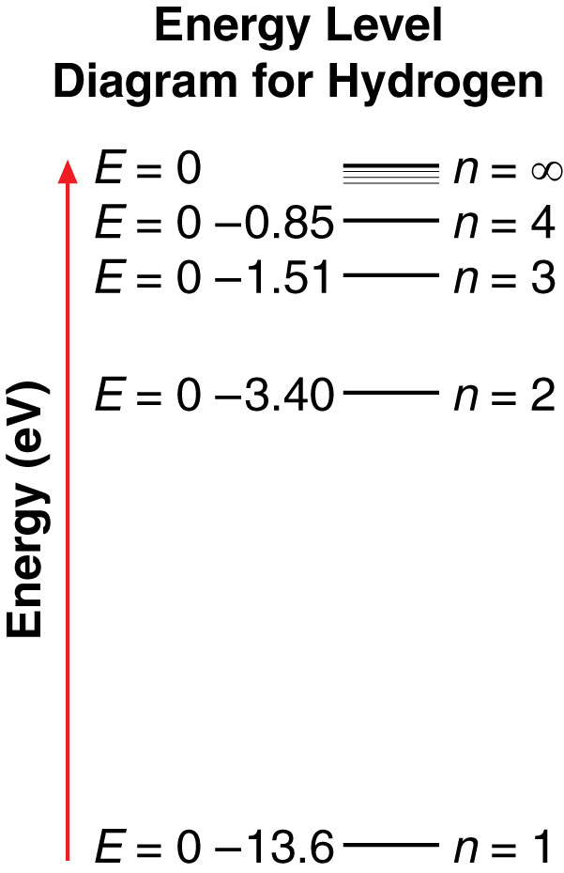

Answer:

(3 marks) | A 6. | An electron in the third stationary state around a hydrogen atom has energy of  – 1.512 eV. What will the electron’s energy be if the hydrogen atom absorbs a photon with a wavelength of 109 nm?

Answer:

(3 marks) | A 7. | What is the shortest wavelength photon that is emitted in the hydrogen atom? What transition emits this photon? Hint: If the wavelength is small, then the energy is large. Looking at the energy level diagram will also help you.

Answer:

(3 marks) | A 8. | Bohr’s model of the atom explains why emission and absorption lines match up. Prove this for the hydrogen atom. Choose any transition (and its opposite) and calculate the wavelength of the emitted and absorbed photon. Verify your answer using the applet.

Answer:

Once you have completed all of the questions, submit your work to your teacher.

