Learning Activity 3: Supervising Children

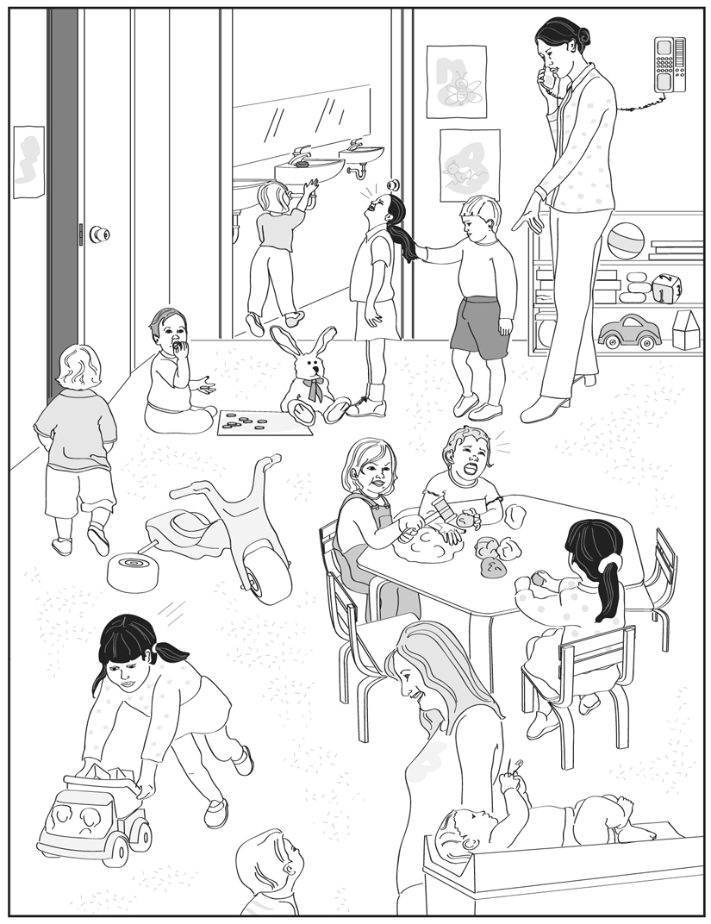

Indoor supervision is inadequate because . . .

Answer:
a.
b.
c.
d.
e.

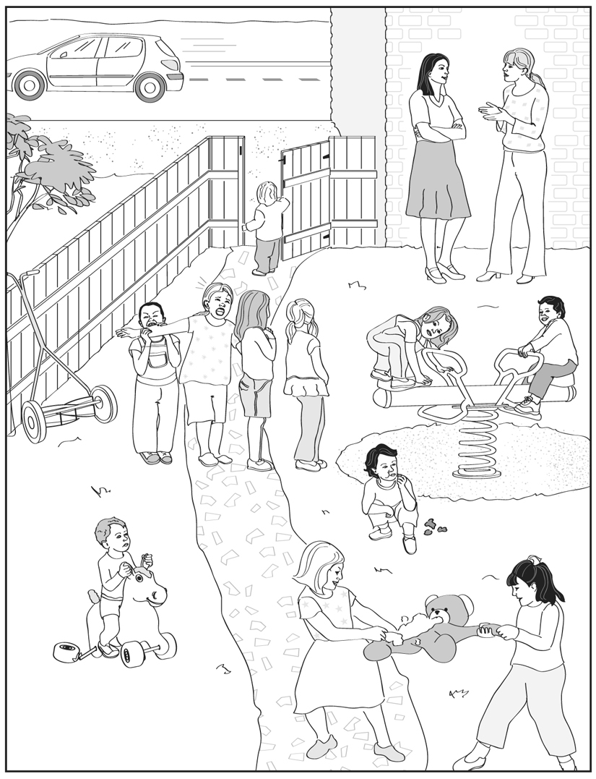

Outdoor supervision is inadequate because . . .

Answer:
a.
b.
c.
d.
e.

