ALIGNMENT AND BOLD

Select cell first and then format.

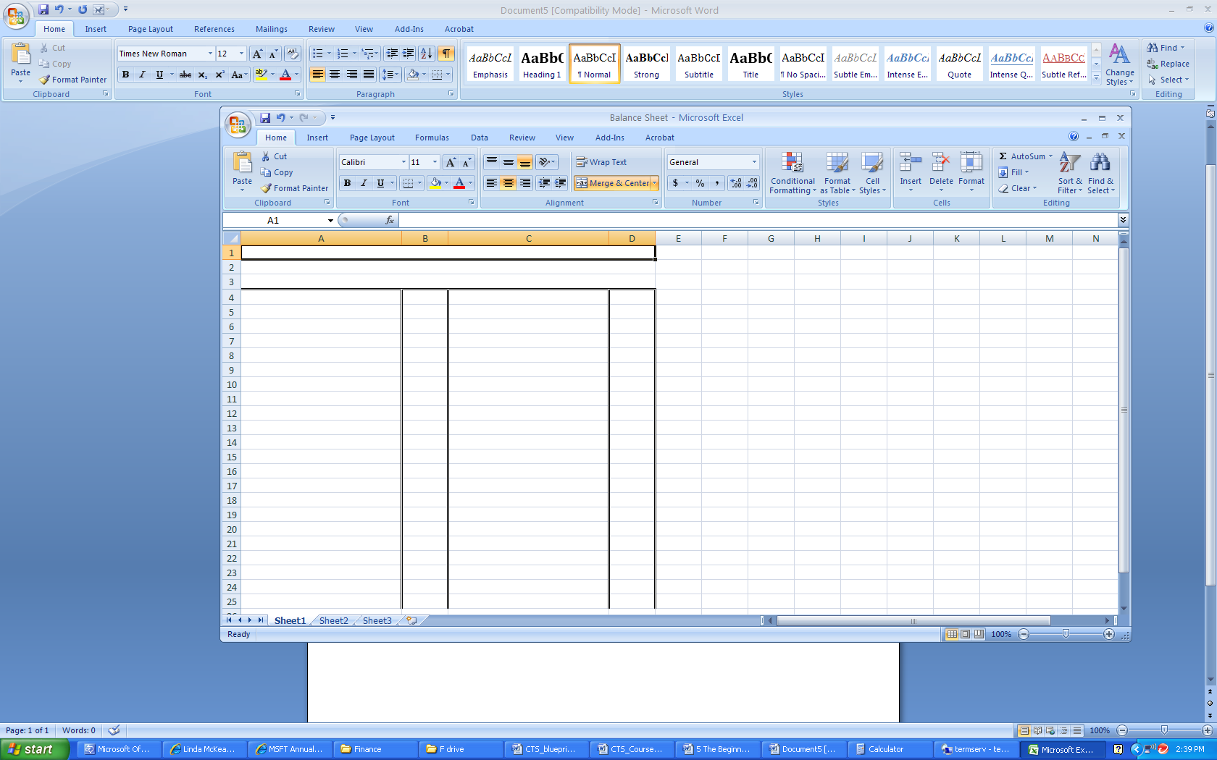
Centre
Right
Left
Bold

Microsoft product screen shot(s) reprinted with permission from Microsoft Corporation.

