Borders

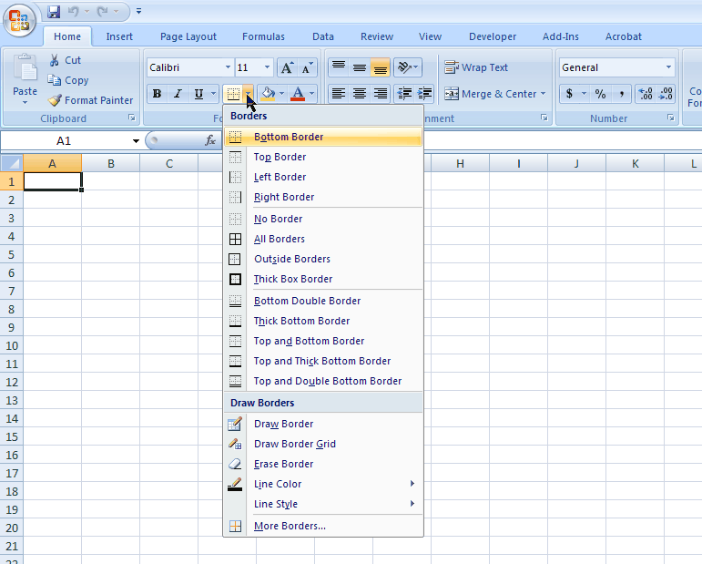
Step 1
Cursor in Cell
where you want a border
Step 2
Select Border Icon
Step 3
Select Border of Choice

Microsoft product screen shot(s) reprinted with permission from Microsoft Corporation.

