Finding Trial Balance Errors

Step 1: Add up the Debit column, and then add up the Credit column.

Step 2: Find the difference between the total of the Debit column and the total of the Credit column. Look for an amount equal to this difference in the general ledger. You may have omitted this account balance from the trial balance.

Step 3: Divide the difference between the Debit column and Credit column by 2. Look for an amount equal to this result in the trial balance. You may have written a debit balance in the Credit column, or a credit balance in the Debit column.

Step 4: Divide the difference between the Debit column and Credit column by 9. If the difference is evenly divisible by 9, you may have reversed the figures in an amount. For example, you may have written 47 instead of 74, 1.50 instead of 5.10, or 5.98 instead of 5.89.

This type of error is called a transposition error, which is an error in accounting when numbers are reversed.

As in the example below, assume that your trial balance is out by 0.45.

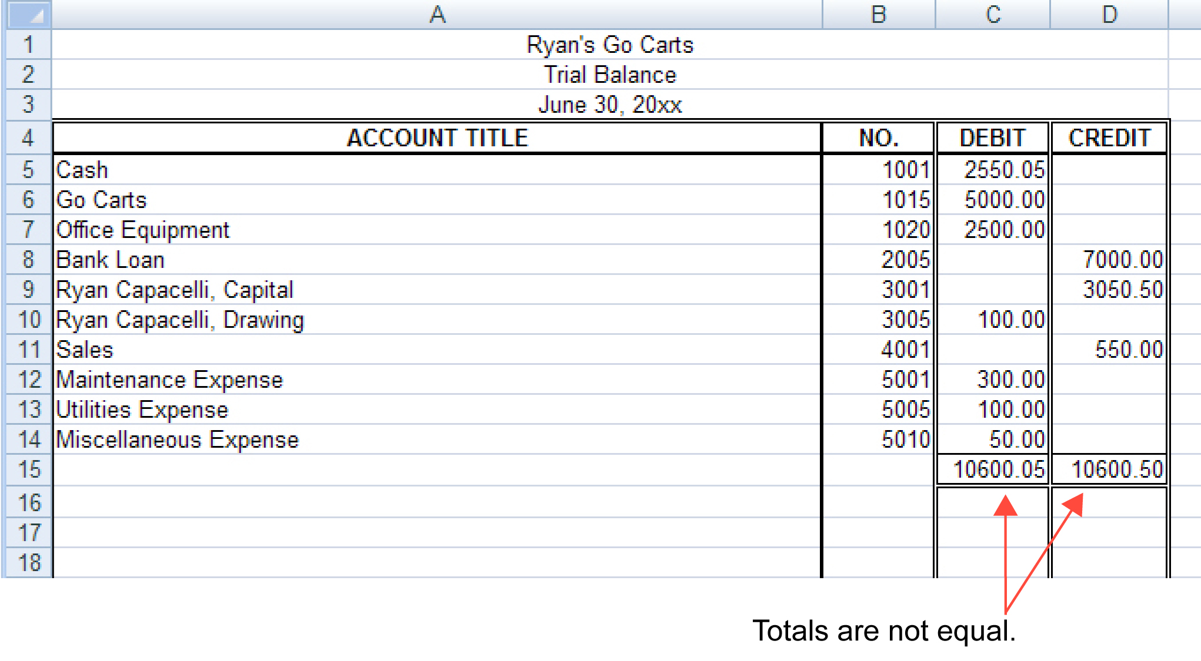
Microsoft product screen shot(s) reprinted with permission from Microsoft Corporation.

The total credits minus the total debits is 0.45.

The number 45 is a multiple of 9 (9 × 5 = 45). You have probably made a transposition error in the cents column.

When you checked the ledger, you found out that the Cash account total was copied incorrectly. The Cash account total was $2550.50 and not $2550.05.

The following is the Cash account total at the end of the month.

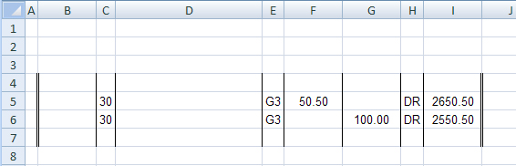

Microsoft product screen shot(s) reprinted with permission from Microsoft Corporation.

Another common error is to putting the decimal point in the wrong position. This type of error is known as a slide error, which is when the decimal point is incorrectly placed to the left or the right. An example would be writing 73.00 instead of 730.00.

Therefore, if the difference is exactly divisible by 9, the error is most likely a transposition or a slide error.

A trial balance may also be out of balance because of errors in posting. For example, mistakes made in calculating account balances in the general ledger, or mistakes made in copying amounts incorrectly from a journal to the general ledger, or forgetting to post one part of an entry from the journal to the general ledger are all common errors.

